Examination Report
Part 1 Fellowship of the Royal College of Ophthalmologists (FRCOphth) Examination
January 2020
Matthew Turner, David Budzynski, Ben Smith

Contents
1 Summary 3
2 Multiple choice question (MCQ) paper 4
2.1 Paper statistics 5
2.2 Quality of questions 6
2.3 Standard setting 6
3 Constructed response question (CRQ) paper 8
3.1 Paper statistics 8
3.2 Standard setting 10
4 Overall Results 12
4.1 Comparison with previous Part 1 examinations 13
4.2 Breakdown of results 14
Appendix 1: Overall results for each deanery 16

Summary
The Part 1 Fellowship of the Royal College of Ophthalmologists (FRCOphth) examination took place in January 2020. A total of 116 candidates sat the examination, of which 53 (46 per cent) fulfilled the criteria required to pass the examination overall.
The pass rate for candidates in Ophthalmic Specialist Training (OST) is 47 per cent compared with a 49 per cent pass rate for non-trainees.
The multiple choice question (MCQ) exam had a reliability of 0.97 and the constructed response question (CRQ) exam had a reliability of 0.91. The correlation between the two examinations was 0.75.

Multiple choice question (MCQ) paper
The table below gives the paper contents compared with previous years.
- MCQ paper content
Date | Anatomy/embryology | Optics | Pathology | Pharmacology & genetics | Physiology | Miscellaneous & investigations | Total
Oct 2014 | 24 | 24 | 23 | 18 | 23 | 8 | 120
Jan 2015 | 24 | 24 | 23 | 18 | 23 | 8 | 120
May 2015 | 24 | 24 | 23 | 18 | 23 | 8 | 120
Oct 2015 | 24 | 24 | 23 | 18 | 23 | 8 | 120
Jan 2016 | 24 | 23 | 23 | 18 | 23 | 8 | 119*
May 2016 | 24 | 24 | 22 | 18 | 23 | 8 | 119*
Oct 2016 | 24 | 24 | 23 | 18 | 23 | 8 | 120
Jan 2017 | 24 | 24 | 22 | 18 | 23 | 8 | 119*
May 2017 | 24 | 24 | 23 | 18 | 23 | 7 | 119*
May 2018 | 24 | 24 | 23 | 18 | 23 | 8 | 120
Oct 2018 | 24 | 24 | 23 | 18 | 23 | 8 | 120
Jan 2019 | 22 | 24 | 23 | 18 | 22 | 8 | 117*
Apr 2019 | 24 | 24 | 22 | 18 | 23 | 8 | 119*
Oct 2019 | 24 | 23 | 23 | 18 | 23 | 8 | 119*
Jan 2020 | 24 | 24 | 23 | 18 | 23 | 8 | 120
* = questions removed

Paper statistics
- MCQ paper summary statistics
Statistic | Value | Percentage
Mean score | 60/120 | 50.0%
Median score | 66/120 | 55.0%
Standard deviation | 24.7 | 20.6%
Candidates | 130
Reliability: Cronbach's alpha | 0.97
Standard error of measurement (SEM) | 4.54 | 3.8%
Range of marks | 0 – 98 | 0.0% – 81.7%
Pass mark derived from standard setting | 73/120 | 60.8%
Pass - 1 SEM | 69/120 | 57.5%
Pass rate | 45/130 | 34.6%

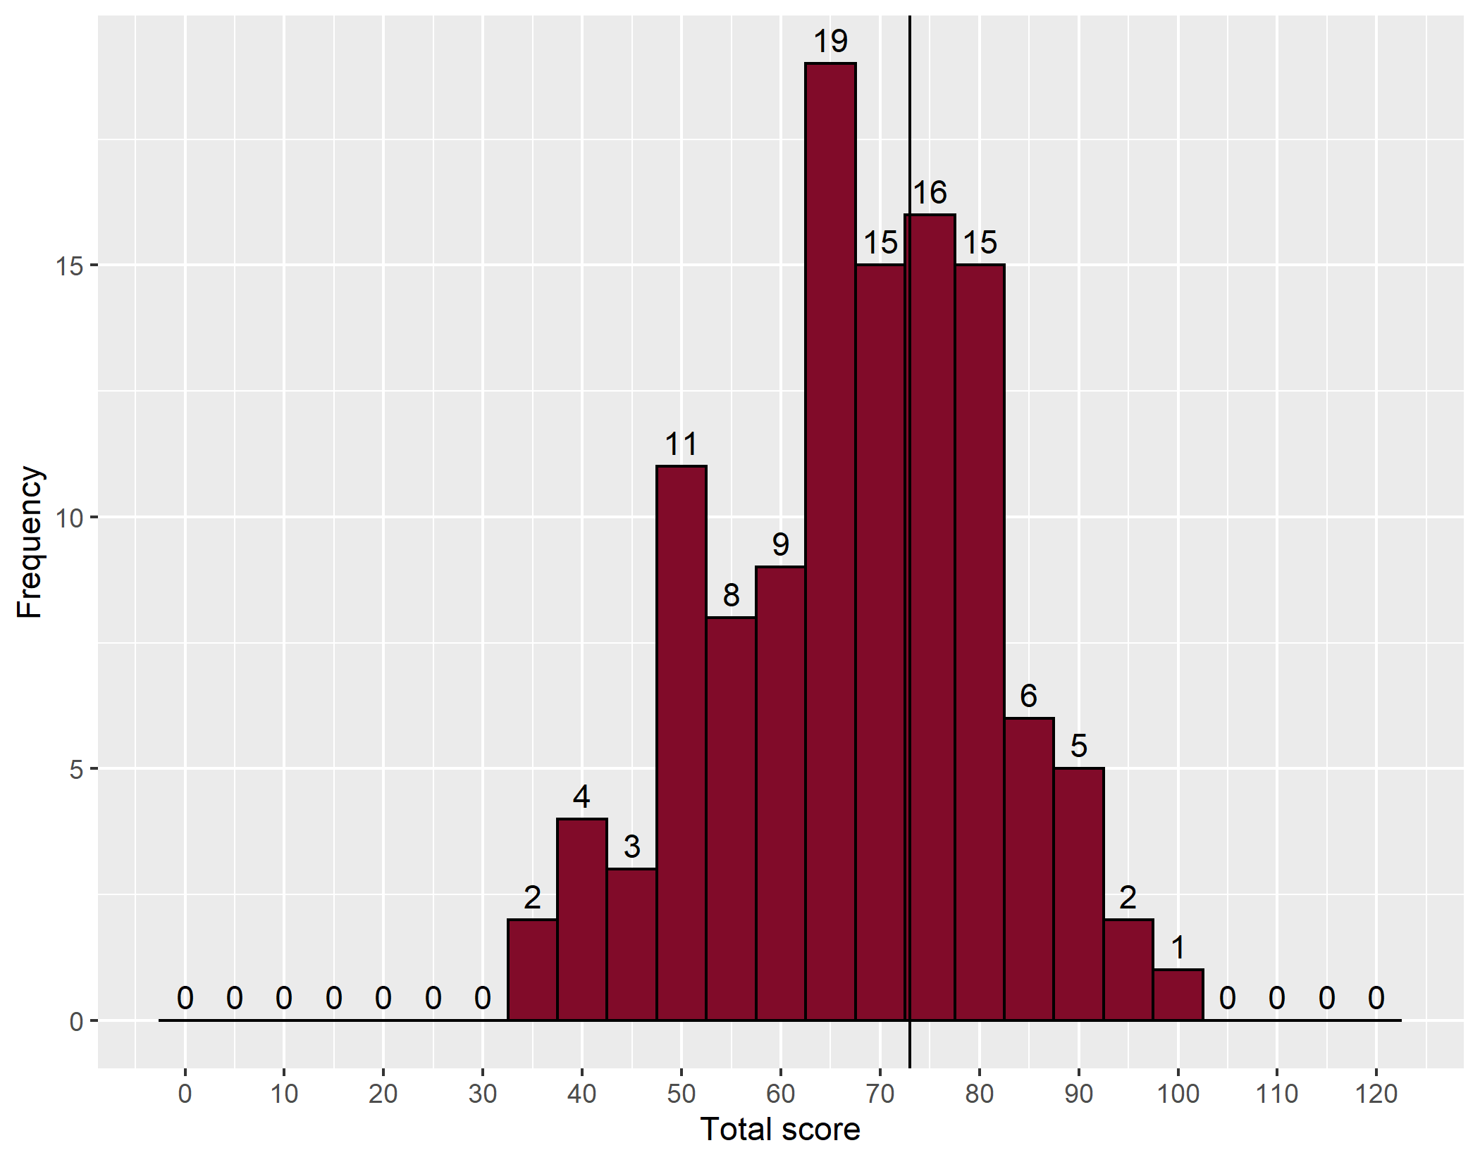
- Distribution of marks – MCQ
The vertical line denotes the point on the mark distribution where the pass mark lies.

Quality of questions
The Speedwell data allows us to identify easy, moderate and difficult questions, and those which are good, poor or perverse (negative) discriminators. Ideally, all questions should be moderately difficult and good discriminators.
- MCQ paper quality
 |  |  | Discrimination
 |  |  | Negative |  | Poor |  | Good |  | Total | %
 |  |  | <0 |  | 0-0.249 |  | ≥0.250
 |  |  | Number | % | Number | % | Number | %
Facility | Difficult | <25% | 1 | 0.8 | 11 | 9.2 | 3 | 2.5 | 15 | 12.5
 | Moderate | 25–75% | 0 | 0.0 | 9 | 7.5 | 87 | 72.5 | 96 | 80.0
 | Easy | ≥75% | 0 | 0.0 | 0 | 0.0 | 9 | 7.5 | 9 | 7.5
 | Total |  | 1 | 0.8 | 20 | 16.7 | 99 | 82.5 | 120 | 100.0

Standard setting
The pass mark for the paper was agreed using the Ebel method.
- MCQ Ebel categories
 | Difficult | Moderate | Easy | Total
Essential | 0 | 15 | 54 | 69
Important | 3 | 18 | 17 | 38
Supplementary | 2 | 4 | 7 | 13
Total | 5 | 37 | 78 | 120
The Part 1 FRCOphth subcommittee considered the success of a minimally competent candidate in each category as below:
- MCQ Ebel categories – expert decision
 | Difficult | Moderate | Easy
Essential | 0.55 | 0.65 | 0.75
Important | 0.45 | 0.50 | 0.55
Supplementary | 0.25 | 0.25 | 0.25
- MCQ Ebel categories – expert decision
 | Difficult | Moderate | Easy | Total
Essential | 0.00 | 10.00 | 40.00 | 50.00
Important | 1.00 | 9.00 | 9.00 | 20.00
Supplementary | 0.00 | 1.00 | 2.00 | 3.00
Total | 2.00 | 20.00 | 52.00 | 73.00
The MCQ pass mark was 73/120 (61%)

- Comparison of pass marks and rates for previous MCQ papers
 |  |  |  |  |  |  | 33% discrimination |  |  | Facility
Year | Candidates | Mean score | Reliability  (KR 20) | SEM | Standard setting | Pass mark | Negative | Poor  (0-0.249) | Good  (>0.250) | Difficult  (<25%) | Moderate | Easy  (>75%) | Number of questions | Pass number (rate)
Oct 2015 | 188 | 68 | 0.85 | 4.90 | Ebel | 71  (60%) | 3 | 59 | 58 | 6 | 90 | 24 | 120 | 79  (42%)
Jan 2016 | 107 | 69 | 0.90 | 4.90 | Ebel | 71  (59%) | 3 | 55 | 62 | 6 | 91 | 23 | 119 | 47  (44%)
May 2016 | 123 | 70 | 0.90 | 4.90 | Ebel | 71  (60%) | 6 | 34 | 79 | 3 | 90 | 26 | 119 | 71  (58%)
Oct 2016 | 194 | 71 | 0.88 | 4.80 | Ebel | 72  (60%) | 5 | 49 | 66 | 9 | 88 | 23 | 120 | 72  (37%)
Jan 2017 | 101 | 64 | 0.80 | NA | Ebel | 71  (60%)
May 2017 | 136 | 69 | 0.80 | 4.80 | Ebel | 75  (63%) | 6 | 63 | 50 | 8 | 89 | 22 | 119 | 45  (33%)
May 2018 | 119 | 70 | 0.83 | 4.73 | Ebel | 72  (60%) | 15 | 61 | 44 | 9 | 70 | 41 | 120 | 59  (50%)
Oct 2018 | 214 | 70 | 0.86 | 4.84 | Ebel | 72  (60%) | 7 | 68 | 45 | 4 | 87 | 29 | 120 | 103  (48%)
Jan 2019 | 96 | 65 | 0.82 | 4.68 | Ebel | 70  (60%) | 15 | 63 | 39 | 15 | 70 | 32 | 117 | 39  (41%)
Apr 2019 | 119 | 72 | 0.89 | 4.70 | Ebel | 73  (61%) | 10 | 46 | 63 | 9 | 79 | 31 | 119 | 64  (54%)
Oct 2019 | 186 | 68 | 0.84 | 4.67 | Ebel | 72  (61%) | 10 | 65 | 44 | 13 | 68 | 38 | 119 | 81  (44%)
Jan 2020 | 130 | 60 | 0.97 | 4.54 | Ebel | 73  (61%) | 1 | 20 | 99 | 15 | 96 | 9 | 120 | 45  (35%)

Constructed response question (CRQ) paper
The table below gives the paper contents.
- CRQ paper content
Question | Subsections
1 | 5
2 | 7
3 | 4
4 | 5
5 | 4
6 | 3
7 | 4
8 | 6
9 | 4
10 | 6
11 | 6
12 | 10

Paper statistics
- CRQ paper summary statistics
Statistic | Value | Percentage
Mean score | 62/120 | 51.7%
Median score | 64/120 | 53.3%
Standard deviation | 14.9 | 12.4%
Candidates | 116
Reliability: Cronbach's alpha | 0.91
Standard error of measurement (SEM) | 4.51* | 3.8%
Range of marks | 10 – 96 | 8.3% – 80.0%
Pass mark derived from standard setting | 62/120 | 51.7%
Pass - 1 SEM | 58/120 | 48.3%
Pass rate | 69/116 | 59.5%

*Note that the CRQ paper is scored out of 240, with two examiners each marking out of 120. In order to put the score back on the same scale as the MRQ paper and give each equal weight, the mark out of 240 is halved and so is the SEM. As such this SEM value is technically [SEM out of 240]/2.

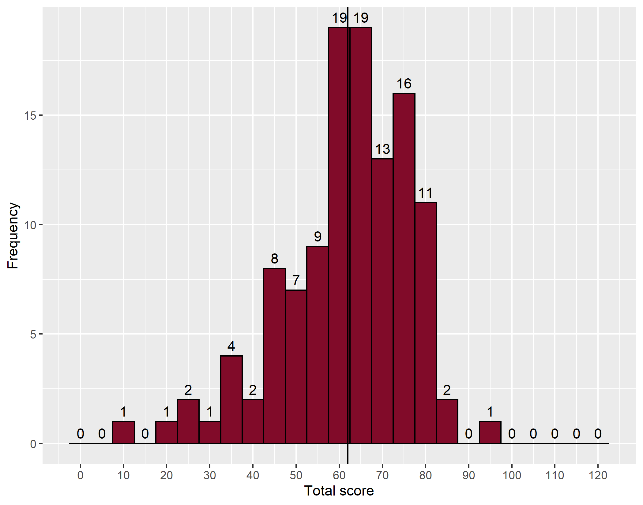
- Distribution of marks – CRQ
The vertical line denotes the point on the mark distribution where the pass mark lies.
Two examiners marked each question in the CRQ papers and the average mark from each was used to produce the candidate mark. Each question has a maximum possible 10 marks. Candidate performance was variable for each question, with mean, median, minimum and maximum scores (with standard deviations) set out in Table 10 below.
- Results for each question
Question | Subject | Mean | Median | Min | Max | SD | BCM
1 | Anatomy | 5.20 | 5.00 | 0 | 10 | 2.72 | 5.50
2 | Pathology | 4.63 | 5.00 | 1 | 10 | 1.66 | 4.50
3 | Pathology | 4.18 | 4.00 | 0 | 8 | 1.76 | 4.00
4 | Optics* | 4.84 | 5.00 | 0 | 9 | 1.96 | 4.50
5 | Optics* | 5.19 | 5.00 | 0 | 10 | 2.35 | 5.50
6 | Optics | 4.97 | 5.00 | 0 | 10 | 2.70 | 5.00
7 | Optics* | 2.39 | 2.00 | 0 | 8 | 2.15 | 4.00
8 | Investigations | 7.97 | 9.00 | 0 | 10 | 1.92 | 6.00
9 | Investigations | 5.86 | 6.00 | 0 | 10 | 2.83 | 5.00
10 | Investigations | 7.20 | 7.00 | 1 | 10 | 1.58 | 6.50
11 | Investigations | 5.91 | 6.00 | 0 | 10 | 1.98 | 6.00
12 | Statistics | 5.66 | 6.00 | 1 | 9 | 2.03 | 5.25

Candidates performed badly in or were particularly ill prepared for question 7 (Optics*).

Standard setting
The borderline candidate method was used to identify the pass mark for the CRQ. The examiners who marked the CRQ paper were asked to allocate a mark according to the marking scheme provided and, in addition, class the candidate's performance as a pass, fail or borderline. The sum of each median borderline mark was used to produce the pass mark.
- CRQ standard setting
Question | Topic | Examiner A |  |  |  | Examiner B
 |  | Fail no. | Border no. | Pass no. | Sum of MBM | Fail no. | Border no. | Pass no. | Sum of MBM
1 | Anatomy | 48 | 37 | 31 | 6 | 41 | 44 | 31 | 5
2 | Pathology | 50 | 33 | 33 | 5 | 47 | 42 | 27 | 5
3 | Pathology | 58 | 24 | 34 | 4 | 56 | 34 | 26 | 4
4 | Optics* | 36 | 35 | 45 | 5 | 20 | 41 | 55 | 4
5 | Optics* | 43 | 23 | 50 | 5 | 30 | 55 | 31 | 4
6 | Optics | 51 | 37 | 28 | 5 | 45 | 41 | 30 | 5
7 | Optics* | 74 | 12 | 30 | 4 | 92 | 7 | 17 | 4
8 | Investigations | 16 | 86 | 14 | 6 | 12 | 89 | 15 | 6
9 | Investigations | 26 | 60 | 30 | 5 | 40 | 55 | 21 | 6
10 | Investigations | 9 | 80 | 27 | 6 | 12 | 46 | 58 | 7
11 | Investigations | 37 | 53 | 26 | 6 | 49 | 30 | 37 | 7
12 | Statistics | 36 | 57 | 23 | 5 | 37 | 33 | 46 | 6
Total |  | 484 | 537 | 371 | 62 | 481 | 517 | 394 | 63

- Comparison with previous years
Date | Mean score | Median score | Reliability | SEM | Pass mark | Pass rate | Correlation  with MCQ
Oct 2014 | 50% | 52% | 0.94 | 4.3 | 57% | 38% | 0.76
Jan 2015 | 58% | 62% | 0.92 | 4.6 | 61% | 56% | 0.77
May 2015 | 51% | 52% | 0.93 | 4.6 | 54% | 49% | 0.75
Oct 2015 | 48% | 50% | 0.94 | 4.3 | 59% | 28% | 0.81
Jan 2016 | 48% | 50% | 0.94 | 3.0 | 54% | 32% | 0.80
May 2016 | 51% | 54% | 0.94 | 4.5 | 56% | 41% | 0.85
Oct 2016 | 50% | 50% | 0.93 | 4.0 | 59% | 30% | 0.83
Jan 2017 | 49% | 51% | 0.92 | 4.0 | 51% | 50% | Unknown
May 2017 | 57% | 58% | 0.92 | 5.0 | 53% | 67% | 0.76
May 2018 | 57% | 59% | 0.93 | 8.1 | 54% | 71% | 0.78
Oct 2018 | 58% | 60% | 0.93 | 4.8 | 55% | 68% | 0.75
Jan 2019 | 50% | 52% | 0.93 | 4.3 | 49% | 62% | 0.71
Apr 2019 | 44% | 44% | 0.94 | 4.6 | 51% | 35% | 0.83
Oct 2019 | 46% | 49% | 0.92 | 4.7 | 51% | 41% | 0.75
Jan 2020 | 51% | 53% | 0.91 | 4.5 | 52% | 59% | 0.75

Overall Results
To pass the Part 1 FRCOphth examination candidates are required to both
- obtain a combined mark from both papers that equals or exceeds the combined pass marks obtained by the standard setting exercise explained above, and
- obtain a mark in both papers that equals or exceeds the pass mark minus one standard error of measurement for each paper.
A candidate is therefore allowed to compensate a poor performance in one paper by a very good performance in the other paper. They cannot compensate for an extremely poor performance in one paper whatever the combined mark.
The minimum mark required in order to meet standard 1 above for this examination was 135/240 (56 per cent). The minimum mark required in each paper (to meet standard 2 above) was 69/120 in the MCQ paper and 58/120 in the CRQ paper.
Fifty three (46 per cent) gained a total mark that met both standards 1 and 2 above. Thirteen candidates achieved 135/240 or greater but failed to achieve 69/120 in the MCQ paper. In total, 53 out of 116 (46 per cent) candidates passed the examination.
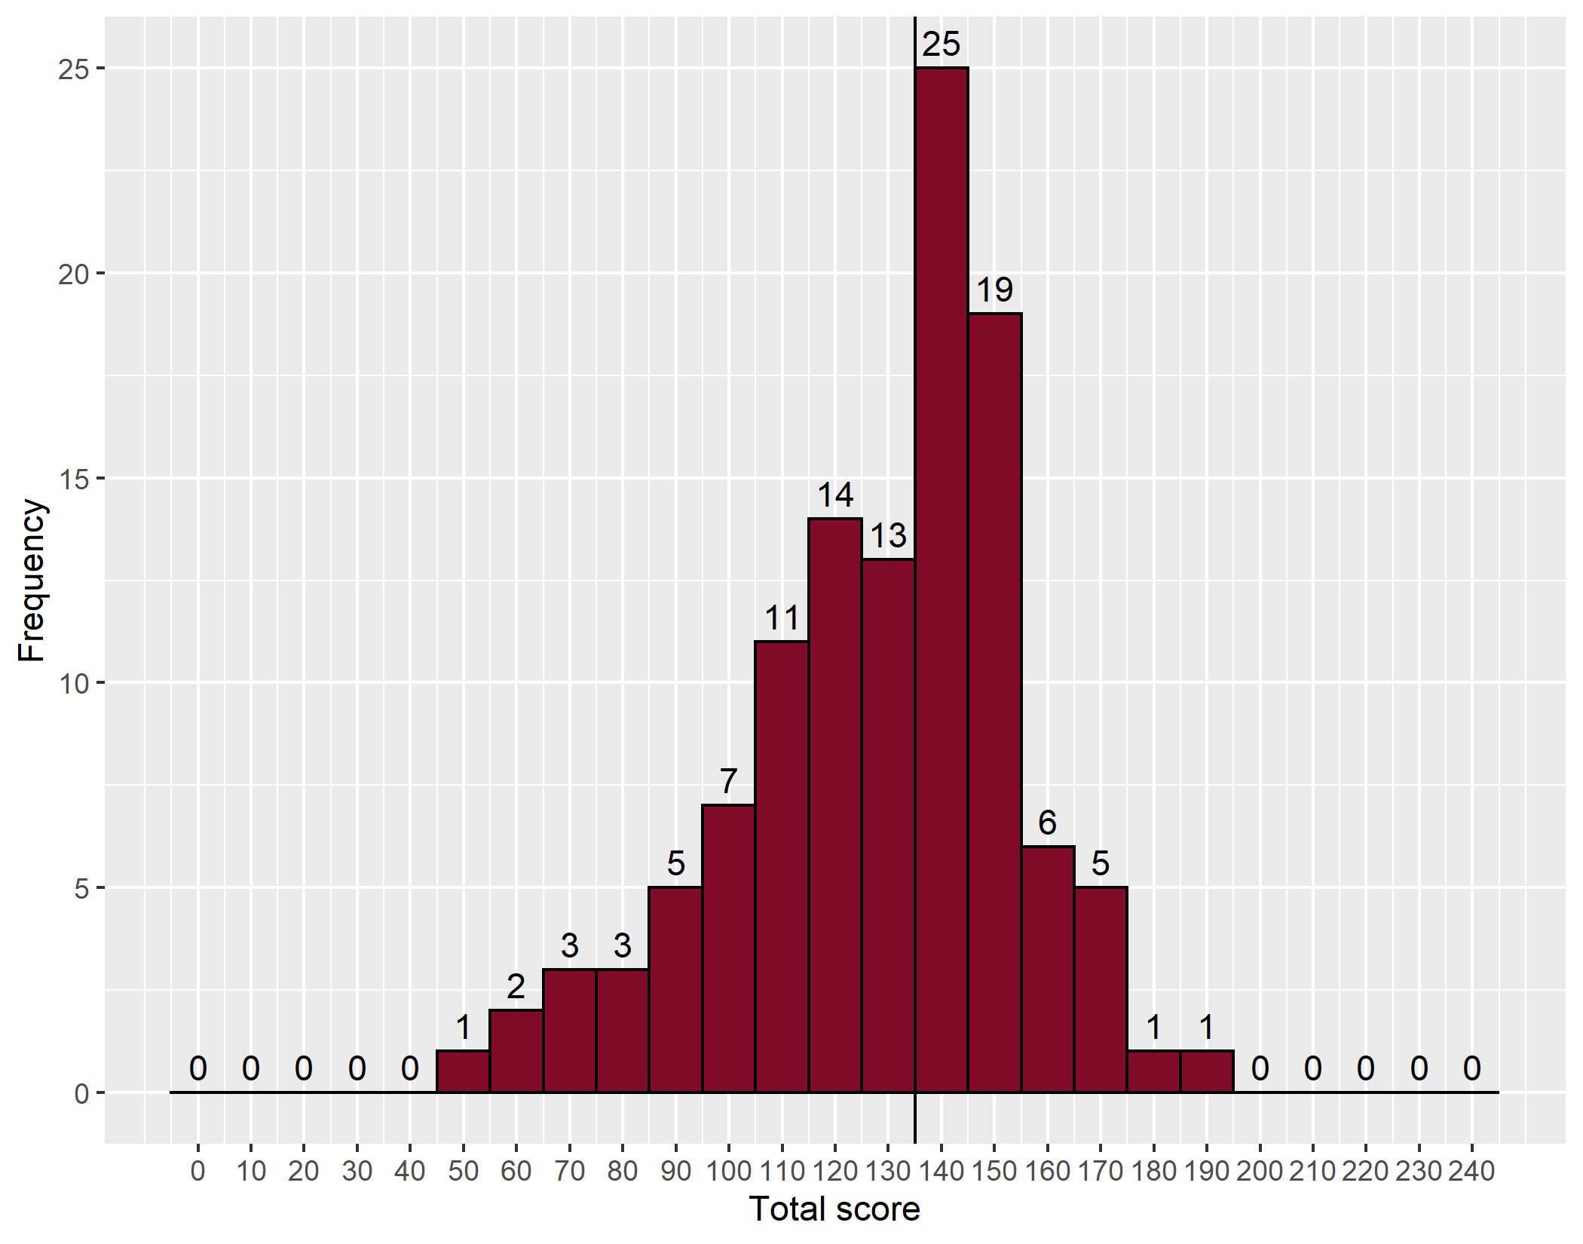
- Distribution of marks – Combined
The vertical line denotes the point on the mark distribution where the pass mark lies.

Comparison with previous Part 1 examinations
- Comparison with previous years
Examination | Candidates | Number passing | % passed | MCQ pass mark % | CRQ pass mark %
Oct 2006 | 33 | 3 | 9 | 58 | 62
Jan 2007 | 24 | 4 | 16 | 60 | 43
May 2007 | 32 | 5 | 15 | 50 | 64
Oct 2007 | 56 | 13 | 23 | 51 | 59
Jan 2008 | 73 | 27 | 37 | 56 | 55
May 2008 | 66 | 16 | 24 | 57 | 48
Oct 2008 | 88 | 45 | 51 | 58 | 51
Jan 2009 | 79 | 37 | 47 | 61 | 57
Jul 2009 | 49 | 33 | 67 | 63 | 58
Oct 2009 | 101 | 56 | 56 | 62 | 56
Jan 2010 | 50 | 20 | 40 | 63 | 58
May 2010 | 79 | 31 | 39 | 60 | 57
Oct 2010 | 89 | 34 | 38 | 61 | 54
Jan 2011 | 62 | 23 | 37 | 59 | 58
May 2011 | 95 | 47 | 49 | 54 | 57
Oct 2011 | 122 | 63 | 52 | 56 | 56
Jan 2012 | 66 | 20 | 33 | 57 | 54
May 2012 | 104 | 53 | 51 | 56 | 58
Oct 2012 | 150 | 84 | 56 | 56 | 54
Jan 2013 | 91 | 47 | 52 | 57 | 53
May 2013 | 102 | 54 | 53 | 58 | 58
Oct 2013 | 151 | 65 | 43 | 58 | 60
Jan 2014 | 77 | 23 | 30 | 57 | 57
May 2014 | 119 | 55 | 46 | 58 | 56
Oct 2014 | 232 | 102 | 44 | 58 | 57
Jan 2015 | 89 | 50 | 56 | 58 | 61
May 2015 | 114 | 62 | 54 | 57 | 54
Oct 2015 | 188 | 57 | 30 | 59 | 59
Jan 2016 | 107 | 36 | 34 | 59 | 54
May 2016 | 123 | 61 | 50 | 60 | 56
Oct 2016 | 194 | 70 | 36 | 60 | 59
Jan 2017 | 101 | 38 | 38 | 60 | 51
May 2017 | 136 | 62 | 46 | 63 | 53
May 2018 | 119 | 64 | 54 | 60 | 54
Oct 2018 | 214 | 122 | 57 | 60 | 55
Jan 2019 | 96 | 37 | 39 | 60 | 50
Apr 2019 | 119 | 45 | 38 | 61 | 51
Oct 2019 | 186 | 89 | 48 | 61 | 51
Jan 2020 | 116 | 53 | 46 | 61 | 52
- Comparison to previous years
Sitting | Candidates | Number passing | Pass rate (%)
January | 1031 | 415 | 40
May | 1089 | 510 | 47
October | 1771 | 817 | 46
Total | 3891 | 1742 | 45

Breakdown of results
- Breakdown of results by training number (%)
Training | Failed | Passed | Percentage | Total
In OST | 24 | 21 | 46.7 | 45
Not in OST | 30 | 29 | 49.2 | 59
Unknown | 9 | 3 | 25.0 | 12
Total | 63 | 53 | 45.7 | 116

- Breakdown of results by deanery
Country | Deanery | Failed | Passed | Total
UK | East Midlands | 2 | 1 | 3
 | East of England | 3 | 1 | 4
 | East of Scotland | 2 | 1 | 3
 | KSS (Kent, Surrey & Sussex) | 0 | 1 | 1
 | London | 3 | 2 | 5
 | Mersey | 1 | 1 | 2
 | North of Scotland | 0 | 2 | 2
 | North Western | 0 | 1 | 1
 | Northern | 0 | 1 | 1
 | Northern Ireland | 0 | 1 | 1
 | Oxford | 0 | 1 | 1
 | Peninsula (South West) | 0 | 1 | 1
 | Wales | 2 | 1 | 3
 | West Midlands | 1 | 1 | 2
 | Yorkshire | 3 | 1 | 4
Overseas | Europe and Overseas | 1 | 1 | 2
Total |  | 18 | 18 | 36

- Breakdown of results by stage of training
Stage | Failed | Passed | Percentage | Total
FY2 | 3 | 1 | 75.0 | 4
MO ST5 | 1 | 0 | 100.0 | 1
OST1 | 10 | 12 | 45.5 | 22
OST2 | 7 | 7 | 50.0 | 14
OST3 | 2 | 0 | 100.0 | 2
OST5 | 0 | 1 | 0.0 | 1
OST6 | 1 | 0 | 100.0 | 1
Total | 24 | 21 | 53.3 | 45

Appendix 1: Overall results for each deanery
Result data by deanery has been available since October 2010. The summary results for each deanery are listed below.
- Cumulative pass by deanery
Country | Deanery | Total candidates passed | Total candidates | Pass rate %
UK | East Midlands | 40 | 86 | 47
 | East of England | 55 | 122 | 45
 | East of Scotland | 14 | 17 | 82
 | KSS (Kent, Surrey & Sussex) | 47 | 76 | 62
 | London | 149 | 268 | 56
 | Mersey | 46 | 108 | 43
 | North of Scotland | 20 | 40 | 50
 | North Western | 39 | 63 | 62
 | Northern | 42 | 76 | 55
 | Northern Ireland | 33 | 82 | 40
 | Oxford | 25 | 38 | 66
 | Peninsula (South West) | 32 | 71 | 45
 | Severn | 18 | 32 | 56
 | South East of Scotland | 25 | 39 | 64
 | Wales | 51 | 106 | 48
 | Wessex | 49 | 105 | 47
 | West Midlands | 81 | 177 | 46
 | West of Scotland | 57 | 112 | 51
 | Yorkshire | 58 | 96 | 60
Overseas | Eire | 6 | 18 | 33
 | Europe and Overseas | 23 | 52 | 44
Total |  | 910 | 1784 | 51

