Examination Report
December 2018 Part 2 Fellowship in Ophthalmology (FRCOphth) Written Examination
Matthew Turner, Ben Smith

Contents
1 Summary 3
2 The candidates 3
3 The written paper 3
4 Results 4
4.1 Analysis of Questions 5
4.2 Standard setting for MCQ paper (Ebel method) 6
4.3 Breakdown of written results 6
4.4 Comparison to previous years 8

Summary
The written paper of the XX sitting of the Part 2 Fellowship in Ophthalmology (FRCOphth) examination was held on 01 December 2018.
The pass mark for this part 2 written paper was elevated by +1 SEM.
The reliability of this exam was 0.82, and the proportion of questions with a good item discrimination (>0.25) was 18%. Two questions were removed from paper 1 and one question was removed from paper 2, so the examination was therefore marked out of 177.
The pass mark for the written examination was raised by 1 SEM above the mark identified by the standard set by the Ebel method from 62% to 65%. The pass rate for the examination was 58%. The pass mark was 115/177 (65%).
Eighteen candidates obtained the Ebel mark (62%) but fell below the pass mark of Ebel +1 SEM (65%). The addition of +1 SEM has had a substantial impact on the pass rate which would be 72% rather than 58%.
The pass rate for those sitting at their first attempt was 68%. Five of the training sectors had a high pass rate (greater than 50%).

The candidates
127 candidates presented themselves for the examination. 80/127 (63%) were in an Ophthalmic Specialty Training (OST), with the majority (42%) in OST4.

The written paper
The written part of the part 2 FRCOphth examination consists of a multiple choice question paper, which is administered in two parts. Candidates must pass the written paper to be allowed to sit the clinical part of the examination.
As part of the quality management of the College's assessment process, the written papers are reviewed by the senior examiner after marking, but before the results are known. Three questions were removed from the examination papers as a result of this review.
The Part 2 FRCOphth sub-committee reviews all of the questions with a low item discrimination and facility.

- The MCQ paper blueprint
Topic | Sub-Topic | Paper 1 | Paper 2 | Total
Clinical Ophthalmology | Trauma | 2 | 2 | 4
 | Oculoplastic & Orbit | 5 | 5 | 10
 | Glaucoma | 4 | 4 | 8
 | Strabismus | 4 | 4 | 8
 | Paediatrics | 4 | 4 | 8
 | Retina | 10 | 10 | 20
 | Cataract | 5 | 5 | 10
 | Cornea & External Eye | 10 | 10 | 20
 | Uveitis & Oncology | 6 | 6 | 12
 | Neurology & Pupils | 7 | 8 | 15
 | Medicine | 5 | 5 | 10
Pharmacology & Therapeutics | Pharmacology & Therapeutics | 6 | 6 | 12
Investigations | Ophthalmic | 5 | 4 | 9
 | Orthoptic | 1 | 2 | 3
 | Neuro-Imaging | 2 | 1 | 3
 | Other | 0 | 1 | 1
Miscellaneous | Statistics and epidemiology | 2 | 1 | 3
 | Research and EBM | 1 | 2 | 3
 | Nutrition | 1 | 0 | 1
 | Ethics and driving | 2 | 2 | 4
 | Standards and guidelines | 2 | 2 | 4
 | Economics | 0 | 1 | 1
Basic Science | Anatomy and physiology | 1 | 1 | 2
 | Pathology and microbiology | 1 | 1 | 2
 | Genetics | 2 | 1 | 3
 | Optics | 0 | 1 | 1
Total |  | 88* | 89** | 177
* Two questions were removed from the marking
** One question was removed from the marking

Results
- MCQ Statistics
Statistic | Value | Percentage
Mean score: | 117/177 | 66.1%
Median score: | 116/177 | 65.5%
Standard deviation: | 13.2 | 7.5%
Candidates: | 127
Reliability: | 0.8
Standard error of measurement (SEM): | 5.57 | 3.4%
Range of marks: | 89 – 147 | 50.3% –83.1%
Pass mark derived from Standard Setting: | 110/177 | 61.6%
Pass rate without addition of SEM: | 92/127 | 72.4%
Pass mark + 1 SEM: | 115/177 | 65%
Pass rate: | 74/127 | 58.3%
Pass rate in OST: | 47/80 | 58.8%

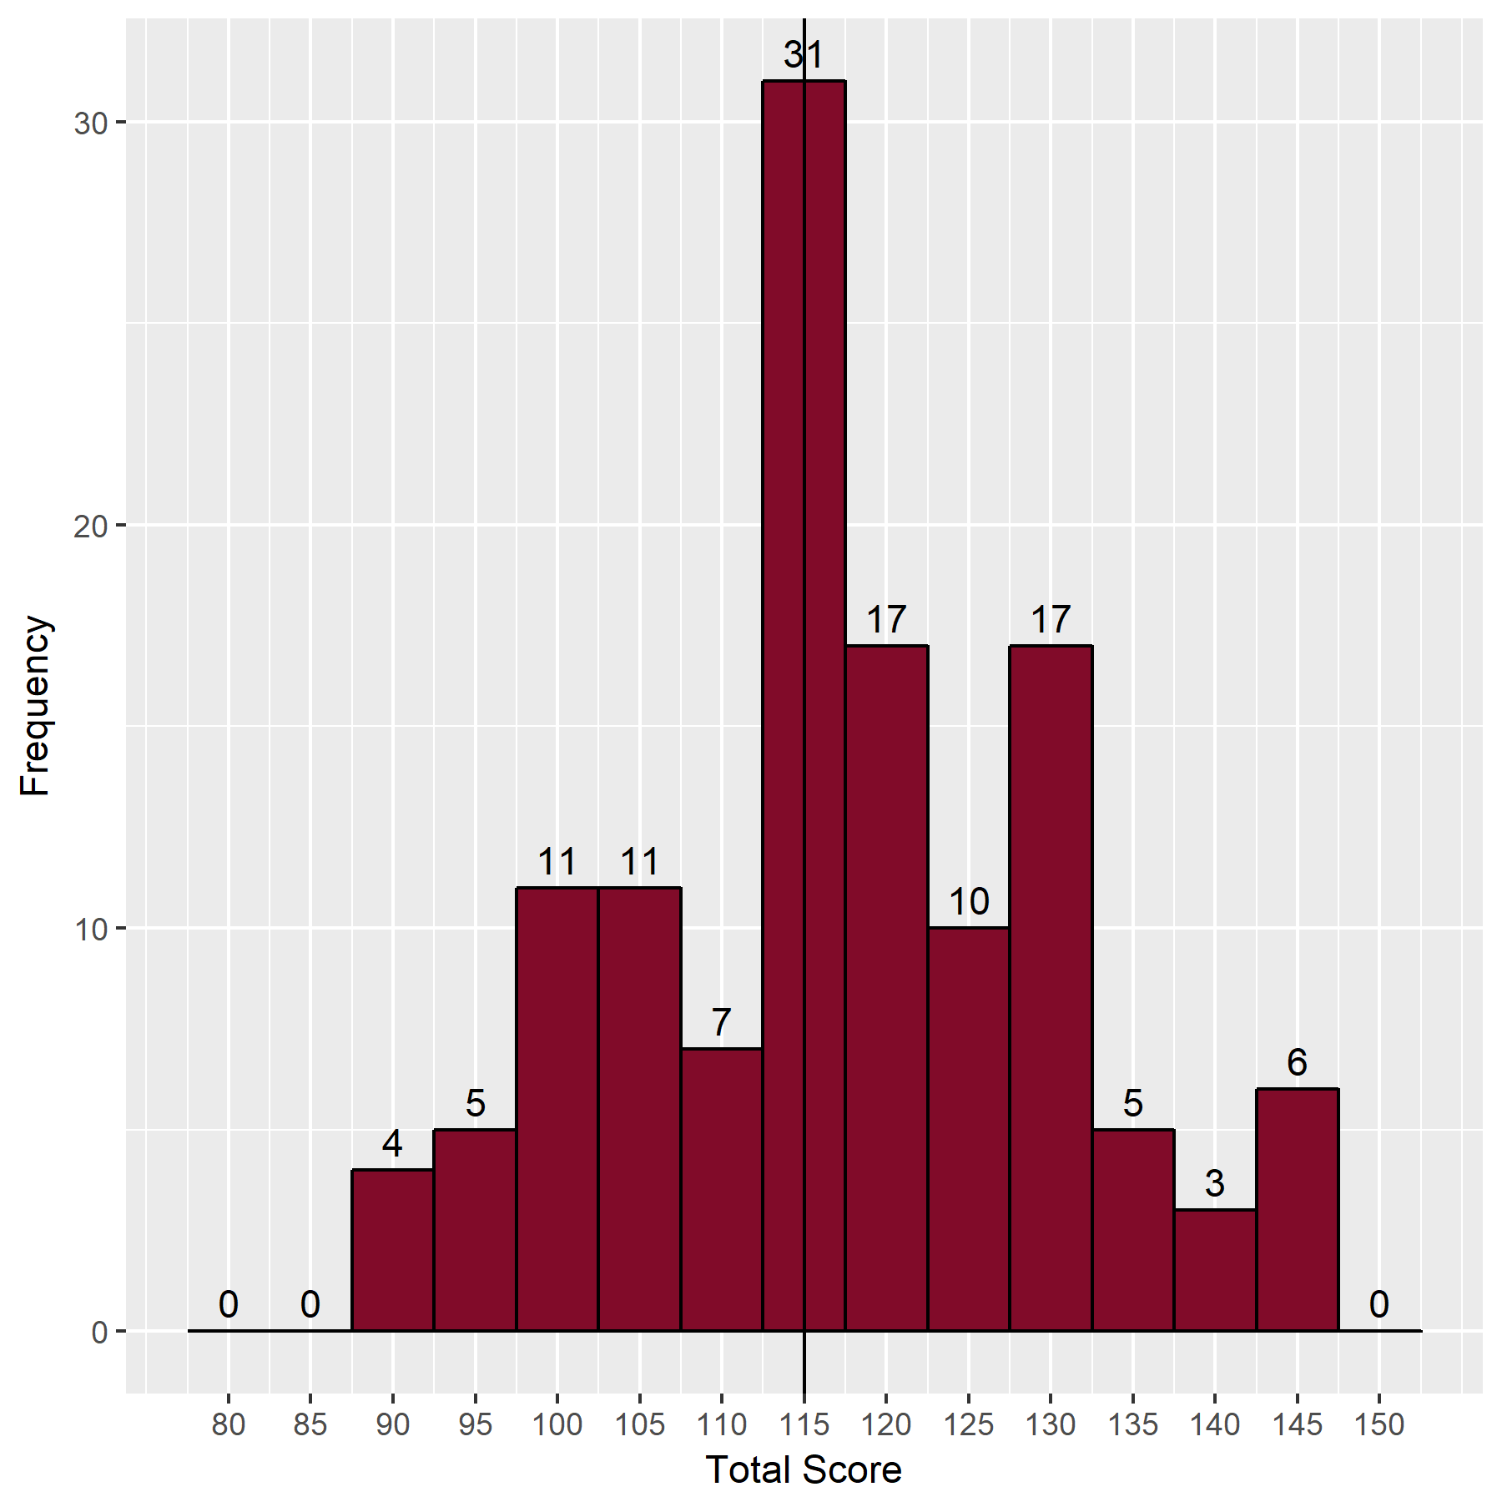
- Distribution of Scores

Analysis of Questions
The Speedwell data provides analysis and identification of questions with low, moderate and high facility, and those, which are good, poor or perverse (negative) discriminators. Ideally all questions should have moderate facility and be good discriminators.
- Discrimination against Facility Value
 | Facility Value
Discrimination |  | Low  (<25 correct) | Moderate  (25-74 Correct) | High  (>75 Correct) | Total
 | Negative discrimination | 3 | 7 | 8 | 18
 | Poor discrimination  (0-0.19) | 5 | 53 | 43 | 101
 | Good discrimination  (0.2-1.0) | 1 | 29 | 28 | 58
 | Total | 9 | 89 | 79 | 177

Standard setting for MCQ paper (Ebel method)
- Classification of the questions
 | Difficult | Moderate | Easy | Total
Essential | 0 | 24 | 45 | 69
Important | 8 | 27 | 52 | 87
Supplementary | 2 | 6 | 13 | 21
Total | 10 | 57 | 110 | 177

- Expected percentage correct by borderline candidates
 | Difficult | Moderate | Easy
Essential | 0.60 | 0.70 | 0.8
Important | 0.50 | 0.55 | 0.6
Supplementary | 0.25 | 0.30 | 0.3

- Weighted score
 | Difficult | Moderate | Easy | Total
Essential | 0.0 | 16.80 | 36.0 | 52.80
Important | 4.0 | 14.85 | 31.2 | 50.05
Supplementary | 0.5 | 1.80 | 3.9 | 6.20
Total | 4.5 | 33.45 | 71.1 | 109.05

SEM: | 5.57
MCQ pass mark (Ebel + 1 SEM): | 115

Breakdown of written results
- Breakdown of written results by training
Training | Failed | Passed | Total
In OST | 33 | 47 (59%) | 80
Not in OST | 20 | 27 (57%) | 47
Total | 53 | 74 (58%) | 127

- Breakdown of written results by stage of training
Training | Failed | Passed | Total
OST2 | 0 | 1 (100%) | 1
OST3 | 0 | 3 (100%) | 3
OST4 | 12 | 22 (65%) | 34
OST5 | 11 | 14 (56%) | 25
OST6 | 6 | 7 (54%) | 13
OST7 | 4 | 0 (0%) | 4
Total | 33 | 47 (59%) | 80

- Breakdown of results by deanery
Deanery | Failed | Passed | Total
East Midlands | 2 | 4 | 6
East of England | 3 | 3 | 6
East of Scotland | 0 | 1 | 1
Eire | 1 | 0 | 1
Europe and Overseas | 3 | 3 | 6
London KSS | 6 | 10 | 16
Mersey | 2 | 1 | 3
North Western | 0 | 2 | 2
Northern | 0 | 1 | 1
Oxford | 2 | 3 | 5
Peninsula | 1 | 4 | 5
Severn | 1 | 4 | 5
Wales | 1 | 0 | 1
Wessex | 1 | 2 | 3
West Midlands | 3 | 3 | 6
West of Scotland | 3 | 0 | 3
Yorkshire | 3 | 5 | 8
Total | 32 | 46 | 78

- Breakdown of results by attempt
Attempt | Failed | Passed | Total
1 | 29 | 63 | 92
2 | 15 | 6 | 21
3 | 7 | 4 | 11
4 | 1 | 1 | 2
6 | 1 | 0 | 1
Total | 53 | 74 | 127

Comparison to previous years
- Comparison with the written papers from previous examinations
Examination | Candidates | Pass mark | Pass rate | Pass rate in OST
September 2008 | 7 | 63% | 86%
February 2009 | 15 | 59% | 53%
September 2009 | 16 | 61% | 38%
February 2010 | 21 | 65% | 48%
September 2010 | 26 | 65% | 58% | 75%
February 2011 | 46 | 65% | 46% | 50%
September 2011 | 77 | 59% | 68% | 71%
February 2012 | 104 | 58% | 65% | 68%
September 2012 | 95 | 57% | 81% | 84%
February 2013* | 109 | 61% | 85% | 89%
September 2013 | 103 | 59% | 93% | 97%
February 2014 | 117 | 58% | 90% | 94%
September 2014** | 136 | 63% | 70% | 71%
December 2014** | 106 | 65% | 47% | 54%
June 2015** | 118 | 65% | 48% | 53%
November 2015** | 145 | 64% | 41% | 46%
June 2016** | 171 | 64% | 70% | 79%
December 2016** | 143 | 64% | 77% | 83%
July 2018** | 90 | 65% | 61% | 77%
December 2018** | 127 | 65% | 58% | 59%
* The written papers changed from MCQ and EMQ papers (90 questions on each) to a 180-question MCQ paper at this sitting
** The pass mark is now set at Ebel + 1 SEM

- Quality of questions compared to previous years
Exam | Facility |  |  |  | Discrimination
 | Low | Moderate | High |  | Negative | Poor | Good
February 2013 | 8 | 96 | 76 |  | 15 | 96 | 69 (38%)
September 2013 | 7 | 83 | 88 |  | 12 | 98 | 68 (38%)
February 2014 | 7 | 98 | 75 |  | 16 | 102 | 62 (35%)
September 2014 | 5 | 107 | 67 |  | 10 | 107 | 62 (35%)
June 2015 | 9 | 97 | 73 |  | 17 | 76 | 86 (48%)
November 2015 | 7 | 106 | 65 |  | 17 | 102 | 59 (33%)
June 2016 | 7 | 90 | 83 |  | 12 | 101 | 67 (37%)
November 2016 | 7 | 96 | 74 |  | 11 | 96 | 70 (40%)
July 2018 | 4 | 96 | 78 |  | 17 | 89 | 72 (40%)
December 2018 | 9 | 89 | 79 |  | 18 | 101 | 58 (33%)

- Cumulative results by deanery (September 2010 to date)
Deanery | Number of passes | Number of candidates | Pass Rate (%)
East Midlands | 46 | 69 | 66.7
East of England | 38 | 74 | 51.4
East of Scotland | 1 | 1 | 100.0
East Scotland | 9 | 10 | 90.0
Eire | 1 | 3 | 33.3
Europe and Overseas | 15 | 23 | 65.2
London KSS | 219 | 303 | 72.3
Mersey | 40 | 68 | 58.8
North of Scotland | 1 | 1 | 100.0
North Scotland | 9 | 12 | 75.0
North Western | 43 | 74 | 58.1
Northern | 33 | 45 | 73.3
Northern Ireland | 16 | 22 | 72.7
Oxford | 33 | 46 | 71.7
Peninsula | 18 | 32 | 56.2
Severn | 33 | 44 | 75.0
South East Scotland | 14 | 22 | 63.6
Wales | 26 | 51 | 51.0
Wessex | 24 | 40 | 60.0
West Midlands | 59 | 93 | 63.4
West of Scotland | 3 | 9 | 33.3
West Scotland | 24 | 41 | 58.5
Yorkshire | 58 | 101 | 57.4
Total | 763 | 1184 | 64.4

