Examination Report
Report on the November 2018
Part 2 Fellowship in Ophthalmology (FRCOphth) oral examination
Matthew Turner, Ben Smith

Contents
1 Summary 3
2 Candidates 3
3 The Structured Vivas 3
3.1 Results 4
3.2 Standard setting for the structured vivas 6
4 The OSCE 7
4.1 Results 7
4.2 Standard setting for the OSCEs 9
5 Overall results for the oral examination 10
5.1 Results 10
5.2 Breakdown of Oral Examination 11
5.3 Comparison to previous examinations 13

Summary
For the part 2 Fellowship in Ophthalmology (FRCOphth) oral examination, the OSCE consists of 12 stations worth a total of 198 marks whilst the structured viva (SV) consists of 10 stations worth a total of 120 marks.
A total of 106 candidates sat the examination.
The pass mark for the OSCE was 127 and the pass mark for the structured VIVA was 70.
The reliability of the oral examination was 0.8 (SV) and 0.8 (OSCE).
The pass rate for the SV and the OSCE was 84/106 (79%) and 62/106 (58%) respectively. The overall pass rate was 61/106 (58%).

Candidates
106 candidates presented themselves for the examination.

The structured vivas
There were five structured vivas, which were held on Monday 12 November and Tuesday 13 November 2018. The communication skills OSCE station was conducted as one of the viva stations, making six stations in all. Each viva lasted 10 minutes. The stations were:
Station 1: | Patient investigations and data interpretation
Station 2: | Patient management 1
Station 3: | Patient management 2
Station 4: | Attitudes, Ethics and Responsibilities.
Station 5a: | Audit, Research and EBM (5 minutes)
Station 5b: | Health Promotion and Disease Prevention (5 minutes)
Station 6: | Communication Skills (part of OSCE)

Results
Maximum mark (5 stations, 10 examiners, 12 marks per station): 120
- Marks for the viva

Statistic | Value | Percentage
Pass mark (using borderline candidate method) | 63.5/120 | 53%
Mean Score | 82.8/120 | 69%
Median Score | 84/120 | 70%
Range | 47 – 113 | 39% – 94%
Reliability (Cronbach’s alpha) | 0.8
SEM | 7 | 5%
Final adjusted pass mark (+1 SEM) | 70/120 | 58%
Pass rate before adjustment (pass mark 63.5/120) | 94/106 | 89%
Pass rate after adjustment (pass mark 70/120) | 84/106 | 79%

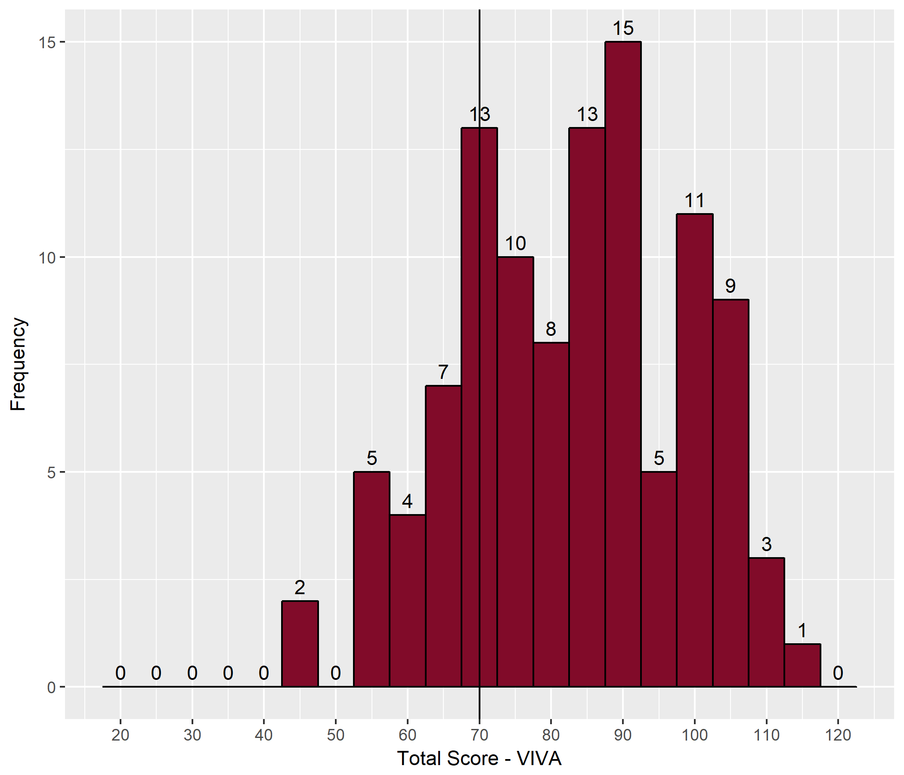
- Distribution of the SV Scores

- Station Summary – viva
Station | Category | Maximum Possible | Mean | Median | Min | Max
1 | PI | 24 | 17.5 | 18.0 | 4 | 24
2 | PM1 | 24 | 14.1 | 14.0 | 4 | 24
3 | PM2 | 24 | 19.7 | 21.0 | 10 | 24
4 | AER | 24 | 15.6 | 16.0 | 0 | 24
5 | HPDP/EBM | 24 | 16.0 | 16.0 | 5 | 24

- Correlation between examiners' marks at each station
Station | Station 1 | Station 2 | Station 3 | Station 4 | Station 5
Category | PI | PM1 | PM2 | AER | HPDP/EBM
Correlation | 0.87 | 0.90 | 0.88 | 0.93 | 0.91
- Mean absolute difference in examiners' marks at each station
Station | Station 1 | Station 2 | Station 3 | Station 4 | Station 5
Category | PI | PM1 | PM2 | AER | HPDP/EBM
Mean absolute difference | 0.92 | 0.85 | 0.67 | 0.82 | 0.75

- Correlation between viva stations
 | Station 1 | Station 2 | Station 3 | Station 4 | Station 5
Station 1
Station 2 | 0.32
Station 3 | 0.31 | 0.31
Station 4 | 0.25 | 0.37 | 0.14
Station 5 | 0.40 | 0.35 | 0.27 | 0.32

Standard setting for the structured vivas
- Viva standard setting
 | Station 1 |  | Station 2 |  | Station 3 |  | Station 4 |  | Station 5 |  | Total
Number of passed candidates | 65 | 70 | 51 | 50 | 89 | 87 | 60 | 64 | 65 | 64
Number of borderline candidates | 33 | 30 | 21 | 31 | 14 | 15 | 24 | 21 | 24 | 25
Number of failed candidates | 8 | 6 | 34 | 25 | 3 | 4 | 22 | 21 | 17 | 17
Median borderline candidate mark | 6 | 7 | 6 | 6 | 6 | 7 | 7 | 6 | 6.5 | 6 | 63.5

The OSCE
There were six OSCE stations in all. The five clinical stations were held Wednesday 14 November – Friday 16 November 2018. The communication OSCE was conducted with the vivas.

Results
- Marks for the OSCE
Statistic | Value | Percentage
Pass mark (using borderline candidate method) | 115.5/198 | 58%
Mean Score | 128.3/198 | 65%
Median Score | 133/198 | 67%
Range | 59 – 172 | 30% – 87%
Reliability (Cronbach’s alpha) | 0.8
SEM | 11 | 5%
Final adjusted pass mark (+1 SEM) | 127/198 | 64%
Pass rate before adjustment (pass mark 115.5/198) | 77/106 | 73%
Pass rate after adjustment (pass mark 127/198) | 62/106 | 58%

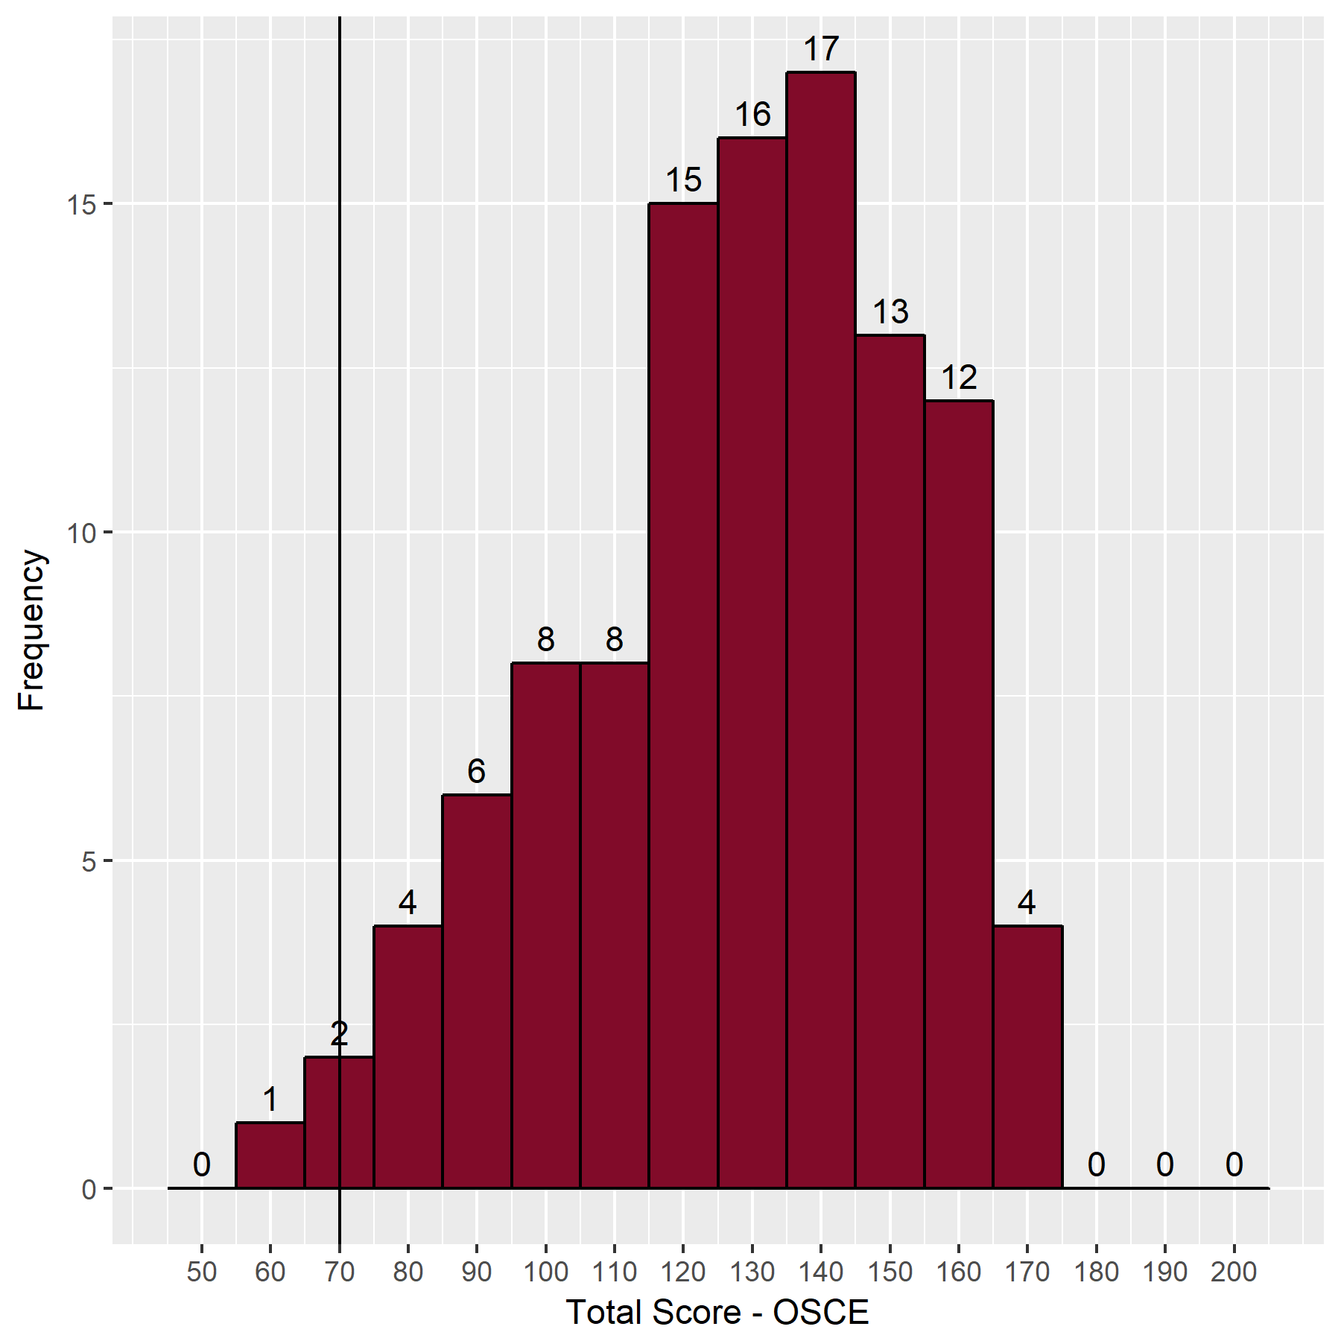
- Distribution of OSCE scores

- Station summary – OSCE
Station | Category | Maximum possible | Mean | Median | Min | Max
1 | Anterior Segment | 33 | 25.9 | 27.0 | 9 | 36
2 | Glaucoma & Lid | 33 | 23.6 | 23.5 | 7 | 36
3 | Posterior Segment | 33 | 22.0 | 23.0 | 3 | 36
4 | Strabismus & Orbit | 33 | 22.4 | 22.5 | 2 | 36
5 | Neuro-Ophthalmology | 33 | 21.0 | 21.0 | 2 | 36
6 | Communication Skills | 33 | 13.4 | 14.5 | 2 | 18

- Correlation between examiner's' marks at each station
Station | Station 1 | Station 2 | Station 3 | Station 4 | Station 5 | Station 6
Category | Anterior Segment | Glaucoma & Lid | Posterior Segment | Strabismus & Orbit | Neuro-Ophthalmology | Communication Skills
Correlation | 0.90 | 0.86 | 0.91 | 0.89 | 0.89 | 0.81

- Mean absolute difference in examiners' marks at each station
Station | Station 1 | Station 2 | Station 3 | Station 4 | Station 5 | Station 6
Category | Anterior Segment | Glaucoma & Lid | Posterior Segment | Strabismus & Orbit | Neuro-Ophthalmology | Communication Skills
Mean absolute difference | 1.25 | 1.36 | 1.29 | 1.38 | 1.47 | 0.93

- Correlation between OSCE stations
 | Station 1 | Station 2 | Station 3 | Station 4 | Station 5 | Station 6
Station 1
Station 2 | 0.11
Station 3 | 0.16 | 0.18
Station 4 | 0.20 | 0.16 | 0.35
Station 5 | 0.33 | 0.03 | 0.30 | 0.34
Station 6 | 0.30 | 0.13 | 0.37 | 0.25 | 0.35

Standard setting for the OSCEs
- OSCE standard setting
 | Station 1 |  | Station 2 |  | Station 3 |  | Station 4 |  | Station 5 |  | Station 6 |  | Total
Number of passed candidates | 63 | 68 | 50 | 55 | 32 | 40 | 48 | 46 | 42 | 46 | 67 | 67
Number of borderline candidates | 31 | 26 | 33 | 34 | 37 | 28 | 27 | 36 | 39 | 35 | 24 | 21
Number of failed candidates | 12 | 12 | 23 | 17 | 37 | 38 | 31 | 24 | 25 | 25 | 15 | 18
Median borderline candidate mark | 11 | 10.5 | 11 | 10 | 12 | 11 | 10 | 11 | 9 | 10 | 5 | 5 | 115.5

Overall results for the oral examination

Results
- Overall Results summary
Statistics | Value | Percentage
Pass Mark | 197/318 | 62%
Mean | 211/318 | 66%
Median | 214/318 | 67%
Range | 106 - 278 | 33% - 87%

To pass the oral examination candidates had to either pass both the viva (70/120 (58%)) and OSCE (127/198 (64%)) or pass the OSCE, achieve 63.5/120 (53%) in the viva and achieve 197/318 (62%) overall.
Overall 61/106 (58%) passed the examination.
- Pass rates
Statistics | Value | Percentage
Pass rate for the oral examination | 61/106 | 58%
Pass rate overall for candidates in Ophthalmic Specialist Training (OST) | 50/68 | 74%
Pass rate overall for non-trainees | 10/37 | 27%

Correlation between structured viva and OSCE = 0.68.
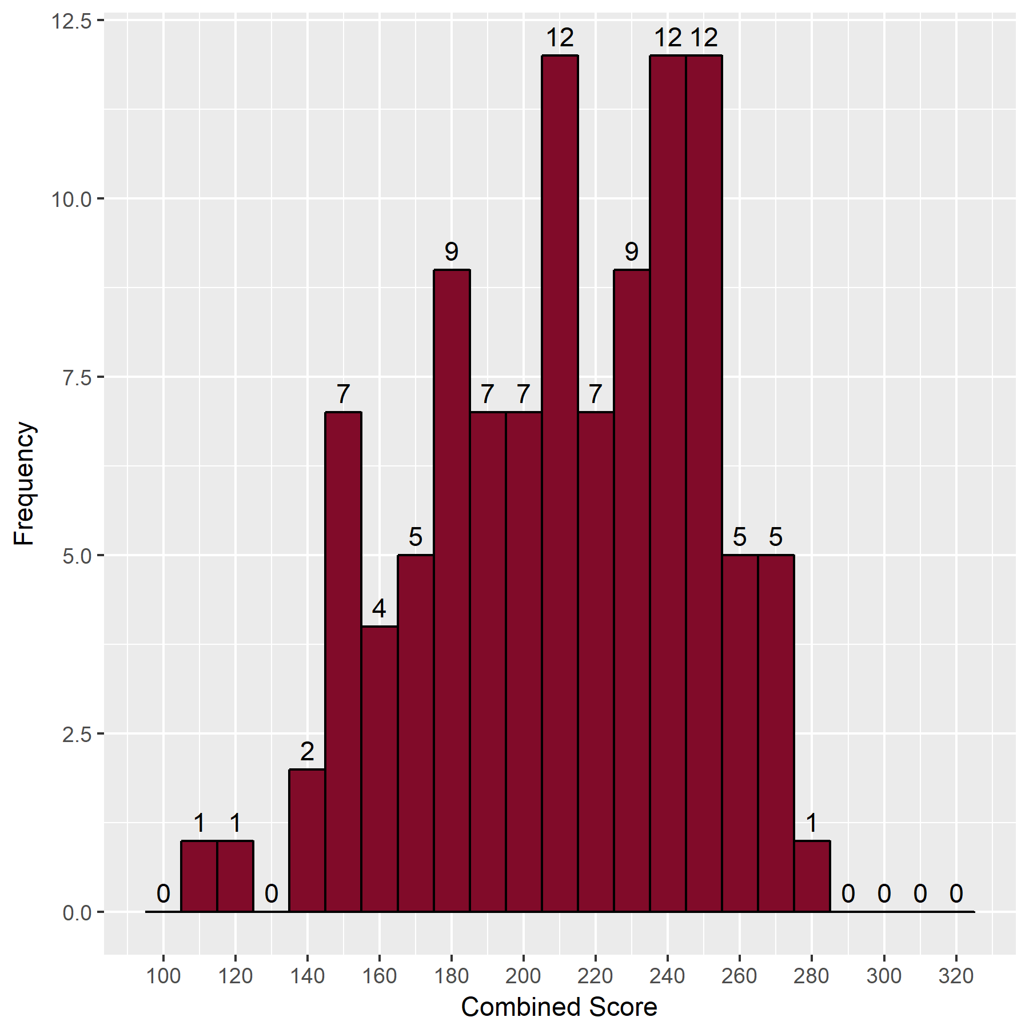
- Distribution of total scores

Breakdown of oral examination
- Breakdown of results by training
Training | Failed | Passed (%) | Total
In OST | 18 | 50 (74%) | 68
Not in OST | 27 | 10 (27%) | 37
Total | 45 | 61 (58%) | 106

- Breakdown of results by level of training
Level of Training | Failed | Passed % | Total
MO ST7 | 0 | 2 (100%) | 2
OST3 | 1 | 0 ( 0%) | 1
OST4 | 1 | 6 ( 86%) | 7
OST5 | 6 | 22 ( 79%) | 28
OST6 | 4 | 17 ( 81%) | 21
OST7 | 6 | 3 ( 33%) | 9
Total | 18 | 50 | 68

- Breakdown of results by number of previous attempts
Sitting Attempt | Failed | Passed % | Total
1 | 28 | 47 (63%) | 75
2 | 6 | 8 (57%) | 14
3 | 9 | 3 (25%) | 12
4 | 1 | 3 (75%) | 4
Total | 45 | 61 | 106

Comparison to previous examinations
- Comparison to previous examinations
Date | Candidates | MCQ pass mark | MCQ Reliability | Viva pass mark | Viva Reliability | OSCE pass mark | OSCE Reliability | Written pass rate | Oral pass rate | Overall pass rate | Oral pass rate in OST
April 13 | 109 | 61% | 0.8 | 60% | 0.8 | 63% | 0.8 | 85% | 57% | 48% | 56%
Nov 12 | 103 | 59% | 0.8 | 58% | 0.9 | 61% | 0.8 | 93% | 58% | 53% | 64%
April 14 | 104 | 58% | 0.8 | 57% | 0.8 | 61% | 0.8 | 90% | 58% | 51% | 65%
Nov 14 | 79 | NA* |  | 63% | 0.8 | 62% | 0.7 | NA* | 63% |  | 70%
April 15 | 77 | NA* |  | 60% | 0.9 | 60% | 0.9 | NA* | 62% |  | 80%
Nov 15 | 72 | NA* |  | 61% | 0.8 | 62% | 0.8 | NA* | 69% |  | 86%
April 16 | 61 | NA* |  | 63% | 0.8 | 63% | 0.9 | NA* | 56% |  | 69%
Nov 16 | 107 | NA* |  | 60% | 0.8 | 63% | 0.8 | NA* | 71% |  | 84%
April 17 | 105 | NA* |  | 61% | 0.8 | 63% | 0.8 | NA* | 66% |  | 82%
Nov 17 |  | NA* |  |  |  |  |  | NA*
April 18 | 74 | NA* | NA* | 62% | 0.8 | 60% | 0.8 | NA* | 70% | NA* | 80%
November 18 | 106 | NA* | NA* | 58% | 0.8 | 64% | 0.8 | NA* | 58% | NA* | 74%
* The MCQ examination is now de-coupled from the oral examination

- Cumulative results by deanery (September 2010 to date)
Deanery | Number of passes | Number of candidates | Pass Rate (%)
East Midlands | 35 | 49 | 71.4
East of England | 33 | 58 | 56.9
East of Scotland | 9 | 10 | 90.0
Europe and Overseas | 3 | 10 | 30.0
London KSS | 197 | 260 | 75.8
Mersey | 37 | 53 | 69.8
North of Scotland | 9 | 14 | 64.3
North Western | 38 | 68 | 55.9
Northern | 29 | 41 | 70.7
Northern Ireland | 15 | 19 | 78.9
Oxford | 33 | 39 | 84.6
Peninsula | 15 | 28 | 53.6
Severn | 28 | 38 | 73.7
South East of Scotland | 17 | 22 | 77.3
Wales | 25 | 44 | 56.8
Wessex | 20 | 38 | 52.6
West Midlands | 56 | 90 | 62.2
West of Scotland | 26 | 43 | 60.5
Yorkshire | 51 | 88 | 58.0
Total | 676 | 1012 | 66.8

