Examination Report
Part 2 Fellowship of the Royal College of Ophthalmologists (FRCOphth) written examination
July 2019
Matthew Turner, Ben Smith

Contents
1 Summary 3
2 The candidates 3
3 The written paper 3
4 Results 5
4.1 Analysis of questions 6
4.2 Standard setting for multiple choice questions (MCQ) paper (Ebel method) 7
4.3 Breakdown of written results 8
4.4 Comparison to previous years 9

Summary
The written paper of this sitting of the Part 2 Fellowship in Ophthalmology (FRCOphth) examination was held in July 2019.
The pass mark for this part 2 written paper was elevated by +1 SEM.
The reliability of this exam was 0.80, whilst the proportion of questions with a good item discrimination (>0.25) was 17 per cent. Two questions were removed from paper 1 and four questions were removed from paper 2; therefore the examination was marked out of 174.
The pass mark for the written examination was raised by 1 SEM above the mark identified by the standard set by the Ebel method from 62 to 66 per cent. The pass rate for the examination was 64 per cent. The pass mark was 114/174 (i.e. 66 per cent of marks available).
Fifteen candidates obtained the Ebel mark (62 per cent) but fell below the pass mark of Ebel +1 SEM (66 per cent). The addition of +1 SEM has had a substantial impact on the pass rate which would be 77 rather than 64 per cent without the addition of the SEM.

The candidates
There were 121 candidates for the examination. Of these 69/121 (57 per cent) were in Ophthalmic Specialist Training (OST). The largest group (38 per cent) were in training level OST4.

The written paper
The written part of the part 2 FRCOphth examination consists of a multiple choice question paper, which is administered in two parts. Candidates must pass the written paper to be allowed to sit the clinical part of the examination.
As part of the quality management of the College's assessment process, the written papers are reviewed by the senior examiner after marking, but before the results are known. Six questions were removed from the examination papers as a result of this review.
The Part 2 FRCOphth subcommittee reviews all of the questions with a low item discrimination and facility.
This sitting was the first instance of the Part 2 exam being administered electronically as opposed to on paper. As with any innovation in assessment, there were some slight issues with the exam’s delivery. In short, there was a problem with questions candidates “flagged” (allowing them to return to the question later) which might have caused their answers to not save correctly (see RCOphth’s statement on this issue for further details). This led to there being three groups of candidates in this examination, as opposed to the conventional “passing” and “failing” candidates:
- “Clear pass” candidates, who achieved the pass mark of 114.
- “Potentially affected” candidates, who achieved close to the pass mark of 114, and for whom the flagged questions issue might have caused them to fall below the pass mark.
- “Clear fail” candidates, who did not achieve close enough to the pass mark of 114 for it to be possible that their flagged questions caused them to fall below it.
In order to be fair to candidates who may have failed due solely to the technical issue meaning correct answers were not recorded, “potentially affected” candidates were awarded a pass despite their marks being lower than 114. Statistics below which show pass rates will clarify whether these candidates are included in the “passing” candidates or not.
In addition, the “Clear fail” candidates were permitted a free resit of this examination, and this series will not be counted as an attempt on their record.

- The MCQ paper blueprint
Topic | Sub-Topic | Paper 1 | Paper 2 | Total
Clinical Ophthalmology | Trauma | 2 | 2 | 4
 | Oculoplastic & Orbit | 5 | 5 | 10
 | Glaucoma | 5 | 5 | 10
 | Strabismus | 4 | 4 | 8
 | Paediatrics | 4 | 4 | 8
 | Retina | 10 | 10 | 20
 | Cataract | 5 | 4 | 9
 | Cornea & External Eye | 9 | 9 | 18
 | Uveitis & Oncology | 6 | 5 | 11
 | Neurology & Pupils | 8 | 7 | 15
 | Medicine | 4 | 5 | 9
Pharmacology & Therapeutics | Pharmacology & Therapeutics | 6 | 6 | 12
Investigations | Ophthalmic | 5 | 4 | 9
 | Orthoptic | 1 | 2 | 3
 | Neuro-Imaging | 2 | 1 | 3
 | Other | 0 | 1 | 1
Miscellaneous | Statistics and epidemiology | 2 | 1 | 3
 | Research and EBM | 1 | 2 | 3
 | Nutrition | 1 | 0 | 1
 | Ethics and driving | 2 | 2 | 4
 | Standards and guidelines | 2 | 2 | 4
 | Economics | 0 | 1 | 1
Basic Science | Anatomy and physiology | 1 | 1 | 2
 | Pathology and microbiology | 1 | 1 | 2
 | Genetics | 2 | 1 | 3
 | Optics | 0 | 1 | 1
Total |  | 88* | 86** | 174
* Two questions were removed from the marking
** Four questions were removed from the marking

Results
In the below table, “clearly passing” candidates (i.e. those who achieved 114) are distinguished from those who passed in the “potentially affected” category, and passed with a score below 114.
- MCQ Statistics
Statistic | Value | Percentage
Mean score | 117/174 | 67.2%
Median score | 119/174 | 68.4%
Standard deviation | 12.3 | 7.1%
Candidates | 121
Reliability | 0.8
Standard error of measurement (SEM) | 5.54 | 3.2%
Range of marks | 72 - 140 | 41.4% - 80.5%
Pass mark derived from standard setting | 109/174 | 62.6%
Pass rate without addition of SEM | 93/121 | 76.9%
Pass mark + 1 SEM | 114/174 | 65.5%
Pass rate (clearly passing) | 78/121 | 64.5%
Pass rate (clearly passing & potentially affected) | 95/121 | 78.5%
Pass rate in OST (clearly passing) | 47/69 | 68.1%
Pass rate in OST (clearly passing & potentially affected) | 58/69 | 84.1%

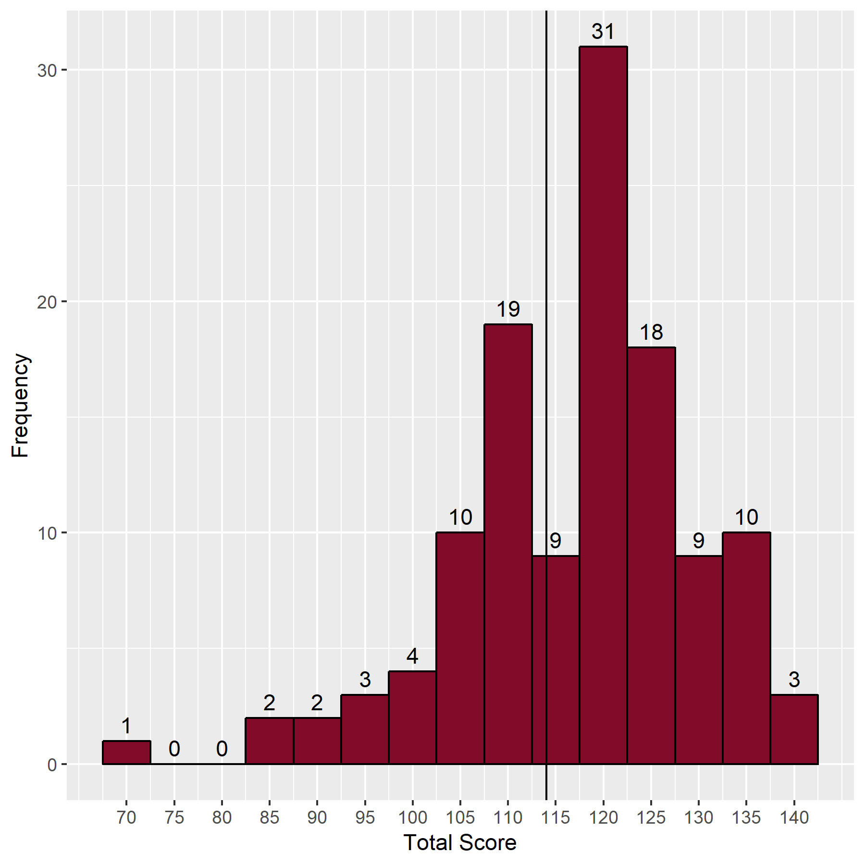
- Distribution of scores

Analysis of questions
The Speedwell data provides analysis and identification of questions with low, moderate and high facility, and those which are good, poor or perverse (negative) discriminators. Ideally, all questions should have moderate facility and be good discriminators.

- Discrimination against facility value
 | Facility Value
Discrimination |  | Low  (<25 correct) | Moderate  (25-74 correct) | High  (≥75 correct) | Total
 | Negative discrimination | 3 | 13 | 6 | 22
 | Poor discrimination  (0-0.19) | 0 | 63 | 39 | 102
 | Good discrimination  (0.2-1.0) | 0 | 20 | 30 | 50
 | Total | 3 | 96 | 75 | 174

Standard setting for multiple choice questions (MCQ) paper (Ebel method)
- Classification of the questions
 | Difficult | Moderate | Easy | Total
Essential | 2 | 20 | 58 | 80
Important | 6 | 19 | 43 | 68
Supplementary | 2 | 8 | 16 | 26
Total | 10 | 47 | 117 | 174

- Expected percentage correct by borderline candidates
 | Difficult | Moderate | Easy
Essential | 0.60 | 0.70 | 0.80
Important | 0.50 | 0.55 | 0.60
Supplementary | 0.25 | 0.30 | 0.30

- Weighted score
 | Difficult | Moderate | Easy | Total
Essential | 1.20 | 14.00 | 46.40 | 61.60
Important | 3.00 | 10.45 | 25.80 | 39.25
Supplementary | 0.50 | 2.40 | 4.80 | 7.70
Total | 4.70 | 26.85 | 77.00 | 108.55

SEM: | 5.54
MCQ pass mark (Ebel + 1 SEM): | 114

Breakdown of written results
These tables include “potentially affected” candidates in “passing” column, as they were awarded passes.
- Breakdown of written results by training
Training | Failed | Passed | Pass rate (%) | Total
In OST | 11 | 58 | 84.1 | 69
Not in OST | 15 | 37 | 71.2 | 52
Total | 26 | 95 | 78.5 | 121

- Breakdown of written results by stage of training
Training | Failed | Passed | Pass rate (%) | Total
MO ST6 | 1 | 2 | 66.7 | 3
MO ST7 | 0 | 1 | 100.0 | 1
OST2 | 0 | 3 | 100.0 | 3
OST3 | 0 | 14 | 100.0 | 14
OST4 | 3 | 23 | 88.5 | 26
OST5 | 4 | 13 | 76.5 | 17
OST6 | 1 | 1 | 50.0 | 2
OST7 | 2 | 1 | 33.3 | 3
Total | 11 | 58 | 84.1 | 69

Comparison to previous years
This table includes “potentially affected” candidates in the “passing” percentage for this series, as they were awarded a pass.
- Comparison with the written papers from previous examinations
Examination | Candidates | Pass mark | Pass rate | Pass rate in OST
Sep 2008 | 7 | 63.0% | 86.0%
Feb 2009 | 15 | 59.0% | 53.0%
Sep 2009 | 16 | 61.0% | 38.0%
Feb 2010 | 21 | 65.0% | 48.0%
Sep 2010 | 26 | 65.0% | 58.0% | 75.0%
Feb 2011 | 46 | 65.0% | 46.0% | 50.0%
Sep 2011 | 77 | 59.0% | 68.0% | 71.0%
Feb 2012 | 104 | 58.0% | 65.0% | 68.0%
Sep 2012 | 95 | 57.0% | 81.0% | 84.0%
Feb 2013* | 109 | 61.0% | 85.0% | 89.0%
Sep 2013 | 103 | 59.0% | 93.0% | 97.0%
Feb 2014 | 117 | 58.0% | 90.0% | 94.0%
Sep 2014** | 136 | 63.0% | 70.0% | 71.0%
Dec 2014** | 106 | 65.0% | 47.0% | 54.0%
Jun 2015** | 118 | 65.0% | 48.0% | 53.0%
Nov 2015** | 145 | 64.0% | 41.0% | 46.0%
Jun 2016** | 171 | 64.0% | 70.0% | 79.0%
Dec 2016** | 143 | 64.0% | 77.0% | 83.0%
Jul 2018** | 90 | 65.0% | 61.0% | 77.0%
Dec 2018** | 127 | 65.0% | 58.0% | 59.0%
Jul 2019** | 121 | 66.0% | 79.0% | 84.0%
* The written papers changed from MCQ and EMQ papers (90 questions on each) to a 180-question MCQ paper at this sitting
** The pass mark is now set at Ebel + 1 SEM

- Quality of questions compared to previous years
Exam | Facility |  |  |  | Discrimination
 | Low | Moderate | High |  | Negative | Poor | Good
Feb 2013 | 4.4% | 53.3% | 42.2% |  | 8.3% | 53.3% | 38.3%
Sep 2013 | 3.9% | 46.6% | 49.4% |  | 6.7% | 55.1% | 38.2%
Feb 2014 | 3.9% | 54.4% | 41.7% |  | 8.9% | 56.7% | 34.4%
Sep 2014 | 2.8% | 59.8% | 37.4% |  | 5.6% | 59.8% | 34.6%
Jun 2015 | 5.0% | 54.2% | 40.8% |  | 9.5% | 42.5% | 48.0%
Nov 2015 | 3.9% | 59.6% | 36.5% |  | 9.6% | 57.3% | 33.1%
Jun 2016 | 3.9% | 50.0% | 46.1% |  | 6.7% | 56.1% | 37.2%
Nov 2016 | 4.0% | 54.2% | 41.8% |  | 6.2% | 54.2% | 39.5%
Jul 2018 | 2.2% | 53.9% | 43.8% |  | 9.6% | 50.0% | 40.4%
Dec 2018 | 5.1% | 50.3% | 44.6% |  | 10.2% | 57.1% | 32.8%
Jul 2019 | 1.7% | 55.2% | 43.1% |  | 12.6% | 58.6% | 28.7%

