Examination Report
Refraction Certificate Examination
April 2019
Matthew Turner, Ben Smith

Contents
1 Introduction 3
1.1 Examination blueprint 3
1.2 Examination structure 3
2 Summary 3
3 Standard setting 4
3.1 Hofstee method 4
4 Results 4
5 Breakdown of results 7
6 Comparison to previous examinations 9

Introduction
There were 87 candidates for the April 2019 sitting of the Refraction Certificate. The examination consisted of 12 objective structured clinical examination (OSCE) stations, covering a range of skills required to assess visual acuity, refractive error and the prescription of spectacles.

Examination blueprint
The Refraction Certificate (RCert) is designed to assess the following learning outcomes from the Royal College of Ophthalmologists curriculum for ophthalmic specialist training (OST):
CA2 | Vision
CA7 | Motility
PM1 | Management plan
PM14 | Spectacles
PS2 | Refraction
PS21 | Hand hygiene
C1 | Rapport
C2 | Communication
C12 | Records
BCS6 | Optics
BCS14 | Instrument technology
AER16 | Time management

Examination structure
The examination consists of 12 OSCE stations. Each station contributes 15 marks to the overall total. The stations used for the examination were:
- Cycloplegic retinoscopy (CR1)
- Cycloplegic retinoscopy (CR2)
- Subjective refraction cylinder (SRC)
- Cycloplegic retinoscopy (CR3)
- Cycloplegic retinoscopy (CR4)
- Lens neutralisation (LN)
- Non cycloplegic retinoscopy (NCR1)
- Non cycloplegic retinoscopy (NCR2)
- Visual acuity and IPD measurement (VA)
- Subjective refraction sphere (SRS)
- Binocular balance (BB)
- Near addition (NA)

Summary
This sitting of the refraction certificate had 12 OSCE stations. The reliability of the examination is below the desired acceptable level (Cronbach's alpha 0.54, desired level >0.8).
The Hofstee method of standard setting was used to identify the pass mark for this examination, which was 72 per cent. Two stations achieved high mean scores, stations 5 and 12. The station with the lowest mean score was station 8.
The overall pass rate was 59 per cent with a higher pass rate in OST at 68 per cent.
Candidates in training appear to be better prepared for the exam than their non-trainee counterparts (achieving a 68 per cent compared with a 49 per cent pass rate).

Standard setting
Candidates must be able to accurately assess visual acuity, measure refractive error and recommend an appropriate spectacle correction to pass the RCert. The pass mark is identified using the Hofstee method:

Hofstee method
After the examination, examiners were asked to review the parameters for the standard setting based upon their judgment of the difficulty of the stations. The following values were used to set the pass mark:
- The maximum credible pass mark for the examination = 75 per cent
- The maximum credible pass rate for the examination = 75 per cent
- The minimum credible pass mark for the examination = 60 per cent
- The minimum credible pass rate for the examination = 30 per cent
The cumulative fail rate as a function of the pass mark and the co-ordinates derived from the four values above were plotted on a graph. The point where a line joining the two coordinates intersects the cumulative function curve is used to identify the pass mark.
The Hofstee pass mark for this examination was 129/180 (72 per cent).

Results
- Results summary
Statistic | Value | Percentage
Number of candidates | 87
Maximum possible mark | 180
Mean candidate mark | 132.79 | 73.8%
Median candidate mark | 131.00 | 72.8%
Standard deviation | 17.02 | 9.5%
Highest candidate mark | 166 | 92.2%
Lowest candidate mark | 86 | 47.8%
Reliability | 0.54
Standard error of measurement (SEM) | 11.50 | 6.4%
Hofstee pass mark | 129/180 | 71.7%
Pass rate | 51/87 | 58.6%
Pass rate in OST | 30/44 | 68.2%
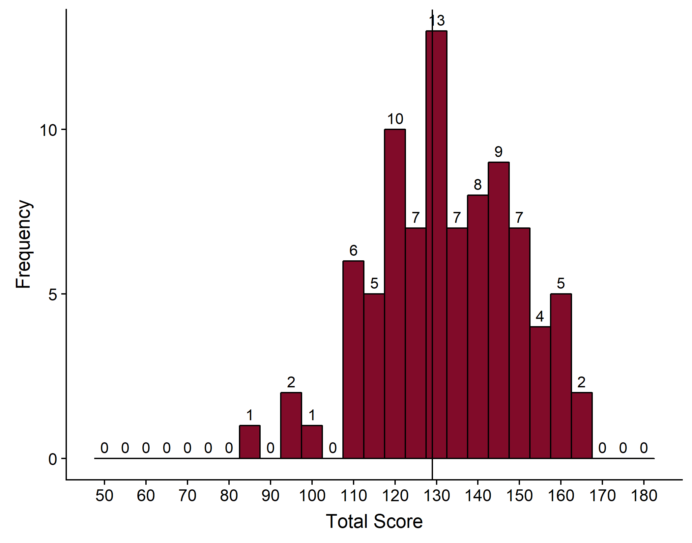
- Distribution of marks
The vertical line denotes the point on the mark distribution where the pass mark lies.
- Station summary
Station | Category | Mean | Median | Standard deviation | Minimum | Maximum
1 | CR1 | 11.54 | 13.00 | 3.32 | 3 | 15
2 | CR2 | 10.91 | 11.00 | 3.71 | 0 | 15
3 | SRC | 11.43 | 13.00 | 4.16 | 1 | 15
4 | CR3 | 10.80 | 12.00 | 4.40 | 0 | 15
5 | CR4 | 12.57 | 14.00 | 3.67 | 0 | 15
6 | LN | 9.63 | 10.00 | 3.12 | 1 | 15
7 | NCR1 | 8.91 | 9.00 | 4.49 | 1 | 15
8 | NCR2 | 8.16 | 8.00 | 4.00 | 0 | 15
9 | VA | 11.86 | 12.00 | 2.37 | 4 | 15
10 | SRS | 11.98 | 13.00 | 2.81 | 3 | 15
11 | BB | 11.94 | 12.00 | 2.70 | 1 | 15
12 | NA | 13.06 | 14.00 | 1.96 | 8 | 15

The relative weights for each skill in refraction (based upon the number of stations) are shown in table 3 below.
- Weights for each skill
Clinical Skill | Number of stations | Contribution to total marks | Median mark
Retinoscopy | 6 | 50% | 11
Subjective | 3 | 25% | 13
Other | 3 | 25% | 12

- Correlation between stations
 | CR1 | CR2 | SRC | CR3 | CR4 | LN | NCR1 | NCR2 | VA | SRS | BB
CR1
CR2 | 0.65
SRC | 0.16 | 0.18
CR3 | 0.13 | 0.10 | -0.03
CR4 | 0.14 | 0.12 | -0.02 | 0.34
LN | 0.30 | 0.34 | 0.13 | 0.21 | 0.31
NCR1 | 0.05 | 0.16 | -0.09 | -0.10 | -0.20 | -0.06
NCR2 | 0.16 | 0.09 | -0.06 | 0.09 | -0.10 | 0.02 | 0.44
VA | 0.18 | 0.20 | 0.27 | -0.03 | 0.23 | 0.20 | -0.11 | -0.09
SRS | 0.11 | 0.13 | 0.26 | 0.03 | -0.17 | 0.26 | 0.09 | 0.10 | 0.05
BB | -0.10 | 0.07 | 0.20 | 0.02 | -0.03 | 0.27 | 0.13 | 0.20 | -0.01 | 0.49
NA | 0.07 | 0.08 | -0.19 | -0.21 | -0.14 | 0.04 | 0.12 | -0.04 | 0.00 | 0.20 | -0.08

The median correlation between the cycloplegic refraction stations was 0.135.
There was moderate correlation between the following pairs of cycloplegic refraction stations: CR1 and CR3, CR1 and CR4, CR2 and CR3, CR2 and CR4, CR3 and CR4.
The median correlation between the non-cycloplegic refraction stations was 0.44.
The best correlation was between station 1 and 2 (0.65).
The poorest correlation between any station was -0.21. All negative correlations are highlighted in red.

- Correlation between each station and the total score
Station | CR1 | CR2 | SRC | CR3 | CR4 | LN | NCR1 | NCR2 | VA | SRS | BB | NA
Correlation with total score | 0.58 | 0.64 | 0.38 | 0.38 | 0.32 | 0.58 | 0.35 | 0.42 | 0.32 | 0.45 | 0.40 | 0.06

Breakdown of results
- Breakdown of results by training
Training | Failed | Passed | Pass rate (%) | Total
In OST | 14 | 30 | 68.2 | 44
Not in OST | 21 | 20 | 48.8 | 41
Unknown | 1 | 1 | 50.0 | 2
Total | 36 | 51 | 58.6 | 87

- Breakdown of results by deanery
Country | Deanery | Failed | Passed | Total
UK | East Midlands | 0 | 2 | 2
 | East of England | 1 | 2 | 3
 | KSS (Kent, Surrey and Sussex) | 1 | 0 | 1
 | London | 2 | 5 | 7
 | Mersey | 1 | 1 | 2
 | North Western | 1 | 1 | 2
 | Northern | 1 | 2 | 3
 | Northern Ireland | 1 | 0 | 1
 | Oxford | 0 | 1 | 1
 | Peninsula (South West) | 0 | 3 | 3
 | Wales | 4 | 1 | 5
 | Wessex | 1 | 1 | 2
 | West Midlands | 0 | 6 | 6
 | Yorkshire | 0 | 5 | 5
Overseas | Europe and Overseas | 1 | 0 | 1
Total |  | 14 | 30 | 44

- Breakdown of results by stage of training
Training | Failed | Passed | Pass rate (%) | Total
MO ST6 | 0 | 1 | 100.0 | 1
OST1 | 2 | 1 | 33.3 | 3
OST2 | 3 | 14 | 82.4 | 17
OST3 | 7 | 14 | 66.7 | 21
OST4 | 2 | 0 | 0.0 | 2
Total | 14 | 30 | 68.2 | 44

- Breakdown of results by number of previous attempts
Sitting Attempt | Failed | Passed | Pass rate (%) | Total
1 | 25 | 34 | 57.6 | 59
2 | 8 | 13 | 61.9 | 21
3 | 2 | 2 | 50.0 | 4
4 | 1 | 0 | 0.0 | 1
5 | 0 | 2 | 100.0 | 2
Total | 36 | 51 | 58.6 | 87

Comparison to previous examinations
- Comparison to previous years' exams
Date | Candidates | Pass mark | Pass rate | Pass rate in OST | Per cent of candidates in OST | Reliability | SEM | Hofstee pass mark
Nov 2010 | 53 | 74% | 42% | 44% | 68% | 0.6 | 7 (7%) | 71%
Apr 2011 | 57 | 71% | 35% | 47% | 63% | 0.6 | 6 (6%) | 67%
Jul 2011 | 41 | 67% | 66% | 72% | 71% | 0.4 | 6 (6%) | 71%
Nov 2011 | 69 | 65% | 71% | 75% | 70% | 0.6 | 8 (8%) | 68%
Mar 2012 | 54 | 73% | 54% | 66% | 57% | 0.6 | 8 (8%) | 72%
Jul 2012 | 44 | 71% | 59% | 67% | 64% | 0.5 | 9 (9%) | 71%
Dec 2012* | 71 | 69% | 75% | 77% | 55% | 0.6 | 11 (6%) | 72%
Apr 2013 | 64 | 74% | 61% | 64% | 64% | 0.8 | 11 (6%) | 74%
Jul 2013 | 42 | 72% | 74% | 90% | 48% | 0.7 | 10 (6%) | 74%
Dec 2013 | 75 | 72% | 67% | 76% | 65% | 0.7 | 10 (6%) | 71%
Apr 2014 | 56 | 73% | 84% | 89% | 66% | 0.6 | 9.5 (5%) | 75%
Jul 2014 | 34 | 74% | 62% | 55% | 65% | 0.4 | 11 (6%) | 74%
Dec 2014* | 63 | 71% | 68% | 77% | 68% | 0.6 | 12 (7%) | 71%
Apr 2015* | 57 | 77% | 65% | 73% | 65% | 0.4 | 11 (7%) | 77%
Jun 2015* | 33 | 69% | 58% | n/a^ | 0% | 0.73 | 10 (6%) | 69%
Jul 2015* | 31 | 66% | 58% | 55% | 65% | 0.65 | 9.4 (5%) | 66%
Jan 2016* | 70 | 70% | 60% | 60% | 81% | 0.8 | 10 (6%) | 70%
Mar 2016* | 57 | 77% | 81% | 83% | 70% | 0.9 | 7.7 (4%) | 77%
Jun 2016* | 23 | 70% | 57% | n/a^ | 0% | 0.7 | 11 (6%) | 70%
Jul 2016* | 64 | 70% | 64% | 67% | 67% | 0.6 | 12 (7%) | 70%
Jan 2017* | 62 | 72% | 63% | 64% | 90% | 0.6 | 10 (6%) | 72%
Apr 2017* | 63 | 73% | 67% | 69% | 62% | 0.7 | 11 (6%) | 73%
Jul 2017* | 62 | 72% | 38% | 68% | 60% | 0.7 | 12 (6%) | 72%
Dec 2017* | 63 | 71% | 35% | 59% | 65% | 0.72 | 11 (6%) | 71%
Apr 2018* | 60 | 75% | 41% | 73% | 75% | 0.55 | 10 (6%) | 75%
Jun 2018* | 39 | 75% | 29% | n/a^ | 0% | 0.69 | 10 (5%) | 75%
Jul 2018* | 64 | 75% | 43% | 77% | 55% | 0.74 | 11 (6%) | 75%
Dec 2018* | 68 | 72% | 37% | 70% | 63% | 0.7 | 11 (6%) | 72%
Apr 2019* | 87 | 72% | 51% | 68% | 51% | 0.54 | 12 (6%) | 72%
* Hofstee pass mark used for these examinations
^ Examination held in Kuching, Malaysia

- Performance of candidate by deanery for all examinations to date, where deanery is known
Country | Deanery | Total passes | Total candidates | Pass rate %
UK | East Midlands | 31 | 44 | 70.5
 | East of England | 42 | 62 | 67.7
 | KSS (Kent, Surrey and Sussex) | 27 | 33 | 81.8
 | London | 158 | 214 | 73.8
 | Mersey | 36 | 49 | 73.5
 | North Western | 6 | 10 | 60.0
 | Northern | 26 | 35 | 74.3
 | Northern Ireland | 16 | 23 | 69.6
 | Oxford | 17 | 22 | 77.3
 | Peninsula (South West) | 19 | 47 | 40.4
 | Wales | 21 | 46 | 45.7
 | Wessex | 25 | 41 | 61.0
 | West Midlands | 59 | 83 | 71.1
 | Yorkshire | 57 | 80 | 71.2
 | East of Scotland | 12 | 15 | 80.0
 | North of Scotland | 3 | 3 | 100.0
 | North Scotland | 8 | 9 | 88.9
 | North West | 28 | 38 | 73.7
 | Severn | 19 | 31 | 61.3
 | South East of Scotland | 6 | 7 | 85.7
 | South East Scotland | 14 | 17 | 82.4
 | West of Scotland | 8 | 9 | 88.9
 | West Scotland | 19 | 29 | 65.5
Overseas | Eire | 1 | 1 | 100.0
 | Europe and Overseas | 2 | 6 | 33.3
Total |  | 660 | 954 | 69.2

