Important information that we suggest you read very carefully before sitting your CertLRS MCQ online examination with the Royal College of Ophthalmologists.
IMPORTANT – Please read fully and carefully all of the following, including the web-links to ensure that you are prepared for your online examination as efficiently as possible BEFORE the exam. Failure to do so may cause delays during the set-up on the day of the examination itself.
One week prior to the exam, candidates will be sent an email with the link for launching the exam. This link will not activate until the start of the actual examination. The keycode to start the exam when then be displayed to the candidate when they are just about to start the exam.

This key code is valid for the duration of the examinations so you will be able to log back into the examination with it if you lose internet connection and have to reconnect.
Please note that as the advice above is communicated to candidates well ahead of the examination day, the College will not be held responsible for any errors that you make in testing and setting up their system or not having the correct equipment for the examination.
Also make sure that you have read thoroughly through:
CertLRS Online MCQ Exam FAQs
https://www.rcophth.ac.uk/wp-content/uploads/2021/07/CertLRS-MCQ-Online-Written-Exam-FAQs.docx
On the day of your examination:
Setting-up
Candidate will be required to log in at their computer at the agreed examination start time. If you log on before the start time, you will be presented with a timer counting down to the start time.

- Make sure that you have all the equipment that you are going to need, including all power leads, in the area / space that you have chosen to sit the examination.
- Log in to your exam with the email link provided.
- When the time comes close all tabs on your browser and then click the e-mail link that you will have been provided to go to your examination. You may later be reminded to close the e-mail browser tab if you have used one.
- If you are early – and we would recommend being so – then you will have to wait until the timer goes to zero before clinking the button to proceed to the set-up process and the examination itself.
- Click the examination link – paste or type in your code and hit enter.
- You are then provided with a few more instructions and are asked to confirm that you agree to the Royal College of Ophthalmologists examination regulations. Your examination will start in 5 minutes or before if you are happy and click the start button.

Navigating the examination
- The examination starts immediately after you click start. There are 2 timers at the top of your screen, one is a time remaining count-down to the end of the examination the other is a progress indicator bar – both are TIME indicators. The follows an annotated example of what you will see.
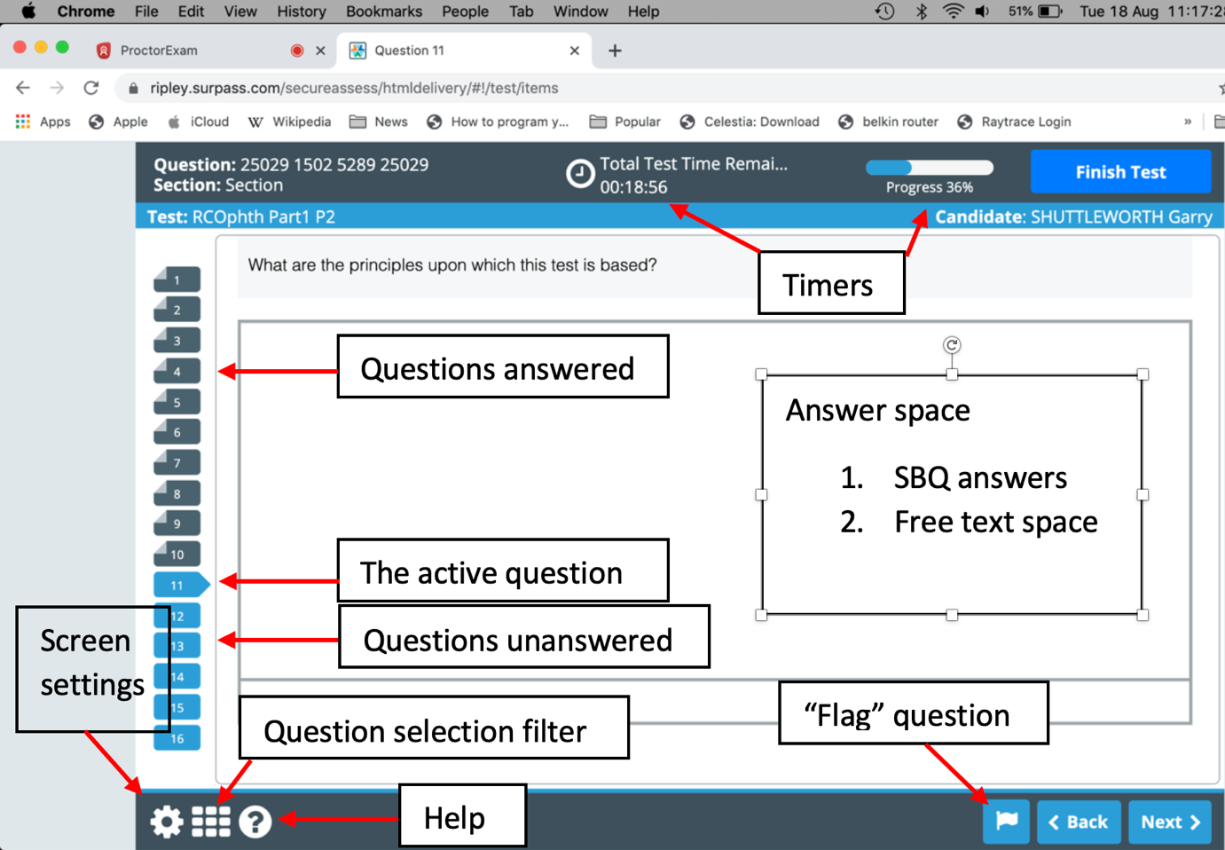

- If you wish to alter the screen colour settings to suit yourself and which only takes a moment, then click on the small cog = screen settings icon bottom left. The rest is essentially self-explanatory.
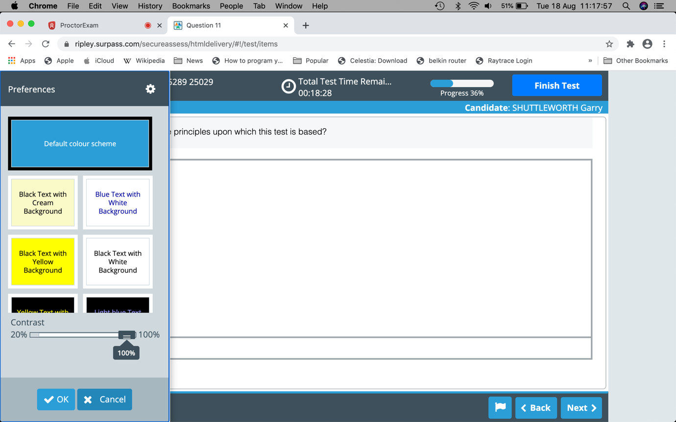

The following is an example of a preferred yellow screen set-up with an example SBA question. There are several answered questions, one not in sequence, and a “flagged” question indicated on the left hand side.
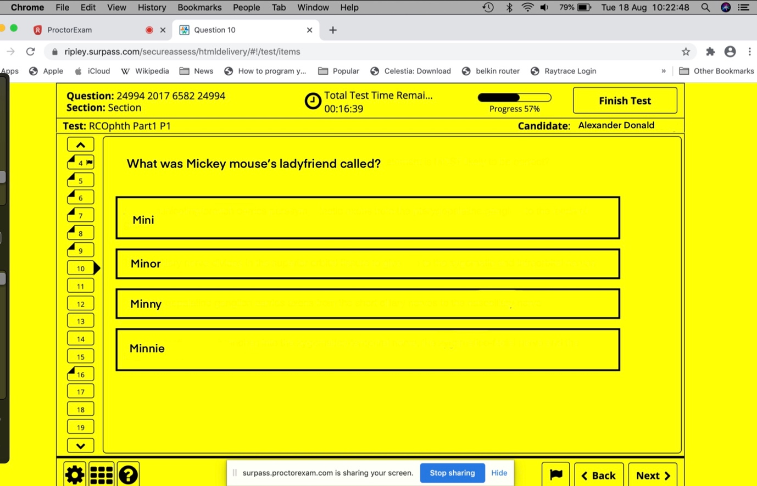

- To progress questions you can either click “back” or “next” in the bottom right or directly access the question number tags on the left hand side which run vertically. The system saves your answers automatically you do not need to use “next” – no confirmation of your answer is required.
- You do not need to answer all the questions in order but it may be best to approach the examination in that manner.
- If you are unsure of an answer, want to think about it etc… you can move on or “flag” the question using the flag icon next to the Back button to return to later.
- The question selection filter tool - very useful: if you wish to navigate rapidly around the examination questions can be accessed by clicking on the square (9 block grid) icon bottom left. This will open a box that will allow question selection by: answered questions, unanswered questions, flagged questions.

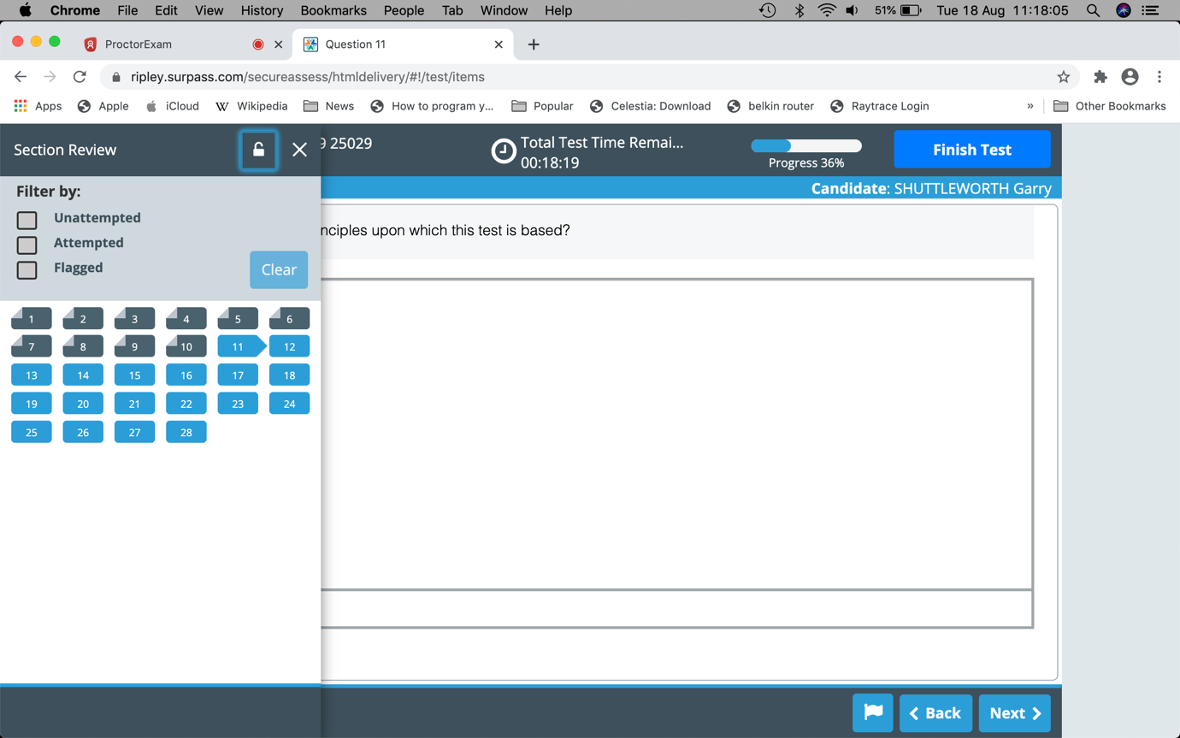

- At the end of your examination. Once the timer counts down to 0:00 the examination will automatically stop. Please note that it is up to you to keep an eye on the timers, you will not receive any warning that the examination will terminate until it does so. If however, you have answered all the questions and are satisfied that you have finished the examination you may terminate the examination by clicking the Finish Test button top right and then proceed through the exiting sequence as directed.
- When the examination finishes, wait and make sure that you have agreed / clicked all the relevant FINISH EXAM boxes / buttons and DO NOT close the browser nor the browser tab until you are instructed that it is safe to do so. Should a connection message appear during these final processes, WAIT, it will sort itself out.

