Examination Report
Part 2 Fellowship of the Royal College of Ophthalmologists (FRCOphth) written examination
December 2021
David Budzynski, Matthew Turner, Ben Smith

Contents
1 Summary 3
2 The candidates 3
3 The written paper 3
4 Results 5
4.1 Analysis of questions 7
4.2 Standard setting for multiple choice questions (MCQ) paper (Ebel method) 7
4.3 Breakdown of written results 8
4.4 Comparison to previous years 10

Summary
The written paper of this sitting of the Part 2 Fellowship in Ophthalmology (FRCOphth) examination was held in December 2021.
The reliability of this exam was 0.81, whilst the percentage of questions with a good item discrimination (>0.25) was 19 per cent. Two questions were removed from paper 1 and no questions were removed from paper 2; therefore the examination was marked out of 178.
The pass mark for the written examination was raised by 1 SEM above the mark identified by the standard set by the Ebel method from 62 per cent to 65 per cent (i.e. 115.77/178). The pass rate for the examination was 72 per cent.
Twenty-six candidates obtained the Ebel mark (62 per cent) but fell below the pass mark of Ebel +1 SEM (65 per cent). Thus, the addition of +1 SEM has had a substantial impact on the pass rate, which would be 85 per cent rather than 72 per cent without the addition of the SEM.

The candidates
There were 203 candidates for the examination. Of these 63/203 (31 per cent) were in Ophthalmic Specialist Training (OST). The largest group (30 per cent) were in training level OST3.

The written paper
The written part of the part 2 FRCOphth examination consists of a multiple-choice question paper, which is administered in two parts. Candidates must pass the written paper to be allowed to sit the clinical part of the examination.
As part of the quality management of the College's assessment process, the written papers are reviewed by the senior examiner after marking, but before the results are known. Two questions were removed from the examination papers as a result of this review.
The Part 2 FRCOphth subcommittee reviews all of the questions with a low item discrimination and facility.

- The MCQ paper blueprint
Topic | Sub-Topic | Paper 1 | Paper 2 | Total
Clinical Ophthalmology | Trauma | 2 | 2 | 4
 | Oculoplastic & Orbit | 5 | 5 | 10
 | Glaucoma | 5 | 5 | 10
 | Strabismus | 4 | 4 | 8
 | Paediatrics | 4 | 4 | 8
 | Retina | 9 | 10 | 19
 | Cataract | 4 | 5 | 9
 | Cornea & External Eye | 10 | 10 | 20
 | Uveitis & Oncology | 6 | 6 | 12
 | Neurology & Pupils | 8 | 8 | 16
 | Medicine | 5 | 5 | 10
Pharmacology & Therapeutics | Pharmacology & Therapeutics | 6 | 6 | 12
Investigations | Ophthalmic | 5 | 4 | 9
 | Orthoptic | 1 | 2 | 3
 | Neuro-Imaging | 2 | 1 | 3
 | Other | 0 | 1 | 1
Miscellaneous | Statistics and epidemiology | 2 | 1 | 3
 | Research and EBM | 1 | 2 | 3
 | Nutrition | 1 | 0 | 1
 | Ethics and driving | 2 | 2 | 4
 | Standards and guidelines | 2 | 2 | 4
 | Economics | 0 | 1 | 1
Basic Science | Anatomy and physiology | 1 | 1 | 2
 | Pathology and microbiology | 1 | 1 | 2
 | Genetics | 2 | 1 | 3
 | Optics | 0 | 1 | 1
Total |  | 88* | 90 | 178
* Two questions were removed from the marking

Results
- MCQ statistics
Statistic | Value | Percentage
Mean score: | 122/178 | 68.5%
Median score: | 122/178 | 68.5%
Standard deviation: | 12.4 | 7.0%
Candidates: | 203
Reliability: | 0.81
Standard error of measurement (SEM): | 5.39 | 3.0%
Range of marks: | 43 - 154 | 24.2% - 86.5%
Pass mark derived from standard setting: | 111/178 | 62.4%
Pass rate without addition of SEM: | 173/203 | 85.2%
Pass mark + 1 SEM: | 116/178 | 65.2%
Pass rate: | 147/203 | 72.4%
Pass rate in OST: | 53/63 | 84.1%

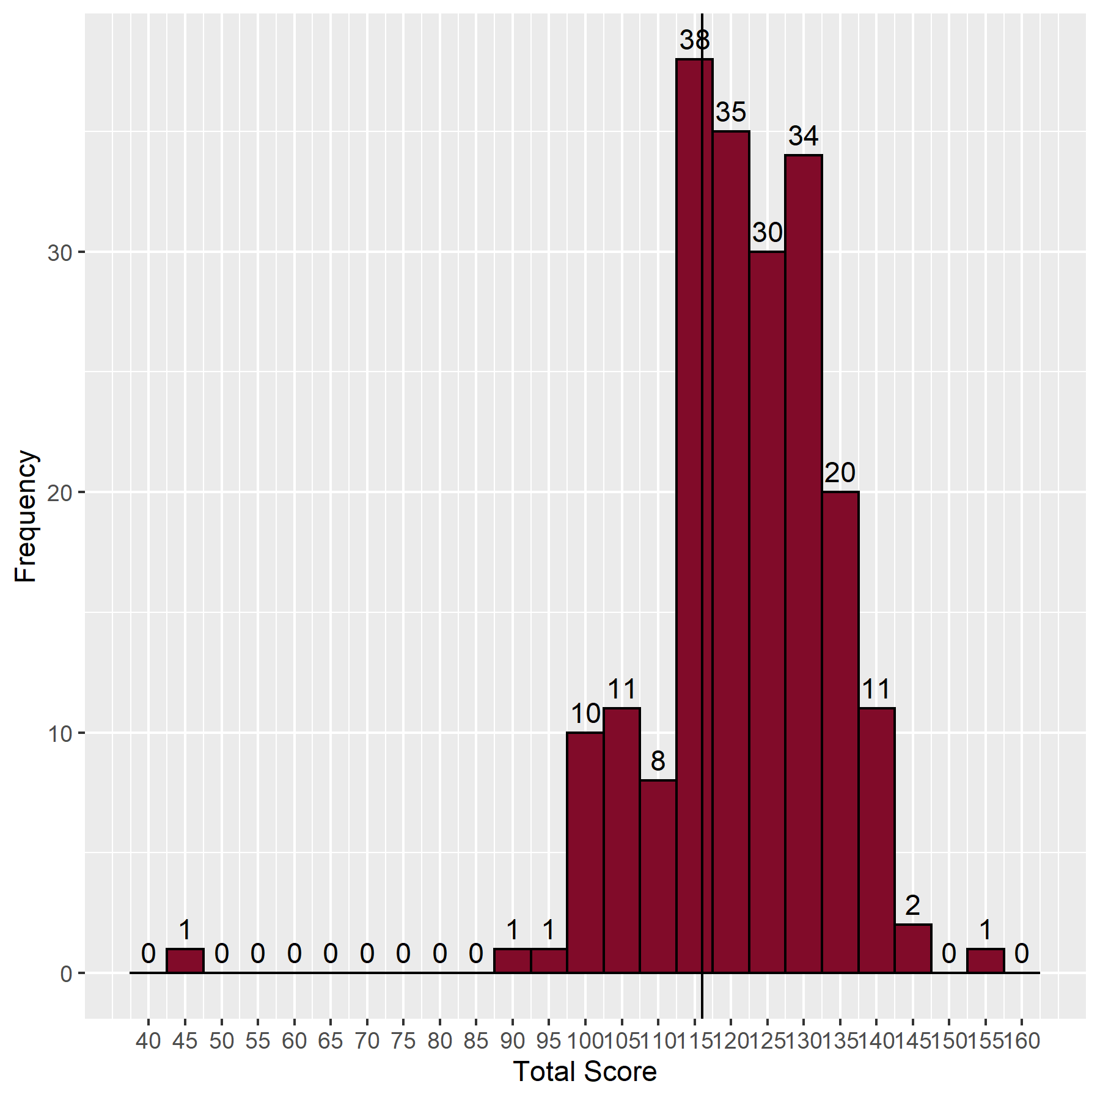
- Distribution of scores

Analysis of questions
The Speedwell data provides analysis and identification of questions with low, moderate and high facility, and those which are good, poor or perverse (negative) discriminators. Ideally, all questions should have moderate facility and be good discriminators.
- Discrimination against facility value
 | Facility Value
Discrimination |  | Low  (<25 correct) | Moderate  (25-74 correct) | High  (≥75 correct) | Total
 | Negative discrimination | 5 | 11 | 1 | 17
 | Poor discrimination  (0-0.19) | 4 | 51 | 45 | 100
 | Good discrimination  (0.2-1.0) | 0 | 22 | 39 | 61
 | Total | 9 | 84 | 85 | 178

Standard setting for multiple choice questions (MCQ) paper (Ebel method)
- Classification of the questions
 | Difficult | Moderate | Easy | Total
Essential | 3 | 27 | 53 | 83
Important | 5 | 19 | 44 | 68
Supplementary | 3 | 8 | 16 | 27
Total | 11 | 54 | 113 | 178

- Expected percentage correct by borderline candidates
 | Difficult | Moderate | Easy
Essential | 0.60 | 0.70 | 0.80
Important | 0.50 | 0.55 | 0.60
Supplementary | 0.25 | 0.30 | 0.30

- Weighted score
 | Difficult | Moderate | Easy | Total
Essential | 1.80 | 18.90 | 42.40 | 63.10
Important | 2.50 | 10.45 | 26.40 | 39.35
Supplementary | 0.75 | 2.40 | 4.80 | 7.95
Total | 5.05 | 31.75 | 73.60 | 110.40

SEM: | 5.39
MCQ pass mark (Ebel + 1 SEM): | 116

Breakdown of written results
- Breakdown of written results by training
Training | Failed | Passed | Pass rate (%) | Total
In OST | 10 | 53 | 84.1 | 63
Not in OST | 35 | 78 | 69.0 | 113
Unknown | 11 | 16 | 59.3 | 27
Total | 56 | 147 | 72.4 | 203

- Breakdown of written results by stage of training
Training | Failed | Passed | Pass rate (%) | Total
FY2 | 1 | 7 | 87.5 | 8
Medical Student | 0 | 2 | 100.0 | 2
MO ST4 | 1 | 0 | 0.0 | 1
MO ST7 | 0 | 1 | 100.0 | 1
OST1 | 2 | 8 | 80.0 | 10
OST2 | 3 | 11 | 78.6 | 14
OST3 | 1 | 18 | 94.7 | 19
OST4 | 0 | 2 | 100.0 | 2
OST5 | 1 | 3 | 75.0 | 4
OST6 | 1 | 0 | 0.0 | 1
OST7 | 0 | 1 | 100.0 | 1
Total | 10 | 53 | 84.1 | 63

- Breakdown of results by deanery
Country | Deanery | Failed | Passed | Total
UK | East Midlands | 0 | 2 | 2
 | East of England | 0 | 5 | 5
 | London and KSS (Kent, Surrey and Sussex) | 4 | 9 | 13
 | Mersey | 0 | 2 | 2
 | North Western | 1 | 1 | 2
 | Northern | 0 | 1 | 1
 | Oxford | 0 | 3 | 3
 | Peninsula (South West) | 0 | 0 | 0
 | Severn Institute | 0 | 1 | 1
 | South East of Scotland | 1 | 1 | 2
 | Wales | 0 | 9 | 9
 | Wessex | 0 | 1 | 1
 | West Midlands | 1 | 6 | 7
 | West of Scotland | 0 | 2 | 2
 | Yorkshire | 1 | 10 | 11
Overseas | Eire | 0 | 0 | 0
 | Europe and Overseas | 2 | 0 | 2
Total | Total | 10 | 53 | 63

Comparison to previous years
- Comparison with the written papers from previous examinations
Examination | Candidates | Pass mark | Pass rate | Pass rate in OST
Sep 2008 | 7 | 63.0% | 86.0%
Feb 2009 | 15 | 59.0% | 53.0%
Sep 2009 | 16 | 61.0% | 38.0%
Feb 2010 | 21 | 65.0% | 48.0%
Sep 2010 | 26 | 65.0% | 58.0% | 75.0%
Feb 2011 | 46 | 65.0% | 46.0% | 50.0%
Sep 2011 | 77 | 59.0% | 68.0% | 71.0%
Feb 2012 | 104 | 58.0% | 65.0% | 68.0%
Sep 2012 | 95 | 57.0% | 81.0% | 84.0%
Feb 2013* | 109 | 61.0% | 85.0% | 89.0%
Sep 2013 | 103 | 59.0% | 93.0% | 97.0%
Feb 2014 | 117 | 58.0% | 90.0% | 94.0%
Sep 2014** | 136 | 63.0% | 70.0% | 71.0%
Dec 2014** | 106 | 65.0% | 47.0% | 54.0%
Jun 2015** | 118 | 65.0% | 48.0% | 53.0%
Nov 2015** | 145 | 64.0% | 41.0% | 46.0%
Jun 2016** | 171 | 64.0% | 70.0% | 79.0%
Dec 2016** | 143 | 64.0% | 77.0% | 83.0%
Jul 2018** | 90 | 65.0% | 61.0% | 77.0%
Dec 2018** | 127 | 65.0% | 58.0% | 59.0%
Jul 2019** | 121 | 66.0% | 64.0% | 68.0%
Dec 2019** | 128 | 62.0% | 70.0% | 84.0%
Dec 2020** | 202 | 65.0% | 45.0% | 52.0%
Jul 2021** | 151 | 66.0% | 70.0% | 78.0%
Dec 2021** | 203 | 65.0% | 72.0% | 84.0%
* The written papers changed from MCQ and EMQ papers (90 questions on each) to a 180-question MCQ paper at this sitting
** The pass mark is now set at Ebel + 1 SEM

- Quality of questions compared to previous years
Exam | Facility |  |  |  | Discrimination
 | Low | Moderate | High |  | Negative | Poor | Good
Feb 2013 | 4.4% | 53.3% | 42.2% |  | 8.3% | 53.3% | 38.3%
Sep 2013 | 3.9% | 46.6% | 49.4% |  | 6.7% | 55.1% | 38.2%
Feb 2014 | 3.9% | 54.4% | 41.7% |  | 8.9% | 56.7% | 34.4%
Sep 2014 | 2.8% | 59.8% | 37.4% |  | 5.6% | 59.8% | 34.6%
Jun 2015 | 5.0% | 54.2% | 40.8% |  | 9.5% | 42.5% | 48.0%
Nov 2015 | 3.9% | 59.6% | 36.5% |  | 9.6% | 57.3% | 33.1%
Jun 2016 | 3.9% | 50.0% | 46.1% |  | 6.7% | 56.1% | 37.2%
Nov 2016 | 4.0% | 54.2% | 41.8% |  | 6.2% | 54.2% | 39.5%
Jul 2018 | 2.2% | 53.9% | 43.8% |  | 9.6% | 50.0% | 40.4%
Dec 2018 | 5.1% | 50.3% | 44.6% |  | 10.2% | 57.1% | 32.8%
Jul 2019 | 1.7% | 55.2% | 43.1% |  | 12.6% | 58.6% | 28.7%
Dec 2019 | 6.2% | 51.7% | 42.0% |  | 11.9% | 58.5% | 29.5%
Dec 2020 | 7.8% | 52.0% | 40.2% |  | 10.6% | 58.1% | 31.3%
Jul 2021 | 6.1% | 48.3% | 45.6% |  | 8.9% | 54.4% | 36.7%
Dec 2021 | 5.1% | 47.2% | 47.8% |  | 9.6% | 56.2% | 34.3%

- Cumulative results by deanery (September 2010 to date)
Country | Deanery | Number of passes | Number of candidates | Pass Rate (%)
UK | East Midlands | 55 | 89 | 61.8
 | East of England | 59 | 112 | 52.7
 | East of Scotland | 4 | 4 | 100.0
 | East Scotland | 9 | 10 | 90.0
 | London and KSS (Kent, Surrey and Sussex) | 303 | 435 | 69.7
 | Mersey | 58 | 90 | 64.4
 | North of Scotland | 3 | 4 | 75.0
 | North Scotland | 9 | 12 | 75.0
 | North Western | 66 | 104 | 63.5
 | Northern | 65 | 92 | 70.7
 | Northern Ireland | 19 | 25 | 76.0
 | Oxford | 46 | 64 | 71.9
 | Peninsula (South West) | 24 | 40 | 60.0
 | Severn | 36 | 47 | 76.6
 | Severn Institute | 6 | 7 | 85.7
 | South East of Scotland | 8 | 12 | 66.7
 | South East Scotland | 14 | 22 | 63.6
 | Wales | 54 | 89 | 60.7
 | Wessex | 39 | 63 | 61.9
 | West Midlands | 83 | 133 | 62.4
 | West of Scotland | 10 | 19 | 52.6
 | West Scotland | 24 | 41 | 58.5
 | Yorkshire | 83 | 145 | 57.2
Overseas | Eire | 1 | 5 | 20.0
 | Europe and Overseas | 46 | 76 | 60.5
Total | Total | 1,124 | 1,740 | 64.6

