Examination Report
Part 1 Fellowship of the Royal College of Ophthalmologists (FRCOphth) Examination
October 2021
Matthew Turner, Ben Smith, David Budzynski

Contents
1 Summary 3
2 Multiple choice question (MCQ) paper 4
2.1 Paper statistics 5
2.2 Quality of questions 6
2.3 Standard setting 6
2.4 Comparison with previous Part 1 examinations 8

Summary
The Part 1 Fellowship of the Royal College of Ophthalmologists (FRCOphth) examination took place in October 2021. A total of 318 candidates sat the examination, of which 70 (22 per cent) fulfilled the criteria required to pass the examination overall.
The multiple-choice question (MCQ) exam had a reliability of 0.87.

Multiple choice question (MCQ) paper
The table below gives the paper contents compared with previous years.
- MCQ paper content
Date | Anatomy/ embryology | Optics | Pathology | Pharmacology & genetics | Physiology | Miscellaneous | Investigations | Total
Oct 2014 | 24 | 24 | 23 | 18 | 23 | 8 |  | 120
Jan 2015 | 24 | 24 | 23 | 18 | 23 | 8 |  | 120
May 2015 | 24 | 24 | 23 | 18 | 23 | 8 |  | 120
Oct 2015 | 24 | 24 | 23 | 18 | 23 | 8 |  | 120
Jan 2016 | 24 | 23 | 23 | 18 | 23 | 8 |  | 119*
May 2016 | 24 | 24 | 22 | 18 | 23 | 8 |  | 119*
Oct 2016 | 24 | 24 | 23 | 18 | 23 | 8 |  | 120
Jan 2017 | 24 | 24 | 22 | 18 | 23 | 8 |  | 119*
May 2017 | 24 | 24 | 23 | 18 | 23 | 7 |  | 119*
May 2018 | 24 | 24 | 23 | 18 | 23 | 8 |  | 120
Oct 2018 | 24 | 24 | 23 | 18 | 23 | 8 |  | 120
Jan 2019 | 22 | 24 | 23 | 18 | 22 | 8 |  | 117*
Apr 2019 | 24 | 24 | 22 | 18 | 23 | 8 |  | 119*
Oct 2019 | 24 | 23 | 23 | 18 | 23 | 8 |  | 119*
Jan 2020 | 24 | 24 | 23 | 18 | 23 | 8 |  | 120
Oct 2020 | 24 | 24 | 23 | 18 | 23 | 8 |  | 120
Jan 2021 | 27 | 32 | 27 | 17 | 22 | 24 | 20 | 177*
Apr 2021 | 26 | 32 | 27 | 26 | 23 | 20 | 24 | 178*
Oct 2021 | 26 | 31 | 26 | 26 | 22 | 19 | 24 | 174*
* = questions removed
The MCQ paper was lengthened from 120 to 180 questions for the first time in Jan 2021, largely by increasing the number of Investigations and Miscellaneous items, making the breakdown of the two categories’ items more meaningful important than it has been historically.

Paper statistics
- MCQ paper summary statistics
Statistic | Value | Percentage
Mean score | 91/174 | 52.3%
Median score | 93/174 | 53.4%
Standard deviation | 15.6 | 9.0%
Candidates | 318
Reliability: Cronbach's alpha | 0.87
Standard error of measurement (SEM) | 5.68 | 3.3%
Range of marks | 45 – 131 | 25.9% – 75.3%
Pass mark derived from standard setting | 103/174 | 59.2%
Pass - 1 SEM | 98/174 | 56.3%
Pass rate | 70/318 | 22.0%

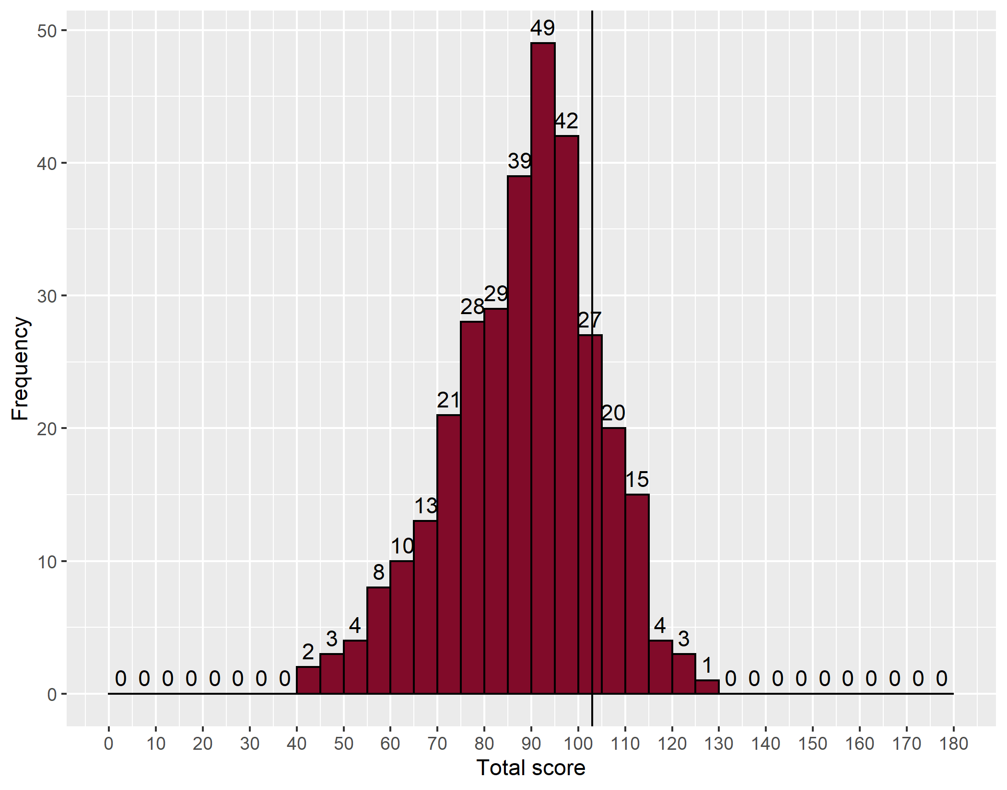
- Distribution of marks – MCQ
The vertical line denotes the point on the mark distribution where the pass mark lies.

Quality of questions
The Speedwell data allows us to identify easy, moderate and difficult questions, and those which are good, poor or perverse (negative) discriminators. Ideally, all questions should be moderately difficult and good discriminators.
- MCQ paper quality
 |  |  | Discrimination
 |  |  | Negative |  | Poor |  | Good |  | Total | %
 |  |  | <0 |  | 0-0.249 |  | ≥0.250
 |  |  | Number | % | Number | % | Number | %
Facility | Difficult | <25% | 12 | 6.9 | 18 | 10.3 | 0 | 0.0 | 30 | 17.2
 | Moderate | 25–75% | 7 | 4.0 | 63 | 36.2 | 34 | 19.5 | 104 | 59.8
 | Easy | ≥75% | 0 | 0.0 | 20 | 11.5 | 20 | 11.5 | 40 | 23.0
 | Total |  | 19 | 10.9 | 101 | 58.0 | 54 | 31.0 | 174 | 100.0

Standard setting
The pass mark for the paper was agreed using the Ebel method.
- MCQ Ebel categories - items per category
 | Difficult | Moderate | Easy | Total
Essential | 1 | 46 | 49 | 96
Important | 0 | 23 | 34 | 57
Supplementary | 1 | 13 | 7 | 21
Total | 2 | 82 | 90 | 174
The Part 1 FRCOphth subcommittee considered the success of a minimally competent candidate in each category as below:
- MCQ Ebel categories – expert decision
 | Difficult | Moderate | Easy
Essential | 0.55 | 0.65 | 0.75
Important | 0.45 | 0.50 | 0.55
Supplementary | 0.25 | 0.25 | 0.25
- MCQ Ebel categories – items per category X expert decision
 | Difficult | Moderate | Easy | Total
Essential | 1.00 | 30.00 | 37.00 | 67.00
Important | 0.00 | 12.00 | 19.00 | 30.00
Supplementary | 0.00 | 3.00 | 2.00 | 5.00
Total | 1.00 | 45.00 | 57.00 | 103.00
The MCQ pass mark was 103/174 (59%)

- Comparison of pass marks and rates for previous MCQ papers
Year | Candidates | Mean score | Reliability  (KR 20) | SEM | Standard setting | Pass mark | 33% discrimination |  |  | Facility
 |  |  |  |  |  |  | Negative | Poor  (0-0.249) | Good  (>0.250) | Difficult  (<25%) | Moderate | Easy  (>75%) | Number of questions | Pass number (rate)
May 2014 | 119 | 67 | 0.90 | 4.80 | Ebel | 69 (58%) | 4 | 43 | 72 | 6 | 82 | 31 | 119 | 54 (45%)
Oct 2014 | 232 | 72 | 0.90 | 4.80 | Ebel | 69 (58%) | 5 | 40 | 75 | 3 | 94 | 23 | 120 | 144 (62%)
Jan 2015 | 89 | 69 | 0.86 | 4.90 | Ebel | 69 (58%) | 9 | 56 | 55 | 9 | 91 | 20 | 120 | 53 (60%)
May 2015 | 114 | 72 | 0.89 | 4.70 | Ebel | 68 (57%) | 3 | 47 | 70 | 5 | 90 | 25 | 120 | 73 (64%)
Oct 2015 | 188 | 68 | 0.85 | 4.90 | Ebel | 71 (60%) | 3 | 59 | 58 | 6 | 90 | 24 | 120 | 79 (42%)
Jan 2016 | 107 | 69 | 0.90 | 4.90 | Ebel | 71 (59%) | 3 | 55 | 62 | 6 | 91 | 23 | 119 | 47 (44%)
May 2016 | 123 | 70 | 0.90 | 4.90 | Ebel | 71 (60%) | 6 | 34 | 79 | 3 | 90 | 26 | 119 | 71 (58%)
Oct 2016 | 194 | 71 | 0.88 | 4.80 | Ebel | 72 (60%) | 5 | 49 | 66 | 9 | 88 | 23 | 120 | 72 (37%)
Jan 2017 | 101 | 64 | 0.80 | NA | Ebel | 71 (60%)
May 2017 | 136 | 69 | 0.80 | 4.80 | Ebel | 75 (63%) | 6 | 63 | 50 | 8 | 89 | 22 | 119 | 45 (33%)
May 2018 | 119 | 70 | 0.83 | 4.73 | Ebel | 72 (60%) | 15 | 61 | 44 | 9 | 70 | 41 | 120 | 59 (50%)
Oct 2018 | 214 | 70 | 0.86 | 4.84 | Ebel | 72 (60%) | 7 | 68 | 45 | 4 | 87 | 29 | 120 | 103 (48%)
Jan 2019 | 96 | 65 | 0.82 | 4.68 | Ebel | 70 (60%) | 15 | 63 | 39 | 15 | 70 | 32 | 117 | 39 (41%)
Apr 2019 | 119 | 72 | 0.89 | 4.70 | Ebel | 73 (61%) | 10 | 46 | 63 | 9 | 79 | 31 | 119 | 64 (54%)
Oct 2019 | 186 | 68 | 0.84 | 4.67 | Ebel | 72 (61%) | 10 | 65 | 44 | 13 | 68 | 38 | 119 | 81 (44%)
Jan 2020 | 130 | 60 | 0.97 | 4.54 | Ebel | 73 (61%) | 1 | 20 | 99 | 15 | 96 | 9 | 120 | 45 (35%)
Oct 2020 | 365 | 77 | 0.87 | 4.56 | Ebel | 73 (61%) | 6 | 63 | 51 | 8 | 63 | 49 | 120 | 240 (66%)
Jan 2021 | 149 | 107 | 0.89 | 5.63 | Ebel | 116 (66%) | 7 | 105 | 65 | 15 | 108 | 54 | 177 | 51 (34%)
Apr 2021 | 227 | 107 | 0.89 | 5.73 | Ebel | 112 (63%) | 12 | 97 | 69 | 9 | 110 | 59 | 178 | 95 (42%)
Oct 2021 | 318 | 91 | 0.87 | 5.68 | Ebel | 103 (59%) | 19 | 101 | 54 | 30 | 104 | 40 | 174 | 70 (22%)

* For Jan 2021 and subsequent diets, the MCQ paper was lengthened from 120 to 180 questions.

Comparison with previous Part 1 examinations
- Key statistics in previous years
Examination | Candidates | Number passing | % passed | MCQ pass mark % | CRQ pass mark %
Jan 2013 | 91 | 47 | 52 | 57 | 53
May 2013 | 102 | 54 | 53 | 58 | 58
Oct 2013 | 151 | 65 | 43 | 58 | 60
Jan 2014 | 77 | 23 | 30 | 57 | 57
May 2014 | 119 | 55 | 46 | 58 | 56
Oct 2014 | 232 | 102 | 44 | 58 | 57
Jan 2015 | 89 | 50 | 56 | 58 | 61
May 2015 | 114 | 62 | 54 | 57 | 54
Oct 2015 | 188 | 57 | 30 | 59 | 59
Jan 2016 | 107 | 36 | 34 | 59 | 54
May 2016 | 123 | 61 | 50 | 60 | 56
Oct 2016 | 194 | 70 | 36 | 60 | 59
Jan 2017 | 101 | 38 | 38 | 60 | 51
May 2017 | 136 | 62 | 46 | 63 | 53
May 2018 | 119 | 64 | 54 | 60 | 54
Oct 2018 | 214 | 122 | 57 | 60 | 55
Jan 2019 | 96 | 37 | 39 | 60 | 50
Apr 2019 | 119 | 45 | 38 | 61 | 51
Oct 2019 | 186 | 89 | 48 | 61 | 51
Jan 2020 | 116 | 53 | 46 | 61 | 52
Oct 2020 | 369 | 230 | 62 | 61 | 52
Jan 2021 | 149 | 51 | 34 | 66 | N/A
Apr 2021 | 227 | 95 | 42 | 63 | N/A
Oct 2021 | 318 | 70 | 22 | 59 | N/A

* For Jan 2021 and subsequent diets, the CRQ paper was removed (and 50 per cent more items were added to the MCQ).

- Comparison to previous years
Sitting | Candidates | Number passing | Pass rate (%)
January | 1,180 | 466 | 39
May | 1,089 | 510 | 47
October | 2,140 | 1,047 | 49
Total | 4,409 | 2,023 | 46

