Examination Report
Part 2 Fellowship of the Royal College of Ophthalmologists (FRCOphth) Oral Examination
April 2022
David Budzynski, Matthew Turner, Ben Smith

Contents
1 Summary 3
2 Candidates 3
3 The structured vivas 3
3.1 Results 4
3.2 Standard setting for the structured vivas 5
4 The objective structured clinical examination (OSCE) 6
4.1 Results 6
4.2 Standard setting for the OSCEs 8
5 Overall results for the oral examination 8
5.1 Results 8
5.2 Breakdown of oral examination 9
5.3 Comparison to previous examinations 10

Summary
The part 2 Fellowship of the Royal College of Opthalmologists (FRCOphth) oral examination consists of two elements. The objective structured clinical examination (OSCE) consists of six stations worth a total of 198 marks, whilst the structured viva consists of five stations worth a total of 60 marks. One of the OSCE stations is conducted with the vivas.
A total of 114 candidates sat the examination.
The pass mark for the structured viva was 37 and the pass mark for the OSCE was 125.
The reliability of the oral examination was 0.744 (viva) and 0.809 (OSCE).
The pass rates for the viva and the OSCE were 92/114 (81 per cent) and 77/114 (68 per cent) respectively. The overall pass rate was 77/114 (68 per cent).

Candidates
A total of 114 candidates sat the examination. Of these, 53/114 (46 per cent) were in Ophthalmic Specialist Training (OST). The largest group (28 per cent) were in training level OST5.

The structured vivas
There were five structured vivas, which were held on Monday 4 April and Tuesday 5 April. The communication skills OSCE station was conducted as one of the viva stations, making six stations in all (the OSCE station is not included in the analysis of the viva; it is merely administered at the same time). Each viva lasted 10 minutes. The viva stations were:
Station 1: | Patient investigations and data interpretation
Station 2: | Patient management 1
Station 3: | Patient management 2
Station 4: | Attitudes, ethics and responsibilities.
Station 5a: | Audit, research and EBM (5 minutes)
Station 5b: | Health promotion and disease prevention (5 minutes)
Station 6: | Communication skills (part of OSCE)

Results
Maximum mark (five stations, one examiner per station, 12 marks per station): 60
- Marks for the viva
Statistic | Value | Percentage
Pass mark (using borderline candidate method) | 34/60 | 56.7%
Mean score | 42.3/60 | 70.5%
Median score | 42.5/60 | 70.8%
Range | 23 – 57 | 38.3% – 95.0%
Reliability (Cronbach's alpha adjusted) | 0.744
SEM | 3.44 | 5.7%
Final adjusted pass mark (+1 SEM) | 37/60 | 61.7%
Pass rate before adjustment (pass mark 34/60) | 102/114 | 89.5%
Pass rate after adjustment (pass mark 37/60) | 92/114 | 80.7%

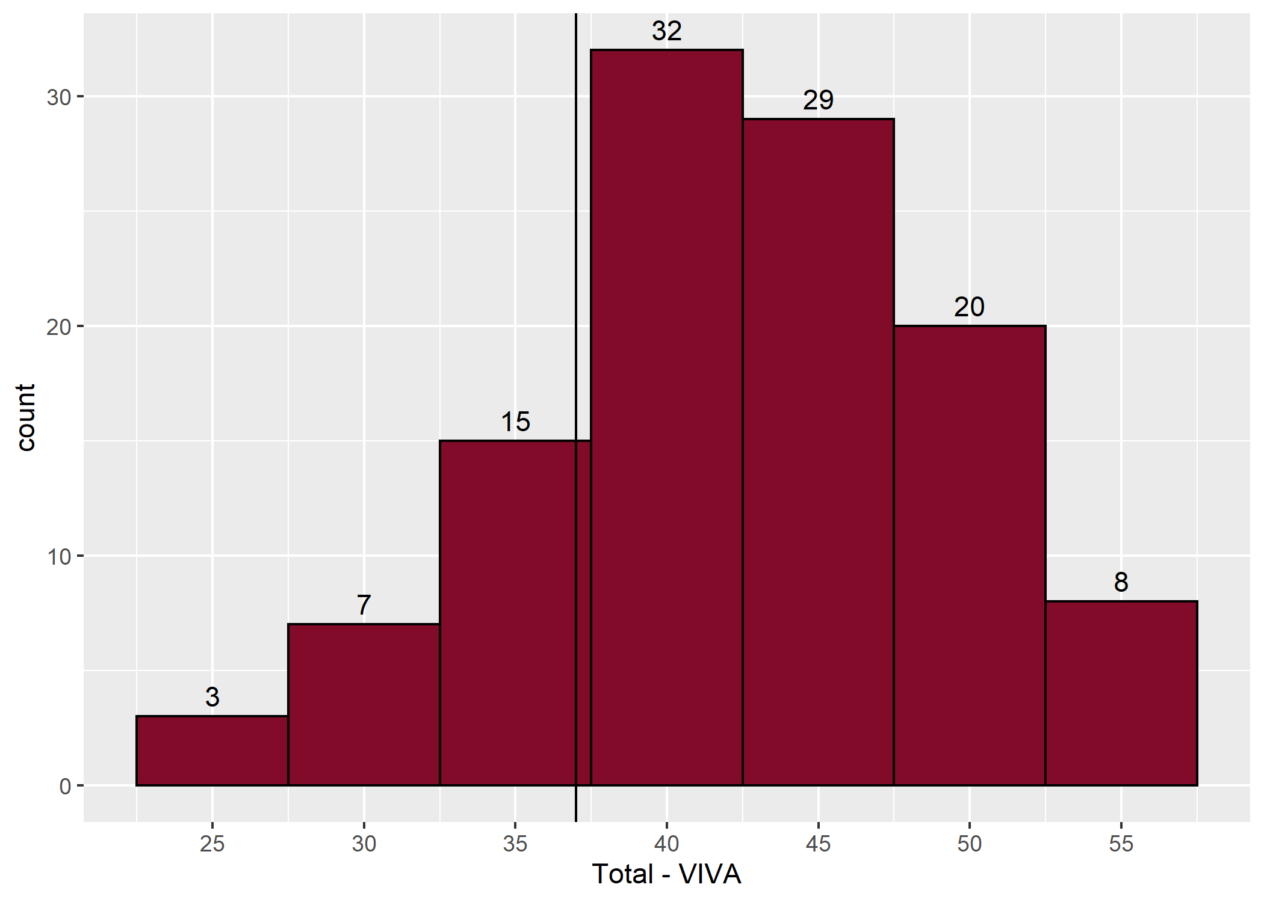
- Distribution of viva scores

- Station summary — viva
Station | Category | Maximum possible | Mean | Median | Min | Max
1 | PI | 12 | 9.7 | 10.0 | 3 | 12
2 | PM1 | 12 | 8.0 | 8.0 | 2 | 12
3 | PM2 | 12 | 7.8 | 8.0 | 3 | 12
4 | AER | 12 | 8.9 | 9.0 | 4 | 12
5 | HPDP/EBM | 12 | 7.9 | 8.0 | 0 | 12
- Correlation between viva stations
 | Station 1 | Station 2 | Station 3 | Station 4 | Station 5
Station 1
Station 2 | -0.01
Station 3 | 0.30 | 0.32
Station 4 | 0.11 | 0.21 | 0.21
Station 5 | 0.16 | 0.27 | 0.30 | 0.36

Standard setting for the structured vivas
- Viva standard setting
 | Station 1 | Station 2 | Station 3 | Station 4 | Station 5 | Total
Number of passed candidates | 89 | 45 | 71 | 91 | 63
Number of borderline candidates | 20 | 44 | 31 | 21 | 31
Number of failed candidates | 5 | 25 | 12 | 2 | 20
Median borderline candidate mark | 7 | 8 | 6 | 6 | 7 | 34

The objective structured clinical examination (OSCE)
There were six OSCE stations in all. The five clinical stations were held from Wednesday 6 April to Friday 8 April.

Results
- Marks for the OSCE
Statistic | Value | Percentage
Pass mark (using borderline candidate method) | 116/198 | 58.6%
Mean score | 132.9/198 | 67.1%
Median score | 133/198 | 67.2%
Range | 72 – 180 | 36.4% – 90.9%
Reliability (Cronbach's alpha) | 0.809
SEM | 9.35 | 4.7%
Final adjusted pass mark (+1 SEM) | 125/198 | 63.1%
Pass rate before adjustment (pass mark 116/198) | 86/114 | 75.4%
Pass rate after adjustment (pass mark 125/198) | 77/114 | 67.5%

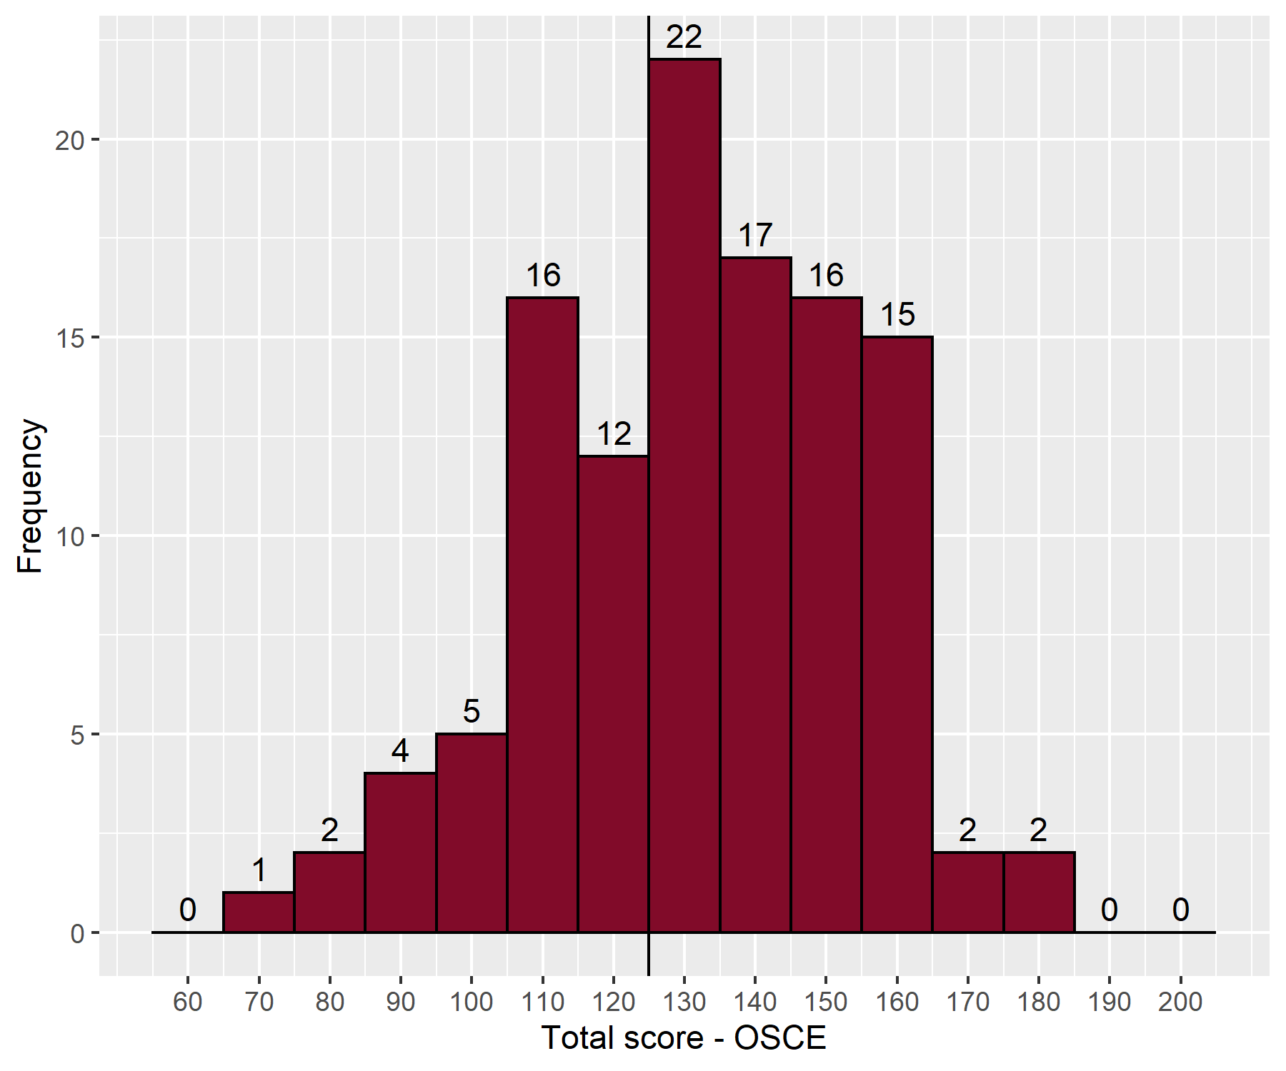
- Distribution of OSCE scores
- Station Summary — OSCE
Station | Category | Maximum Possible | Mean | Median | Min | Max
1 | Anterior segment | 36 | 24.3 | 25.0 | 6 | 36
2 | Glaucoma and lid | 36 | 26.9 | 28.5 | 6 | 36
3 | Posterior segment | 36 | 23.4 | 24.0 | 7 | 36
4 | Strabismus and orbit | 36 | 23.5 | 24.0 | 7 | 35
5 | Neuro-ophthalmology | 36 | 23.3 | 24.0 | 8 | 34
6 | Communication skills | 18 | 11.6 | 12.0 | 2 | 18

- Correlation between examiners' marks at each station
Station | Station 1 | Station 2 | Station 3 | Station 4 | Station 5 | Station 6
Category | Anterior segment | Glaucoma and lid | Posterior segment | Strabismus and orbit | Neuro-ophthalmology | Communication skills
Correlation | 0.89 | 0.84 | 0.89 | 0.89 | 0.83 | 0.89

- Mean absolute difference in examiners' marks at each station
Station | Station 1 | Station 2 | Station 3 | Station 4 | Station 5 | Station 6
Category | Anterior segment | Glaucoma and lid | Posterior segment | Strabismus and orbit | Neuro-ophthalmology | Communication skills
Mean absolute difference | 1.19 | 1.33 | 1.31 | 1.30 | 1.42 | 0.70

- Correlation between OSCE stations
 | Station 1 | Station 2 | Station 3 | Station 4 | Station 5 | Station 6
Station 1
Station 2 | 0.26
Station 3 | 0.28 | 0.06
Station 4 | 0.32 | 0.20 | 0.14
Station 5 | 0.12 | 0.31 | 0.19 | 0.39
Station 6 | 0.16 | 0.00 | 0.30 | 0.39 | 0.19

Standard setting for the OSCEs
- OSCE standard setting
 | Station 1 |  | Station 2 |  | Station 3 |  | Station 4 |  | Station 5 |  | Station 6 |  | Total
Number of passed candidates | 65 | 65 | 71 | 72 | 60 | 58 | 45 | 50 | 53 | 57 | 56 | 63
Number of borderline candidates | 37 | 38 | 27 | 29 | 33 | 37 | 46 | 44 | 39 | 37 | 38 | 27
Number of failed candidates | 12 | 11 | 16 | 13 | 21 | 19 | 23 | 20 | 22 | 19 | 20 | 24
Median borderline candidate mark | 10 | 10 | 12 | 11 | 10 | 10 | 11 | 11 | 10 | 11 | 5 | 5 | 116

Overall results for the oral examination

Results
- Overall results summary
Statistics | Value | Percentage
Pass Mark | 162/258 | 62.8%
Mean | 175/258 | 67.8%
Median | 178/258 | 69.0%
Range | 95 – 237 | 36.8% – 91.9%

To pass the oral examination candidates had to either pass both the viva (37/60 (62 per cent)) and OSCE (125/198 (63 per cent)) or pass the OSCE, achieve 34/60 (57 per cent) in the viva, and achieve 162/258 (63 per cent) overall.
Overall, 77 out of 114 candidates passed the examination.
- Pass rates
Statistics | Value | Percentage
Overall pass rate for the oral examination | 77/114 | 67.5%
Pass rate for candidates in Ophthalmic Specialist Training (OST) | 48/53 | 90.6%
Pass rate for non-trainees | 29/61 | 47.5%

The correlation between the structured viva and the OSCE was 0.58.
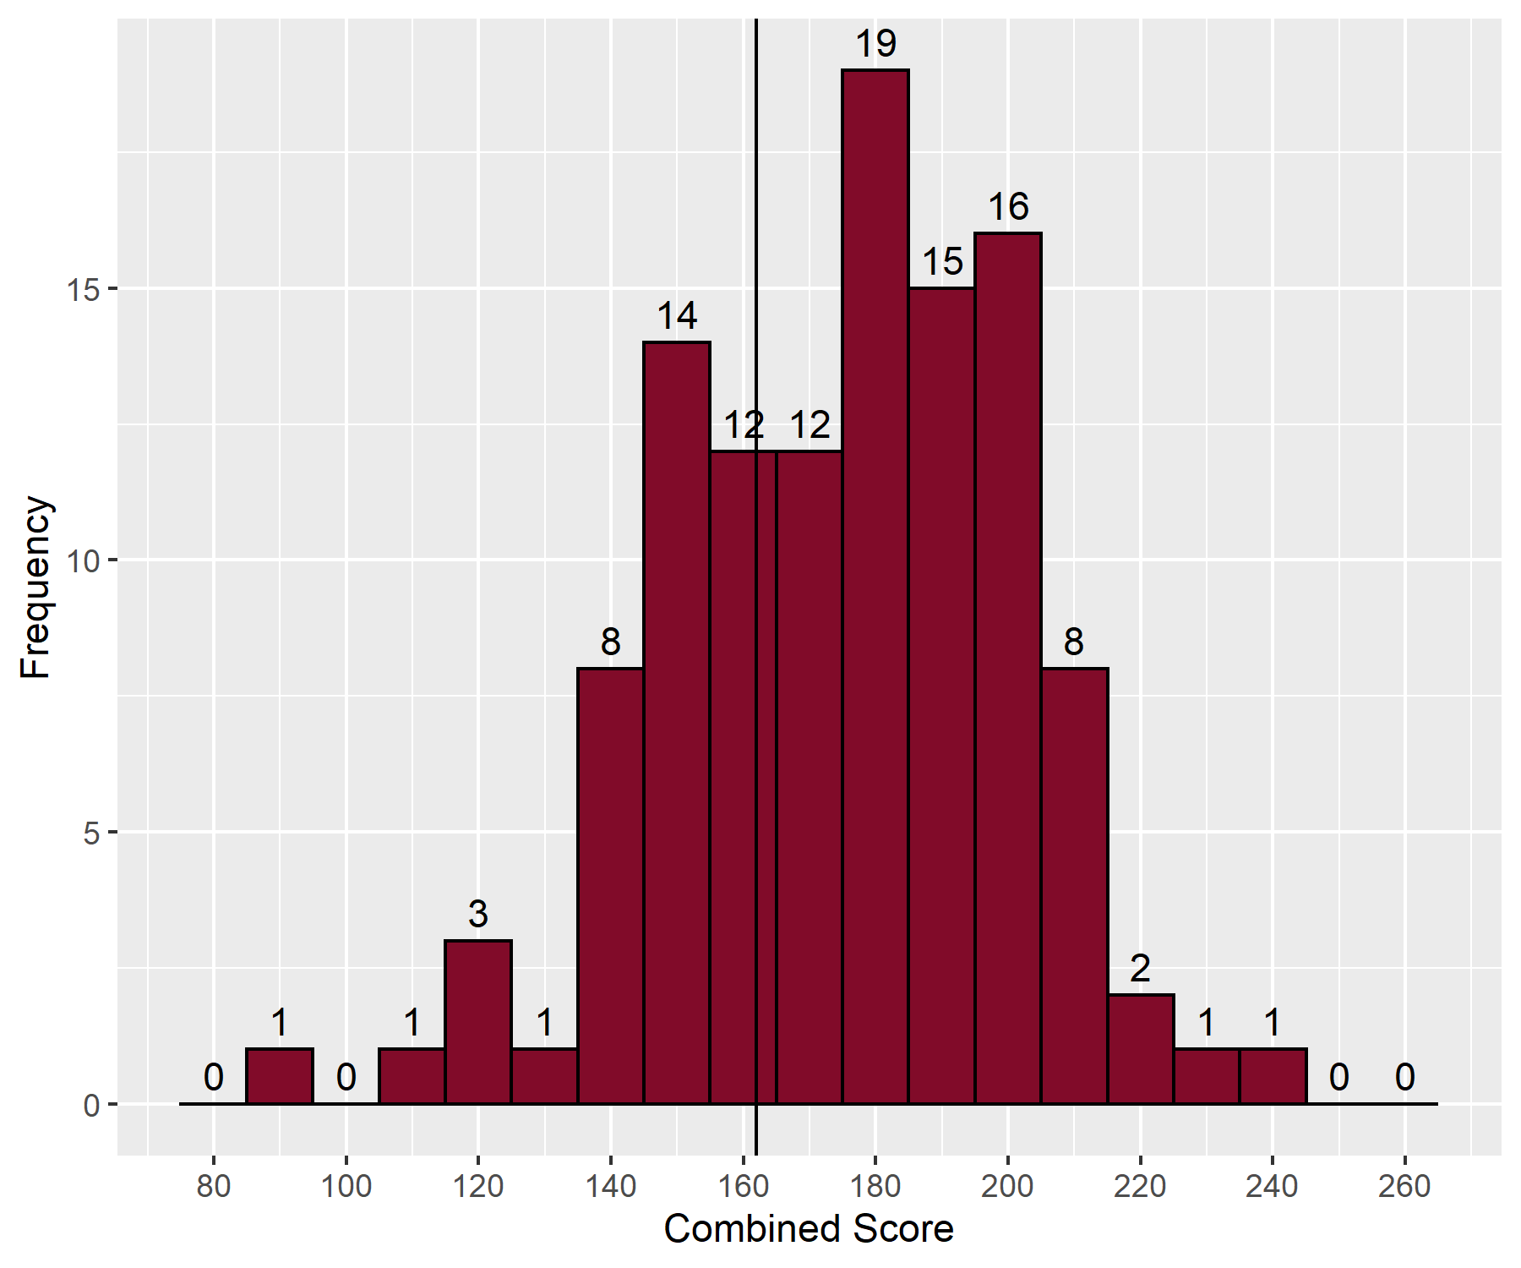
- Distribution of total scores

Breakdown of oral examination
- Breakdown of results by training
Training | Failed | Passed | Pass rate (%) | Total
In OST | 5 | 48 | 90.6 | 53
Not in OST | 32 | 29 | 47.5 | 61
Total | 37 | 77 | 67.5 | 114

- Breakdown of results by level of training
Level of training | Failed | Passed | Pass rate (%) | Total
OST2 | 0 | 1 | 100.0 | 1
OST3 | 0 | 7 | 100.0 | 7
OST4 | 0 | 11 | 100.0 | 11
OST5 | 1 | 14 | 93.3 | 15
OST6 | 1 | 10 | 90.9 | 11
OST6/7 | 0 | 1 | 100.0 | 1
OST7 | 3 | 4 | 57.1 | 7
Total | 5 | 48 | 90.6 | 53

Comparison to previous examinations
- Comparison to previous examinations
Date | Candidates | Viva pass mark | Viva reliability | OSCE pass mark | OSCE reliability | Oral pass rate | Oral pass rate in OST
Nov 2012 | 103 | 58% | 0.9 | 61% | 0.8 | 58% | 64%
Apr 2013 | 109 | 60% | 0.8 | 63% | 0.8 | 57% | 56%
Apr 2014 | 104 | 57% | 0.8 | 61% | 0.8 | 58% | 65%
Nov 2014 | 79 | 63% | 0.8 | 62% | 0.7 | 63% | 70%
Apr 2015 | 77 | 60% | 0.9 | 60% | 0.9 | 62% | 80%
Nov 2015 | 72 | 61% | 0.8 | 62% | 0.8 | 69% | 86%
Apr 2016 | 61 | 63% | 0.8 | 63% | 0.9 | 56% | 69%
Nov 2016 | 107 | 60% | 0.8 | 63% | 0.8 | 71% | 84%
Apr 2017 | 105 | 61% | 0.8 | 63% | 0.8 | 66% | 82%
Apr 2018 | 74 | 62% | 0.8 | 60% | 0.8 | 70% | 80%
Nov 2018 | 106 | 58% | 0.8 | 64% | 0.8 | 58% | 74%
Apr 2019 | 84 | 63% | 0.6 | 64% | 0.9 | 64% | 79%
Nov 2019 | 85 | 67% | 0.7 | 60% | 0.8 | 71% | 80%
Nov2020 | 86 | 62% | 0.4 | 64% | 0.8 | 74% | 85%
Mar2021 | 46 | 58% | 0.8 | 60% | 0.8 | 70% | 94%
Apr2021 | 74 | 62% | 0.7 | 64% | 0.8 | 77% | 84%
Nov2021 | 119 | 60% | 0.6 | 61% | 0.8 | 73% | 85%
Apr2022 | 114 | 62% | 0.7 | 63% | 0.8 | 68% | 91%
The MCQ examination has been de-coupled from the oral examination since April 2014

- Cumulative results by deanery (September 2010 to date)
Country | Deanery | Number of passes | Number of candidates | Pass rate (%)
UK | East Midlands | 55 | 75 | 73.3
 | East of England | 61 | 104 | 58.7
 | East of Scotland | 12 | 13 | 92.3
 | London and KSS (Kent, Surrey and Sussex) | 299 | 392 | 76.3
 | Mersey | 59 | 81 | 72.8
 | North of Scotland | 10 | 18 | 55.6
 | North Western | 65 | 106 | 61.3
 | Northern | 55 | 73 | 75.3
 | Northern Ireland | 17 | 21 | 81.0
 | Oxford | 49 | 57 | 86.0
 | Peninsula (South West) | 25 | 45 | 55.6
 | Severn | 33 | 44 | 75.0
 | Severn Institute | 10 | 12 | 83.3
 | South East of Scotland | 26 | 31 | 83.9
 | Wales | 43 | 69 | 62.3
 | Wessex | 37 | 60 | 61.7
 | West Midlands | 83 | 128 | 64.8
 | West of Scotland | 38 | 58 | 65.5
 | Yorkshire | 89 | 134 | 66.4
Overseas | Eire | 1 | 2 | 50.0
 | Europe and Overseas | 16 | 40 | 40.0
Total |  | 1,083 | 1,563 | 69.3

