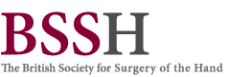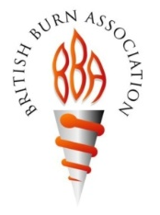
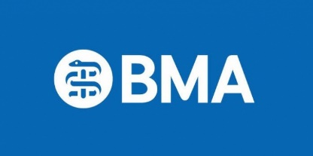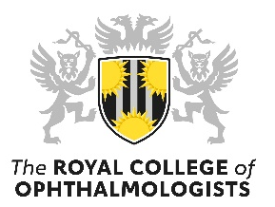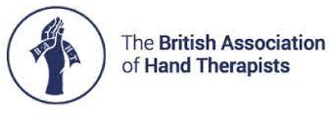

Ms Ash Regan MSP (Edinburgh Eastern Constituency)
The Minister for Community Safety
The Scottish Parliament
Edinburgh
EH99 1SP
21/06/2022
Dear Ms Regan,

Re: Strong support from clinicians for the Scottish Government Fireworks and Pyrotechnics Bill

We write on behalf of a wide coalition of Medical Associations and all our members, who are expert clinicians, to provide our full support for the Scottish Government’s Firework and Pyrotechnics Bill. This is an extremely important piece of new legislation which has been widely consulted upon and carefully considered, including with input from the firework working group.

Sadly, every year Emergency Physicians, Burns & Plastic Surgeons, Ophthalmologists, Hand Surgeons and Therapists, and Trauma Surgeons have to treat many patients with devastating, life changing burn and blast injuries to the face, eye, hand, limbs and trunk from fireworks. These preventable injuries are commonly sustained by children, young men and in communities where there is increased deprivation, which further adds to the long-term burden of disease and disability in the community.

We welcome this well thought out legislation which seeks to enhance the regulation and licensing of fireworks purchase and their use in the community - when implemented this will ensure that fireworks can still be enjoyed, but in a much safer and more responsible manner, and with a significant reduction in the number of these potentially devastating yet eminently preventable fireworks injuries.

We very much hope that the Scottish Parliament will vote to adopt this proposed legislation at the Decision Time stage on 23 June 2022. This would be a historic achievement and a major step forward for injury prevention in the community.

Yours sincerely

BSSH: Mr Ian McNab (Hon Sec & Hand Injury Prevention Lead) & Mr Jonathan Hobby (President)
BAPRAS:Ms Ruth Waters (President)
BBA: Mr Odhran Shelly (Chair)
BOA: Prof. John Skinner (President) & Prof. Deborah Eastwood (Vice President)
RCOpth: Prof. Bernard Chang (President)
BAHT: Ms Hayley Smith (Chair) & Ms Leanne Topcuoglu (Vice Chair)
BMA: Dr Lewis Morrison (Chair of BMA Scotland)

British Society for Surgery of the Hand, Royal College of Surgeons of England, 38-43 Lincoln's Inn Fields, London WC2A 3PE
+44 (0)207 831 5162 / email: secretariat@bssh.ac.uk

