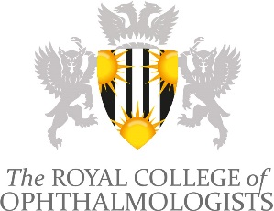
RCOphth Learning Management System
Programme Editors
Trainee & Practitioner Co-Editors
___________________________________________________________________________

Application Form

Closing date: 9am Monday 15 August 2022
E-mail this application form to: education@rcophth.ac.uk

Personal Details
Title
First Names
Surname
Qualifications
Contact telephone number
Email address
Main role (grade and profession)
Current Trust/Employer
Does your employer/supervisor support your application?

Please selectively list the key positions you have held, with dates, which have given you experience that will help you in this role (use the “alt” key with a bullet and a tab)
•
•
•

Please describe why you think you are suitable for this role (max 150 words)

Please double click box to confirm:
Cautions, criminal convictions and other statements
Have you at any time had (or do you have pending) any criminal convictions? | Yes No
Have you at any time had (or do you have pending) any investigations, suspensions, limitations or removal of medical registration in any country? | Yes No
Have you ever been refused or are there any reasons why a certificate of good standing might be refused in any country where you have worked? | Yes No
Do you have any health problem likely to adversely affect your professional work? | Yes No
Are you aware of any matters that may affect your good standing as a member of your professional body? | Yes No
If you have answered ‘Yes’ to any of the above questions please give an explanation below.
I confirm that I have complied with my employer’s requirements for annual appraisal /performance review. | Yes No
I confirm that I am complying with the requirements of my professional body for CPD / CET or ARCP. | Yes No
I confirm that I am registered with the General Medical Council UK or appropriate body for Professional Registration, and I am up to date with my revalidation and/or licencing. | Yes No
To be completed by the applicant
Signature (electronic signature accepted)
Date | / /  DD MM YYYY

Closing date: 9am Monday 15th August 2021
E-mail this application form to: education@rcophth.ac.uk

