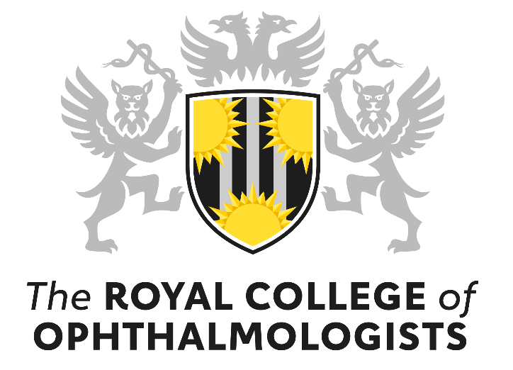

The Ulverscroft David Owen Prize Application Form 2024

Please send completed applications to laurelle.bygraves@rcophth.ac.uk by 17:00 on Wednesday 31st January 2024.

The purpose of this prize is to recognise high quality research in paediatric ophthalmology and visual sciences and promote academic paediatric ophthalmology.

This prize will be awarded to the best research paper in paediatric ophthalmology and visual sciences (encompassing research on or about children or relating to childhood) from a UK based research team and published in any journal in the preceding two years. At least one of the authors must be a member of the RCOphth.

Application criteria:

- The first author and senior author should apply together.
- Either the first or lead author must be an ophthalmologist.
- At least one of the authors must be a member of the RCOphth.
- The applicants should be based and have undertaken the research reported at a British institution.
- The paper must have been published in a peer reviewed scientific journal after 1 January 2022.

The award will be made to the team undertaking the research, but the prize money will be awarded to the first author.

First Author

Job title

Employing organisation

Email

Telephone

Signature and Date

Senior Author

Name

Job title

Employing organisation

Email

Telephone

Signature and Date

Title of Paper

Full citation

(Journal, Publication Date, Issues and Page numbers)

PMID (unique identifier number used in PubMed)

Role of first and senior authors in the submitted work

Please describe the importance of the work and impact or potential impact of the research in terms of any of the following: health, healthcare, policy, scientific knowledge, innovation and enterprise.
WORD LIMIT = 750 words
Please attached a copy of the paper in PDF format

Guidance notes for applicants:

The 2024 prize will be awarded to the best research paper in paediatric ophthalmology and visual sciences i.e. encompassing research on or about children or relating to childhood from a UK based research team and published in any journal between 1 January 2022 and 31 December 2023.

Criteria used to judge the submitted paper:
- The quality of the science
- Impact or potential impact in terms of improving health, healthcare, health policy, scientific understanding or knowledge agenda, innovation and enterprise
- The contribution to advancing academic paediatric ophthalmology

Photographs and filming: The Royal College of Ophthalmologists and its representatives, or external agencies acting on behalf of RCOphth, may take photographs, video footage and voice recordings of any award related promotional activity e.g. photographs of the recipients receiving the award, for future promotional purposes in print or online. Please inform the RCOphth Communications Manager organiser on the day if you do not wish your image to be used in this way.

