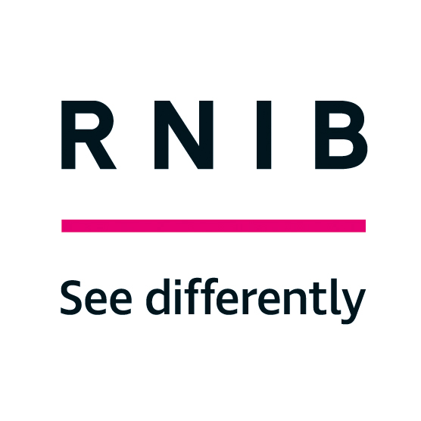
RNIB
105 Judd Street,
London WC1H 9NE

rnib.org.uk
RNIB Helpline: 0303123 9999
helpline@rnib.org.uk

December 2022

Dear Colleague,

RNIB would like your support in helping patients to understand how the Certificate of Vision Impairment (CVI) and sight impairment registration can help during the cost of living crisis.

Please disseminate this information to your whole eye care team

The cost of living crisis is having a disproportionate impact on blind and partially sighted people. Even before prices began to rise, research found that one in five blind and partially sighted people said they had some, or great, difficulty in making ends meet.

Blind and partially sighted people face additional costs for assistive technology, support in their homes, and increased reliance on taxis to get out and about, for instance. At the same time, they’re less likely to be able to find the best money-saving deals or choose the cheapest options.

In addition, people with sight loss are also more reliant on benefits than the general population, with only one in four registered blind and partially sighted people of working age in employment.

More than 100 blind and partially sighted people took part in RNIB’s cost of living survey in May 2022 and explained how the crisis was affecting them:

- More than two thirds said their financial situation had got worse over the last six months.

- More than a third “often” go without essentials such as food and heating, or have struggled to make ends meet.

- Despite some people needing more light, including to safely move around their home, more than two thirds reported using less energy to try and save money. This compares to a third of the general population.

Since that time, prices have continued to rise and the cost of heating, eating, technology and transport are all among the issues being raised with RNIB.

Through registering as blind or partially sighted with their local authority following being assessed/certified as Severely Sight Impaired (SSI) or Sight Impaired (SI), people with sight loss can access state benefits which may alleviate some of the cost of living pressures.

RNIB wanted to send information about this to you and your multidisciplinary colleagues in the eye clinic, because we believe you have an important role in being able to have discussions with patients about the implications and benefits of receiving a CVI and becoming registered.

Key cost of living benefits of registration:

Across England, Northern Ireland and Wales

For both SI and SSI:

1. Access to support services through adult social care which can
include – rehabilitation, aids, equipment etc.

2. Access to premiums on means tested benefits & Disabled Persons
Tax Credits and a route to claiming other disability benefits.

3. Discounted travel – Disabled Person’s Railcard, free or reduced
bus travel fare

SSI specifically:

1. Eligible to claim Blind Person’s Tax Allowance - 2022/2023 rate
£2,600 is added to the yearly personal tax allowance – or can be
transferred to a married partner if more beneficial.

2. Television licence fee reduction of 50%

Scotland:

As above and including:

National Entitlement Card, free bus and rail travel fare - anyone registered SSI can have +1 added to their card to allow a companion to travel free (bus only).

In addition, across all nations, when registered a person would automatically be considered to be disabled and therefore to have a protected characteristic in relation to the Equality Act 2010 (England, Scotland and Wales) or the Disability Discrimination Act 1995 (Northern Ireland).

To find out more, please visit:
www.rnib.org.uk/living-with-sight-loss/money-and-benefits/
or call 0303 123 9999.

If you would like to get in touch with RNIB in Scotland, Northern Ireland or Wales please visit:

www.rnib.org.uk/nations/northern-ireland/
www.rnib.org.uk/nations/scotland/
www.rnib.org.uk/nations/walescymru/

Thank you for your support.

Yours sincerely

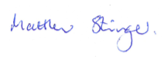

Matt Stringer, Chief Executive, RNIB

