Examination Report
Part 2 Fellowship of the Royal College of Ophthalmologists (FRCOphth) Oral Examination
November 2022
Matthew Turner, Ben Smith

Contents
1 Summary 3
2 Standard setting 3
2.1 Hofstee method 3
3 The structured vivas 3
3.1 Results 4
4 The objective structured clinical examination (OSCE) 8
4.1 Results 8
5 Overall results for the oral examination 11
5.1 Results 11

Summary
A total of 118 candidates sat the examination.
The pass mark for the OSCE was 118 and the pass mark for the structured viva was 77.
The reliability of the oral examination was 0.8 (viva) and 0.8 (OSCE).
The pass rates for the viva and the OSCE were 87/118 (74 per cent) and 85/118 (72 per cent) respectively. The overall pass rate was 73/118 (62 per cent).

Standard setting
Candidates must be able to accurately assess visual acuity, measure refractive error and recommend an appropriate spectacle correction to pass the RCert. The pass mark is identified using the Hofstee method:

Hofstee method
After the examination, examiners were asked to review the parameters for the standard setting based upon their judgment of the difficulty of the stations. The following values were used to set the pass mark:
- The maximum credible pass mark for the examination = 65%
- The maximum credible pass rate for the examination = 100%
- The minimum credible pass mark for the examination = 55%
- The minimum credible pass rate for the examination = 45% (OSCE), 55% (VIVA)
The cumulative fail rate as a function of the pass mark and the co-ordinates derived from the four values above were plotted on a graph. The point where a line joining the two coordinates intersects the cumulative function curve is used to identify the pass mark.
Plots visualising this process for each part of the examination are shown in the relevant sections below.

The structured vivas
There were five structured vivas. The communication skills OSCE station was conducted as one of the viva stations, making six stations in all (the OSCE station is not included in the analysis of the viva; it is merely administered at the same time). Each viva lasted 10 minutes. The stations were:
Station 1: | Patient investigations and data interpretation
Station 2: | Patient management 1
Station 3: | Patient management 2
Station 4: | Attitudes, ethics and responsibilities.
Station 5a: | Audit, research and evidence-based medicine EBM (five minutes)
Station 5b: | Health promotion and disease prevention (5 minutes)
Station 6: | Communication skills (part of OSCE)

Results
Maximum mark (five stations, 10 examiners, 12 marks per station): 120
- Marks for the viva
Statistic | Value | Percentage
Pass mark (using Hofstee) | 77/120 | 64.2%
Mean score | 82.6/120 | 68.8%
Median score | 83/120 | 69.2%
Range | 44 – 110 | 36.7% – 91.7%
Reliability (Cronbach's alpha) | 0.8
SEM | 5.76 | 4.8%
Pass rate (pass mark 77/120) | 87/118 | 73.7%

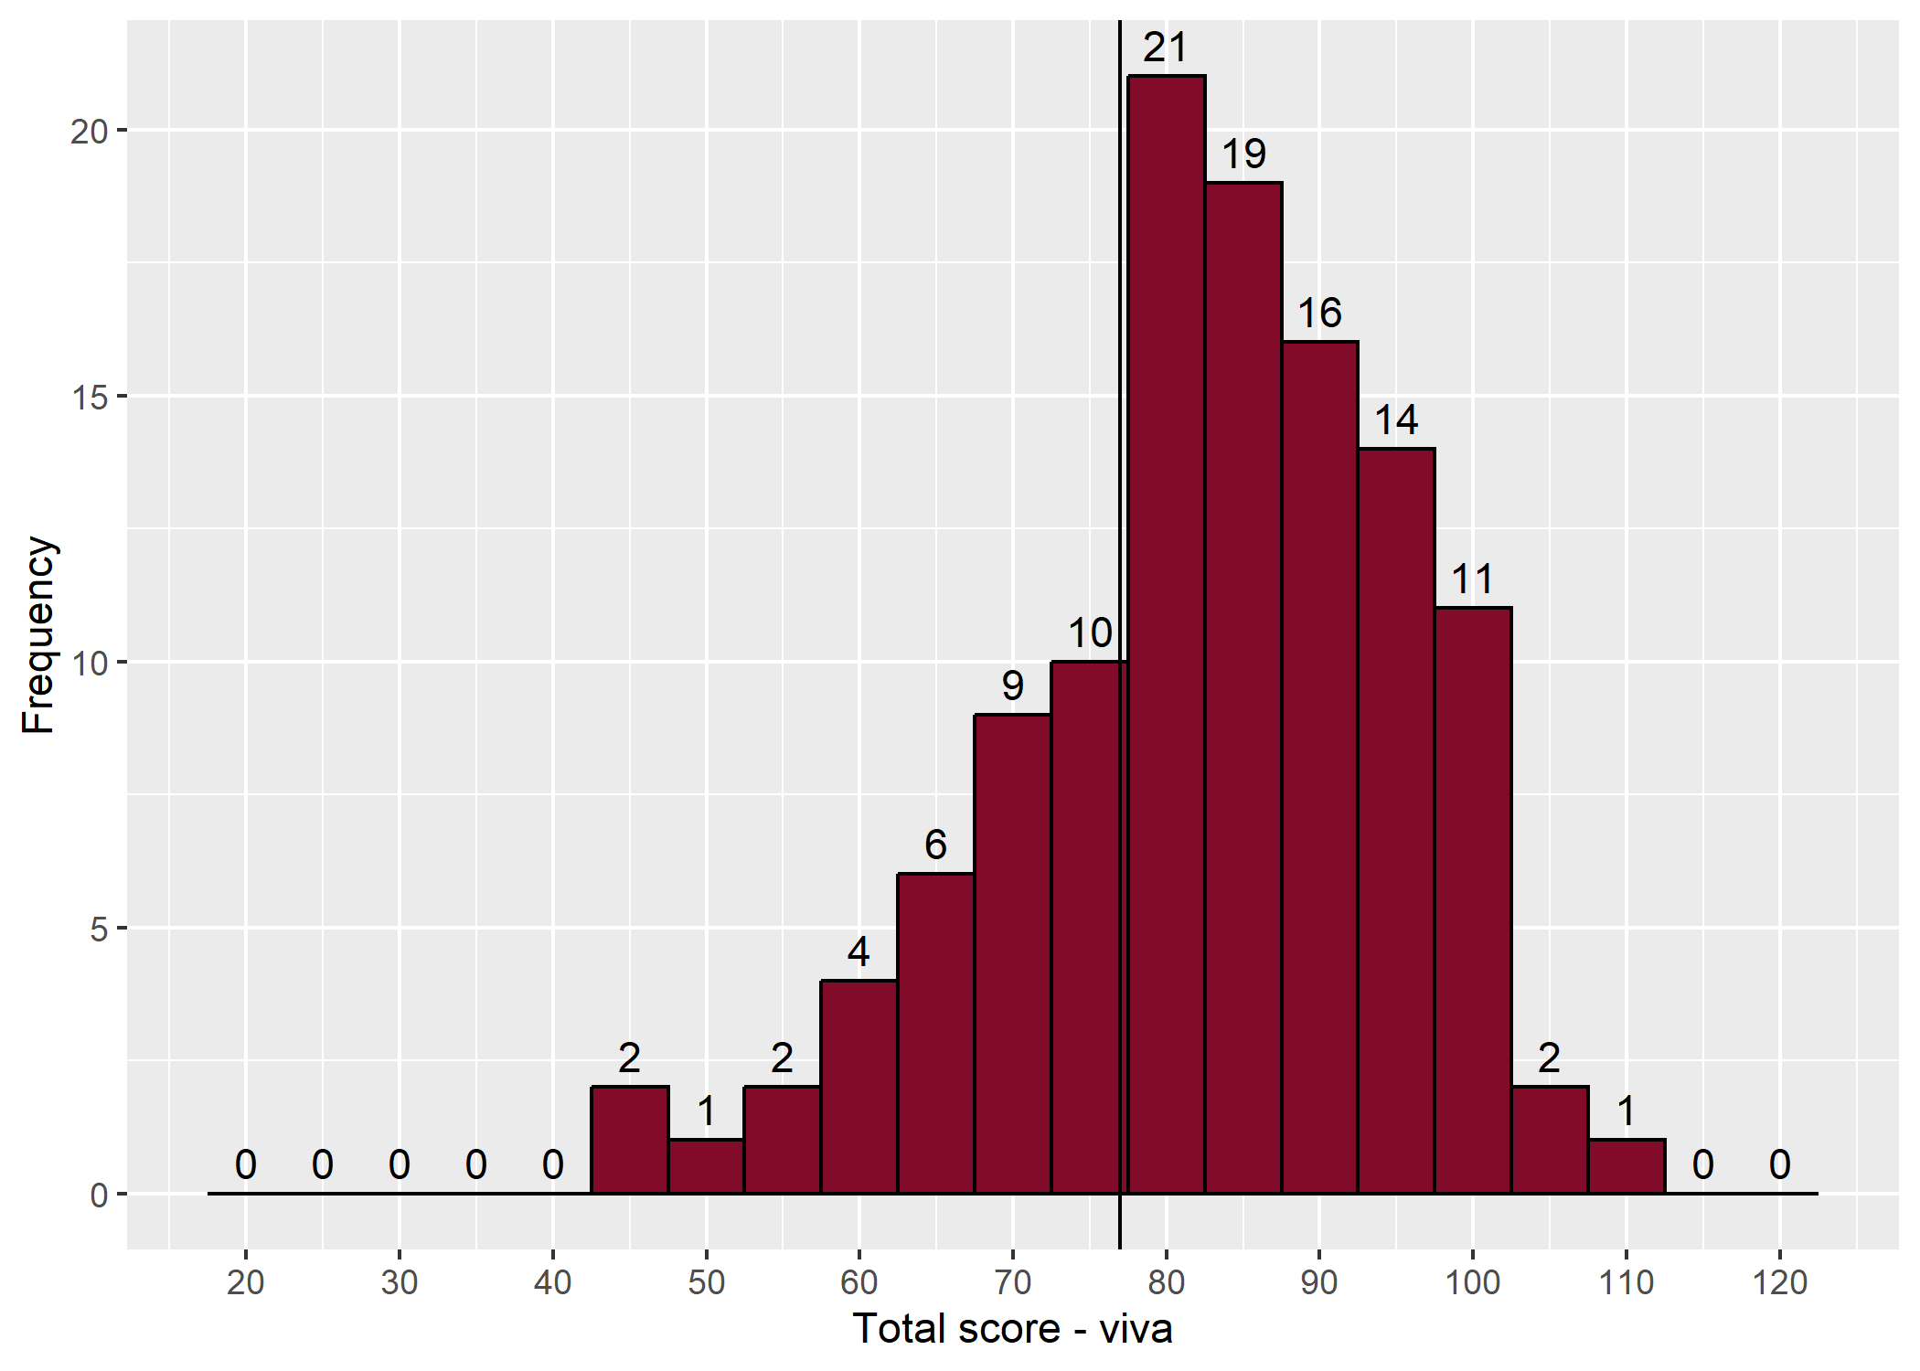
- Distribution of viva scores

- Station summary – viva
Station | Category | Maximum possible | Mean | Median | Min | Max
1 | PI | 24 | 15.9 | 16.0 | 6 | 23
2 | PM1 | 24 | 17.9 | 18.0 | 6 | 24
3 | PM2 | 24 | 16.8 | 17.0 | 4 | 23
4 | AER | 24 | 16.8 | 18.0 | 3 | 24
5 | HPDP/EBM | 24 | 15.2 | 15.5 | 5 | 24
- Correlation between examiners' marks at each station
Station | Station 1 | Station 2 | Station 3 | Station 4 | Station 5
Category | PI | PM1 | PM2 | AER | HPDP/EBM
Correlation | 0.76 | 0.91 | 0.91 | 0.89 | 0.84

- Mean absolute difference in examiners' marks at each station
Station | Station 1 | Station 2 | Station 3 | Station 4 | Station 5
Category | PI | PM1 | PM2 | AER | HPDP/EBM
Mean absolute difference | 1.03 | 0.52 | 0.47 | 0.80 | 1.00

- Correlation between viva stations
 | Station 1 | Station 2 | Station 3 | Station 4 | Station 5
Station 1
Station 2 | 0.44
Station 3 | 0.24 | 0.12
Station 4 | 0.23 | 0.18 | 0.20
Station 5 | 0.27 | 0.33 | 0.30 | 0.23

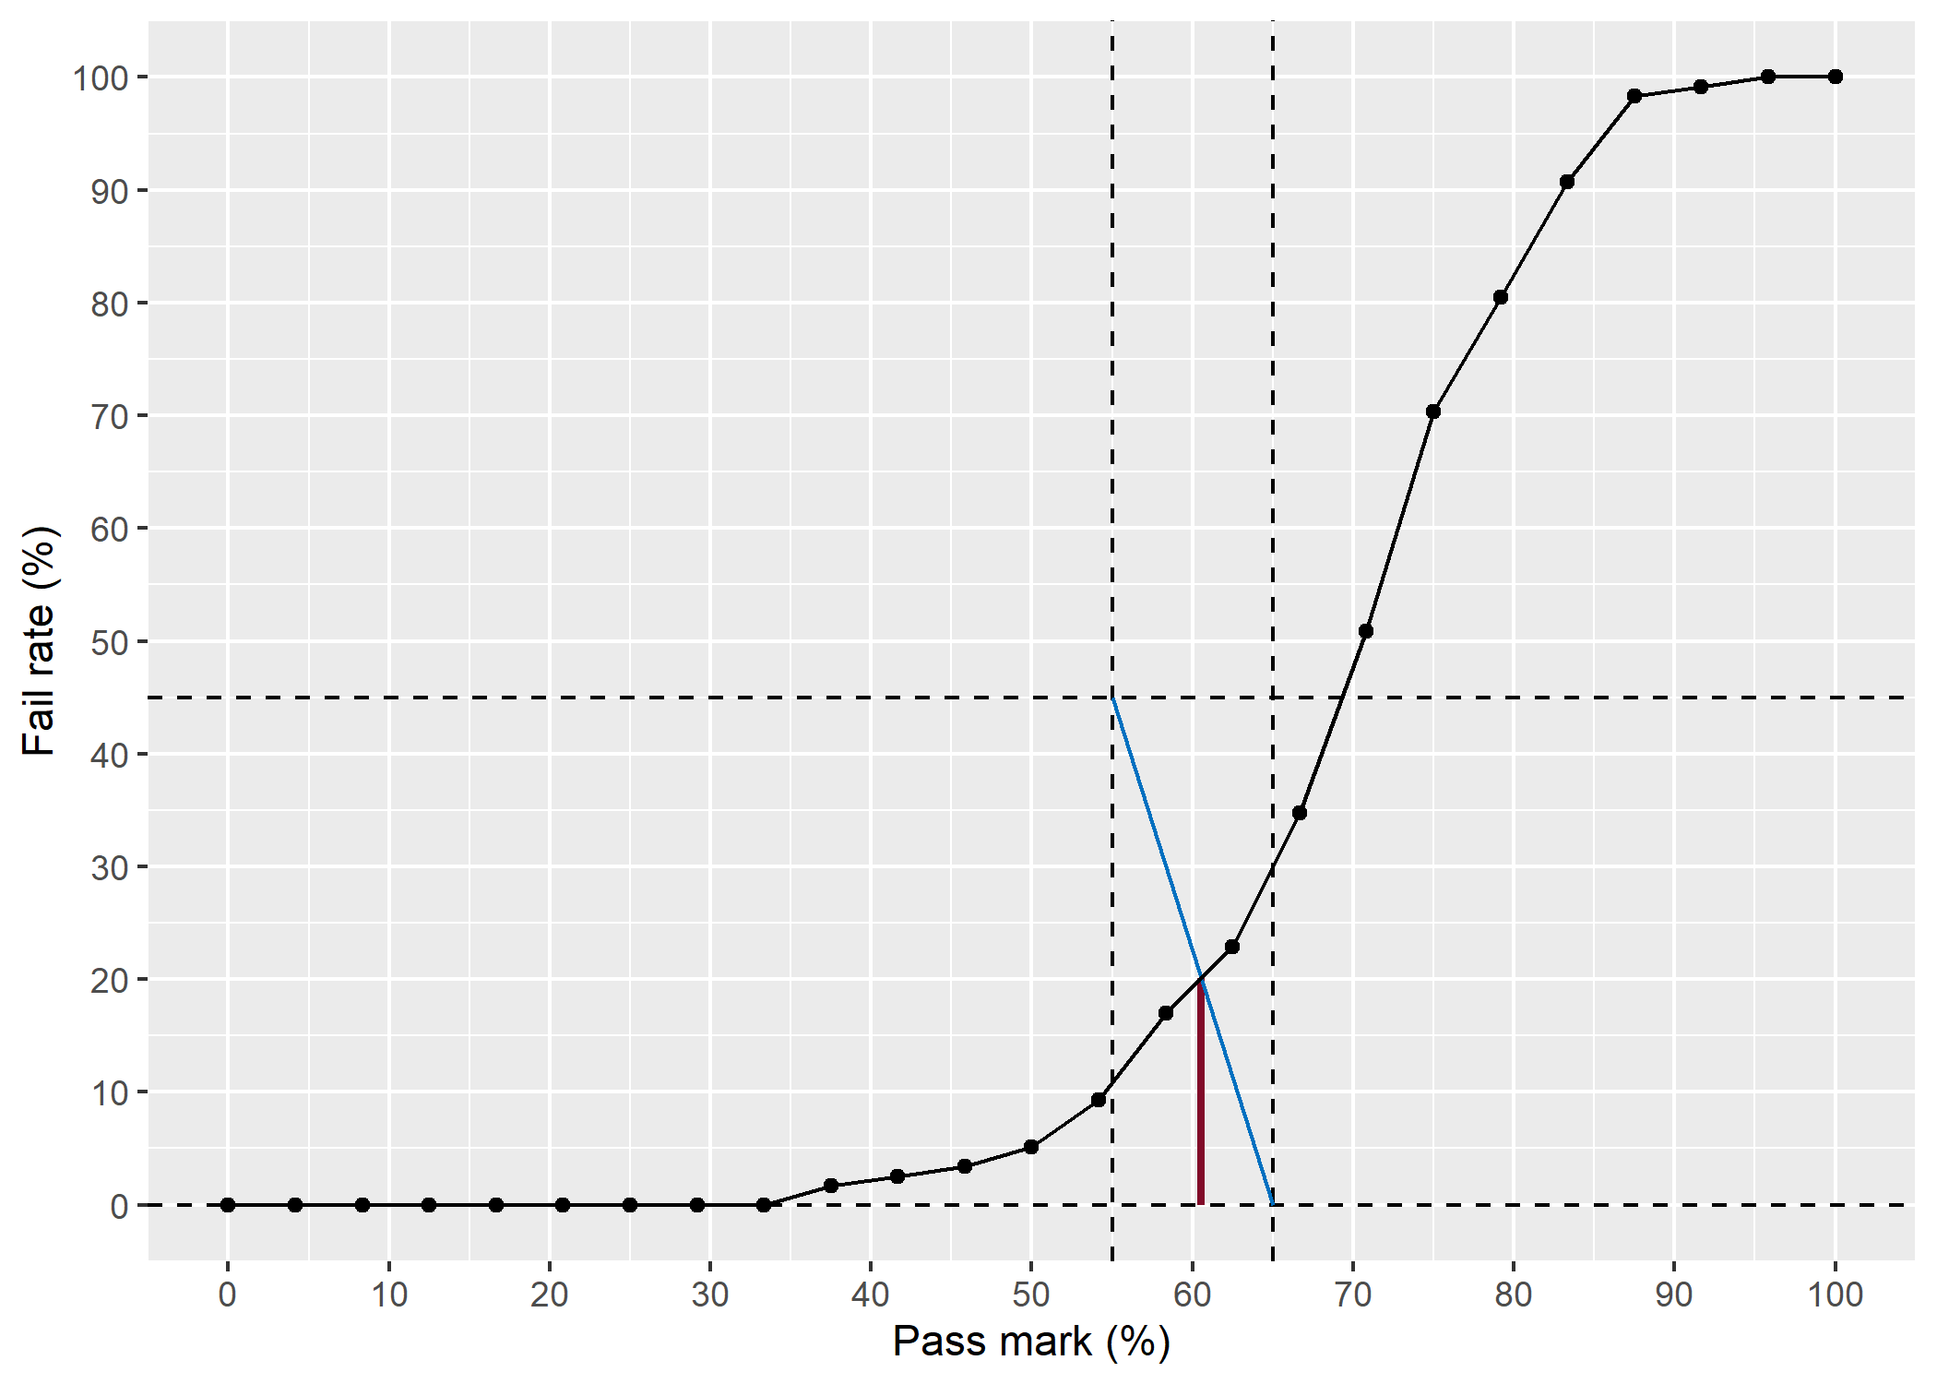
- Hofstee plot – viva

The objective structured clinical examination (OSCE)
There were six OSCE stations in all. The communication OSCE was conducted with the vivas.

Results
- Marks for the OSCE
Statistic | Value | Percentage
Pass mark (using Hofstee) | 118/198 | 59.6%
Mean score | 127/198 | 64.1%
Median score | 126.5/198 | 63.9%
Range | 71 – 172 | 35.9% – 86.9%
Reliability (Cronbach's alpha) | 0.8
SEM | 8.71 | 4.4%
Pass rate (pass mark 118/198) | 85/118 | 72%

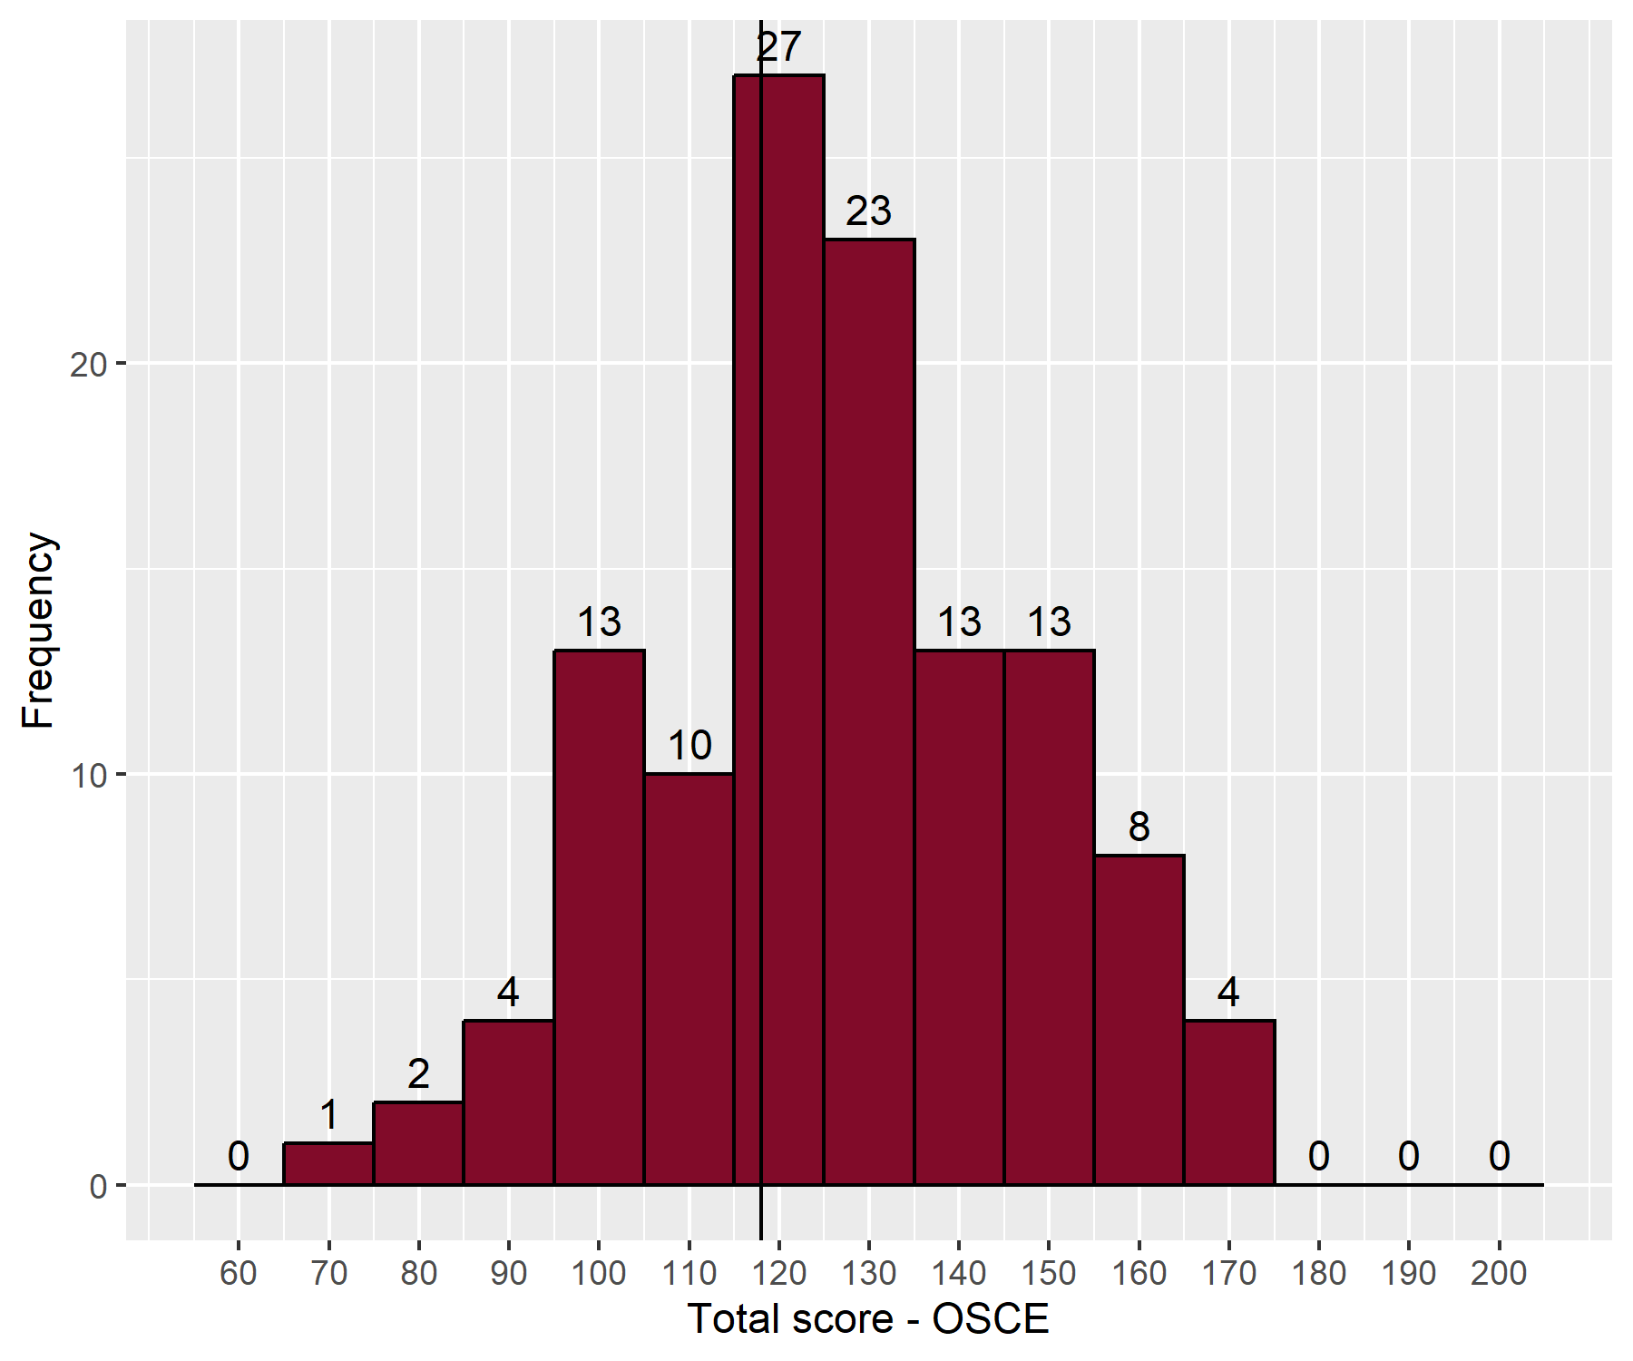
- Distribution of OSCE scores

- Station Summary – OSCE
Station | Category | Maximum Possible | Mean | Median | Min | Max
1 | Anterior segment | 36 | 23.3 | 23.0 | 12 | 36
2 | Glaucoma and lid | 36 | 25.6 | 26.0 | 12 | 36
3 | Posterior segment | 36 | 23.9 | 25.0 | 8 | 33
4 | Strabismus and orbit | 36 | 22.5 | 22.5 | 3 | 36
5 | Neuro-ophthalmology | 36 | 21.5 | 21.0 | 9 | 36
6 | Communication skills | 18 | 10.3 | 11.0 | 2 | 18

- Correlation between examiners' marks at each station
Station | Station 1 | Station 2 | Station 3 | Station 4 | Station 5 | Station 6
Category | Anterior segment | Glaucoma and lid | Posterior segment | Strabismus and orbit | Neuro-ophthalmology | Communication skills
Correlation | 0.88 | 0.89 | 0.89 | 0.89 | 0.88 | 0.84

- Mean absolute difference in examiners' marks at each station
Station | Station 1 | Station 2 | Station 3 | Station 4 | Station 5 | Station 6
Category | Anterior segment | Glaucoma and lid | Posterior segment | Strabismus and orbit | Neuro-ophthalmology | Communication skills
Mean absolute difference | 0.96 | 1.13 | 1.01 | 1.30 | 1.10 | 1.02

- Correlation between OSCE stations
 | Station 1 | Station 2 | Station 3 | Station 4 | Station 5 | Station 6
Station 1
Station 2 | 0.02
Station 3 | 0.11 | 0.37
Station 4 | 0.23 | 0.14 | 0.40
Station 5 | 0.26 | 0.30 | 0.23 | 0.39
Station 6 | 0.15 | 0.06 | 0.30 | 0.38 | 0.30

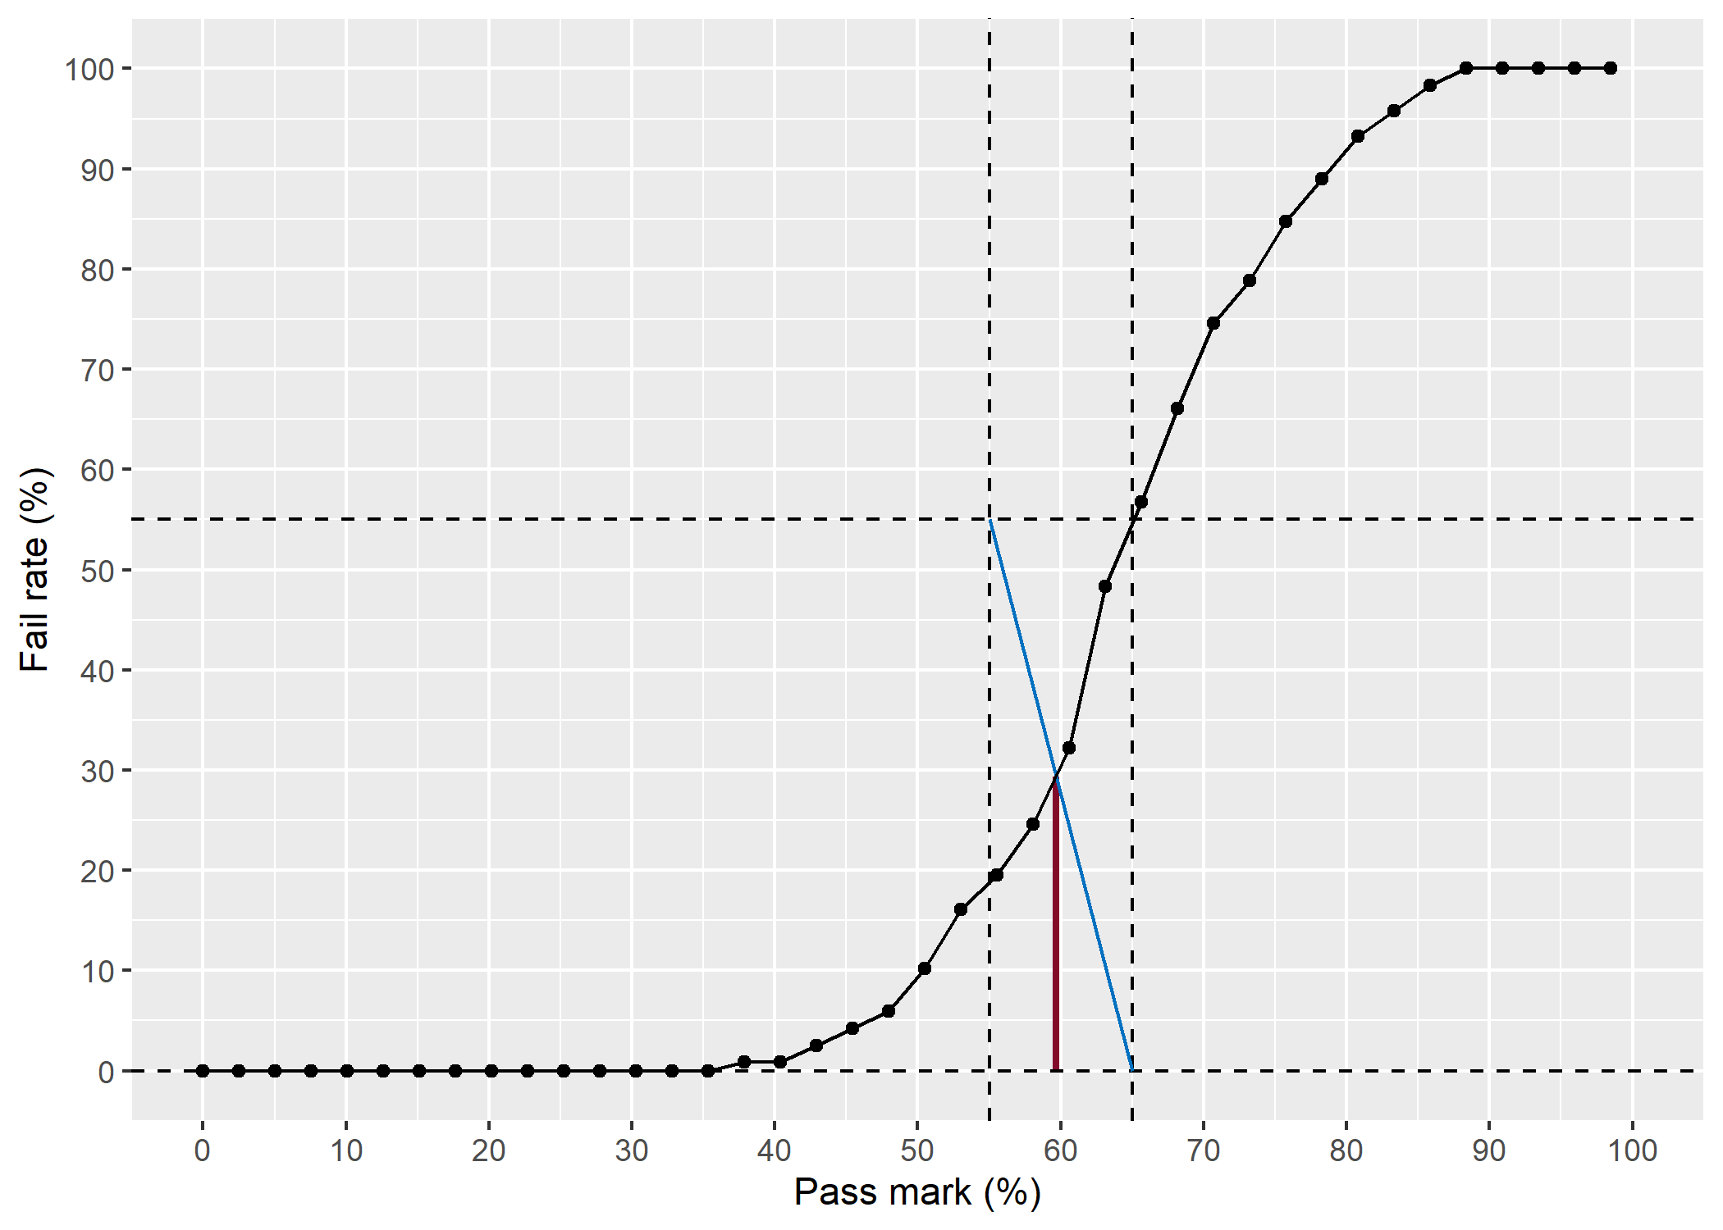
- Hofstee plot – OSCE

Overall results for the oral examination

Results
- Overall results summary
Statistics | Value | Percentage
Pass Mark | 195/318 | 61.3%
Mean | 210/318 | 66.0%
Median | 210/318 | 66.0%
Range | 119 – 276 | 37.4% – 86.8%

To pass the oral examination candidates had to either pass both the viva (77/120 (64 per cent)) and OSCE (118/198 (60 per cent)) or pass the OSCE, achieve 148/240 (62 per cent) in the viva and achieve 195/318 (61 per cent) overall.
Overall, 73 out of 118 candidates passed the examination.
The correlation between structured viva and OSCE was 0.67.
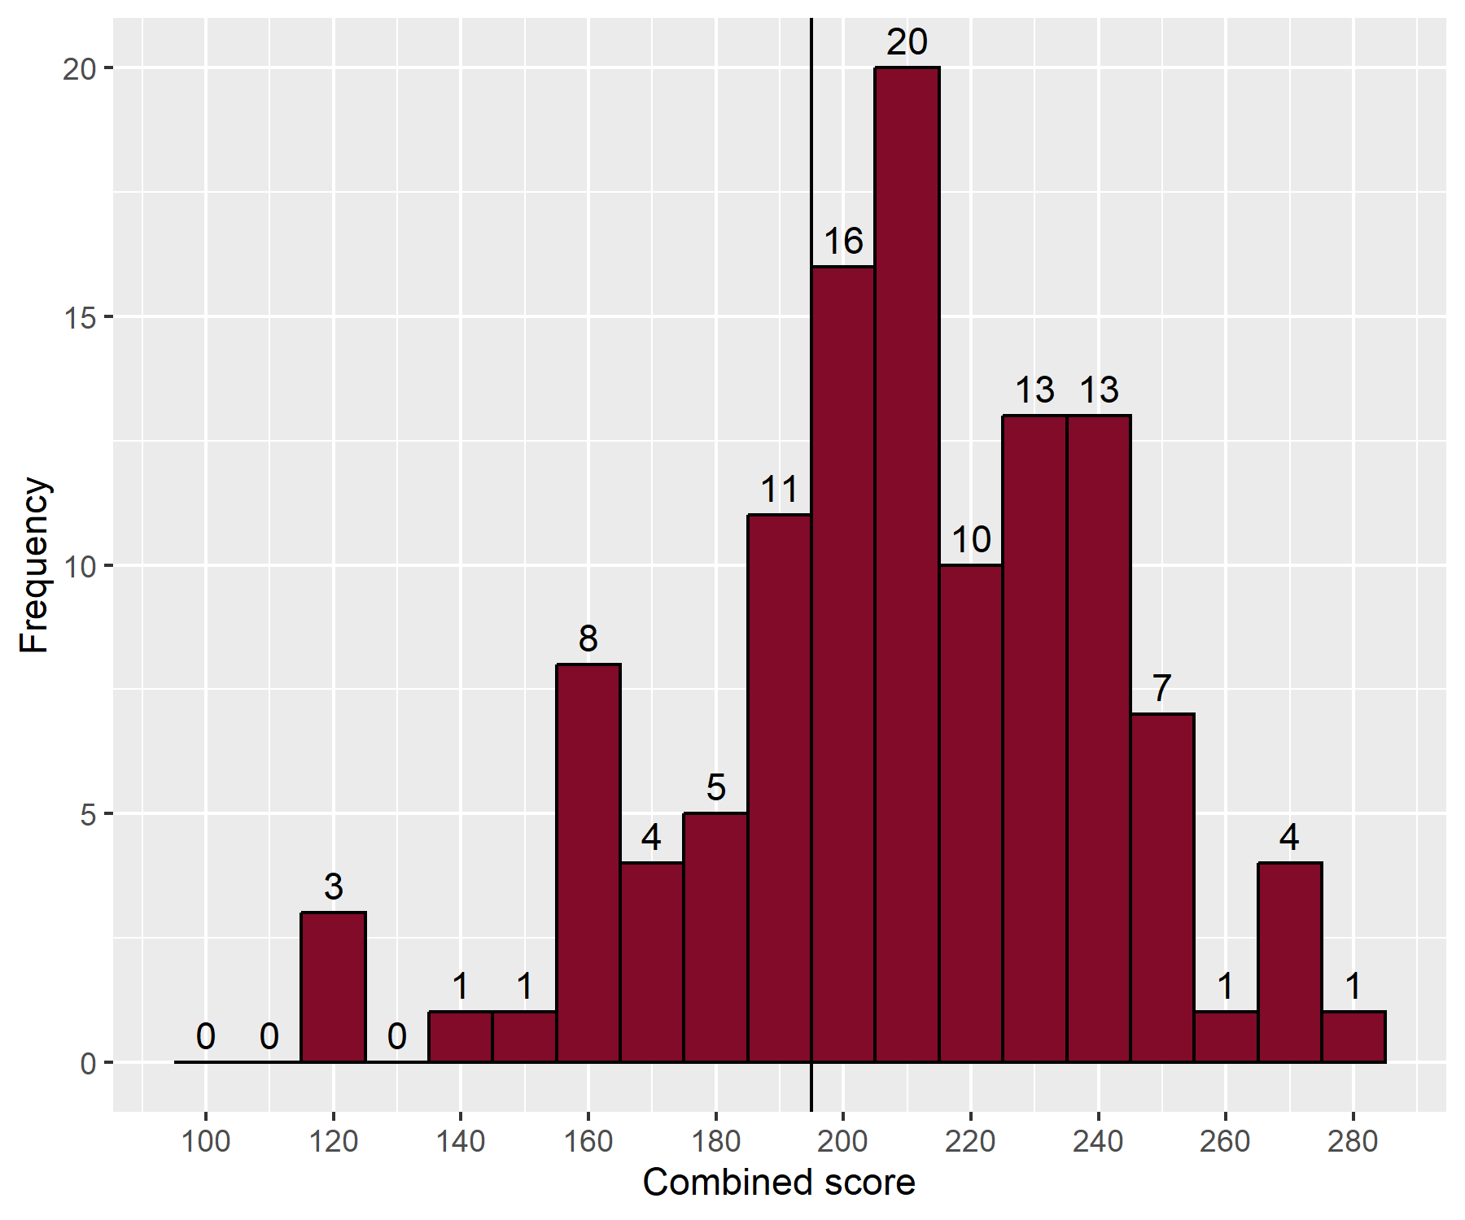
- Distribution of total scores

