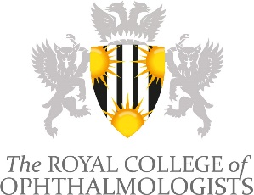
RCOphth INSPIRE Programme Editors
___________________________________________________________________________

Application Form

Closing date: 9am Monday 24 April 2023
E-mail this application form to: education@rcophth.ac.uk

Personal Details
Title
First Names
Surname
Qualifications
Contact telephone number
Email address
Main role (grade and profession)
Current Trust/Employer
Does your employer/supervisor support your application?

Please indicate which area(s) you are interested in being editor ofd a tab)
• Management
• Research
• Historical Ophthalmology
Please selectively list the key positions you have held, with dates, which have given you experience that will help you in this role (use the “alt” key with a bullet and a tab)
•
•
•

Please describe why you think you are suitable for this role (max 150 words)

Please double click box to confirm:
Cautions, criminal convictions and other statements
Have you at any time had (or do you have pending) any criminal convictions? | Yes No
Have you at any time had (or do you have pending) any investigations, suspensions, limitations or removal of medical registration in any country? | Yes No
Have you ever been refused or are there any reasons why a certificate of good standing might be refused in any country where you have worked? | Yes No
Do you have any health problem likely to adversely affect your professional work? | Yes No
Are you aware of any matters that may affect your good standing as a member of your professional body? | Yes No
If you have answered ‘Yes’ to any of the above questions please give an explanation below.
I confirm that I have complied with my employer’s requirements for annual appraisal /performance review. | Yes No
I confirm that I am complying with the requirements of my professional body for CPD / CET or ARCP. | Yes No
I confirm that I am registered with the General Medical Council UK or appropriate body for Professional Registration, and I am up to date with my revalidation and/or licencing. | Yes No
To be completed by the applicant
Signature (electronic signature accepted)
Date | / /  DD MM YYYY

Closing date: 9am Monday 24 April 2023
E-mail this application form to: education@rcophth.ac.uk

