The World Health Organization’s ‘Vision 2020’ project aims to eliminate avoidable blindness. Discuss the achievements of this project, and remaining challenges. (1499 words)

Evolution of the Vision 2020 Project

Tackling blindness has long been on the global health agenda, and rightfully so, from World Health Organization (WHO) attempts to eradicate trachoma in the 1950s¹, through the initiation of the ‘Programme for the Prevention of Blindness’ in 1978². However, towards the end of the 20th century, it was noted that the number of blind people was increasing by nearly 1 million every year: the 28 million blind people in 1978 had grown to 38 million in 1990³, and approximately 80% of these cases were avoidable, i.e. preventable or treatable. More needed to be done to reverse this tide. As such, the WHO collaborated with the International Agency for the Prevention of Blindness (IAPB) and relevant non-governmental organisations (NGOs)⁴ to produce, in 1997, the ‘Global Initiative for the Elimination of Avoidable Blindness’⁵. This document set out a 25-year global plan which became ‘Vision 2020: the Right to Sight’, with the goal to eliminate avoidable blindness (at the time defined as best-corrected acuity <3/60 in the better eye) by the year 2020. As well as the appealing semantic association of the year 2020 with perfect visual acuity, the suggestion of eye care as a human right boosted its importance; in failing to provide ophthalmological services, governments were breaching a right of their citizens.

80-90% of blindness was in low- and middle-income countries (LMICs)³, so these were the focus of Vision 2020, and five major causes of blindness were specifically discussed⁵:
- Cataract
- Trachoma
- Onchocerciasis
- Childhood blindness
  - Vitamin A deficiency
  - Surgically avoidable causes: cataract, glaucoma, retinopathy of prematurity (ROP)
- Refractive errors and low vision

The strategies adopted to tackle these problems included coordinated efforts to raise awareness and advocate for blind people, mobilise resources to develop human resources, technology and infrastructure, and improve service delivery⁶. IAPB were well-placed to advocate, while WHO could advise governments to develop national eye care plans, with decentralised district-level implementation, a model developed by Hannah Faal in the Gambia⁷, and in India⁸.
While in many ways a significant advantage of Vision 2020, the heavy involvement of NGOs had in some places removed impetus for governments to take responsibility for their eye care programmes⁹. To correct this, and amend Vision 2020 to fit in with the Universal Health terminology popular in Ministries of Health, the 66th World Health Assembly¹⁰ built on previous action plans to endorse ‘Universal Eye Health: A Global Action Plan (GAP) 2014-2019’¹¹. The GAP aspired to “a world in which nobody is needlessly visually impaired, where those with unavoidable vision loss can achieve their full potential, and where there is universal access to comprehensive eye care services”¹¹, via a health systems strengthening approach. This plan moved the goal posts diagonally, expanding the target to include avoidable visual impairment (VI) instead of just blindness, but aiming for a 25% reduction in prevalence, rather than elimination.

Achievements of Vision 2020 – Did it work?

- More support. Firstly, the mere existence of a globally coordinated project led to a common focus, enabling NGOs to work together¹². This unified advocacy, and singular, clear message, meant that governments were aware of Vision 2020 and led to more successful fundraising. In some countries, such as Australia and Pakistan⁹, prevention of blindness was prioritised by governments, but often, less sustainable, non-governmental sources of funding were used. (Standard Chartered Bank donated $100million through their Seeing is Believing campaign¹³, which is now coming to an end.)
- Better data. The Global Trachoma Mapping Project (GTMP) made astounding progress, as the largest survey of an infectious disease ever carried out, examining >2.6million people in three years¹⁴.
Rapid Assessment of Avoidable Blindness (RAAB) surveys also collected vital data, from >330 surveys in 79 countries¹⁵. As well as measuring prevalence, these have raised awareness of uncorrected refractive error (URE) as a significant cause of visual impairment, alongside the relevant change in WHO/ICD definition of blindness from “best corrected” to “presenting” visual acuity¹⁶.
- Improved services, and (relative) reduction in blindness. Programmes which preceded Vision 2020 benefitted from this additional boost and showed significant progress, including the Onchocerciasis Control Programme, funded by the World Bank, which successfully closed down its Sub-Saharan African programme in 2002¹⁷. Vitamin A supplementation, supported by UNICEF to reduce child mortality, reduced Vitamin A deficiency (VAD) prevalence among 6–59-month-old children in LMICs from 39% in 1991 to 29% in 2013¹⁸, in line with the Childhood Blindness component of Vision 2020¹⁹.
Progress with trachoma was not limited to data collection. The SAFE strategy (surgery, antibiotics, facial cleanliness and environmental improvement) and Global Elimination of Trachoma by 2020 (GET) mission, have reduced the number of people at risk from 1.5 billion to 142 million between 2002 and 2019, and the number awaiting surgery by two-thirds²⁰. Cataract services also improved; in Bhutan, for example, cataract surgical coverage (CSC) among people with VA<6/60 rose from 58.6% in 2009 to 83.2% in 2018²¹.
At its initiation, the Vision 2020 project was forecast to save 100 million people from blindness²². Figure 1 shows these projections. Comparing 1990 and 2015 global data, the prevalence of visual impairment had fallen from 4.58% to 3.38%, with an estimated 36 million blind people²³, close to the projections.
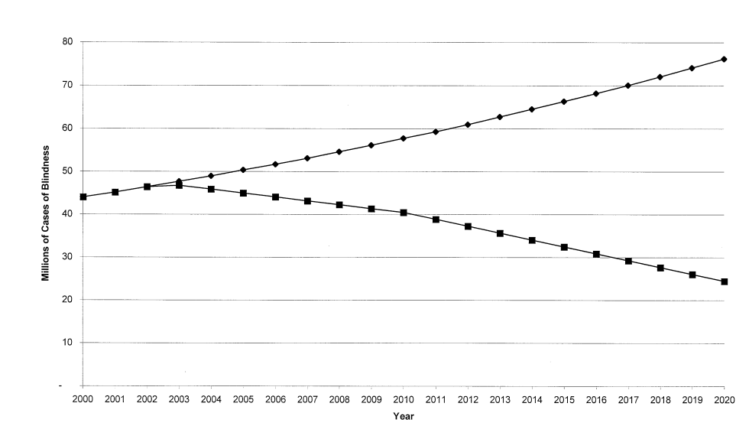
Figure 1: Number of cases of blindness with and without Vision 2020 (squares and diamonds respectively); taken from Frick and Foster, 2003²²

Remaining Challenges

Given the doubling in blindness that could have been, the achievements of Vision 2020 are not to be minimised. That said, the “elimination of avoidable blindness” that felt so achievable when 2020 was >20 years in the future, is still far from accomplished. What’s more, the work that is left to be done is likely to be more difficult than that which has come so far. The 2019 situation, and next steps, were mapped out by the WHO World Report on Vision²⁴. In line with Sustainable Development Goal (SDG) 3 – to ensure healthy lives and promote wellbeing for all at all ages – the World Report recommends making integrated people-centred eye care (IPCEC) part of universal health coverage. This will hopefully be achieved via high-quality implementation and health systems research, accurate monitoring of trends, and the empowerment of communities.
- Increasingly complex problems. The relatively low-hanging fruit of trachoma, onchocerciasis and vitamin A deficiency, which could be solved by mass drug administration (funded by Big Pharma or primary care) are close to solved, and conditions for which we have a swift effective cure, including cataract and refractive error, are being prioritised now. Once these are under control, we will be left with (among others) glaucoma, diabetic retinopathy, and macular degeneration, for which treatment is long-term, and complicated.
- Ageing populations. The growing population was always going to produce more ophthalmology patients, but the ageing of the modern population compounds this. Globally, the proportion of the population aged over 60 is expected to increase from 12% in 2015 to 22% in 2050²⁵, leading to 700 million blind or visually impaired people²⁶. Without a dramatic increase in eye care workers, even areas which are currently adequately staffed risk being swamped by the rising need.
- Inequitable access to eye care workers. The uneven distribution of services is another challenge facing the global eye care force of today, and tomorrow. Worldwide, with approximately 205,000 ophthalmologists²⁷, there are theoretically enough to treat everybody but, as with almost all resources, they are concentrated among the wealthy, both inter- and intranationally. Sub-Saharan Africa gets the raw end of this deal, with only 2.9 surgeons per million population in 2011²⁸, compared to the WHO recommended minimum of 4. In Nigeria, CSC ranges from >80% among literate, urban women to approximately 20% in rural, illiterate women²⁹. Areas in conflict are faced with additional barriers, but eye care services can still be developed^{30, 31}.
- Integration of eye care. As emphasised within the World Report, many eye care programmes have been developed vertically, separate from other healthcare. This is understandable when funding and organisation has been undertaken by eye-specific NGOs; integrating eye care into national healthcare will be one of the challenges in future years²⁴.
- The global COVID-19 pandemic. On top of all of the challenges known when the World Report was published last year, eye care has now been devastated by the pandemic. Many countries intentionally halted non-emergency ophthalmic services, including cataract surgeries³²⁻³⁴, in an attempt to limit COVID-19 transmission, and lockdown protocols were also associated with a reduction in emergency ophthalmic presentations³⁵. As the pandemic drags on, we risk losing the progress made by Vision 2020.
- Climate change. The changing global environment will affect eye health in various ways³⁶: for example, altered environments and increasing natural disasters may change the global distribution of microbial pathogens and infectious eye disease, while social disruption caused by desertification and regions becoming uninhabitable is likely to lead to migration and conflict, with associated barriers to hygiene and healthcare³⁷.

While these six challenges will be difficult to overcome, the lessons learned throughout Vision 2020 could support the realisation of Universal Integrated People-centred Eye Care.

References

1. Mohammadpour M, Abrishami M, Masoumi A, Hashemi H. Trachoma: Past, present and future. J Curr Ophthalmol. 2016;28(4):165-9.
2. Resnikoff S, Pararajasegaram R. Blindness prevention programmes: past, present, and future. Bull World Health Organ. 2001;79(3):222-6.
3. Thylefors B, Négrel AD, Pararajasegaram R, Dadzie KY. Global data on blindness. Bull World Health Organ. 1995;73(1):115-21.
4. Garms RC. The global initiative: launch of Vision 2020. Community Eye Health. 1998;11(28):56-7.
5. World Health Organization. Global Initiative for the Elimination of Avoidable Blindness. Geneva: WHO; 2000. Contract No.: WHO/PBL/97.61.
6. Thylefors B. A global initiative for the elimination of avoidable blindness. Community Eye Health. 1998;11(25):1-3.
7. Faal H, Minassian DC, Dolin PJ, Mohamed AA, Ajewole J, Johnson GJ. Evaluation of a national eye care programme: re-survey after 10 years. Br J Ophthalmol. 2000;84(9):948-51.
8. Murthy GV, Gupta SK, Bachani D, Tewari HK, John N. Human resources and infrastructure for eye care in India: current status. Natl Med J India. 2004;17(3):128-34.
9. Rabiu MM, Al Rajhi A, Qureshi MB, Gersbeck J. Enhancing advocacy for eye care at national levels: what steps to take for the next decade? Middle East Afr J Ophthalmol. 2012;19(1):75-82.
10. World Health Organization. Sixty-sixth World Health Assembly: Resolutions and Decisions. Geneva: WHO; 2013. Contract No.: WHA66/2013/REC/1.
11. World Health Organization. Universal eye health: A global action plan 2014-2019. Geneva: WHO; 2013. Contract No.: WW 140.
12. Foster A, Resnikoff S. The impact of Vision 2020 on global blindness. Eye (Lond). 2005;19(10):1133-5.
13. International Agency for the Prevention of Blindness. Seeing is Believing: IAPB; 2020 [Available from: https://www.iapb.org/learn/knowledge-hub/seeing-is-believing/.
14. Cama A, Keenan JD, Dejene M, Courtright P. Impact of the Global Trachoma Mapping Project. Ophthalmic Epidemiol. 2018;25(sup1):1-2.
15. Mactaggart I, Limburg H, Bastawrous A, Burton MJ, Kuper H. Rapid Assessment of Avoidable Blindness: looking back, looking forward. Br J Ophthalmol. 2019;103(11):1549-52.
16. World Health Organization. Change the Definition of Blindness. Geneva: WHO, ICD; 2018.
17. Etya'alé D. Eliminating onchocerciasis as a public health problem: the beginning of the end. Br J Ophthalmol. 2002;86(8):844-6.
18. Stevens GA, Bennett JE, Hennocq Q, Lu Y, De-Regil LM, Rogers L, et al. Trends and mortality effects of vitamin A deficiency in children in 138 low-income and middle-income countries between 1991 and 2013: a pooled analysis of population-based surveys. Lancet Glob Health. 2015;3(9):e528-36.
19. Gilbert C, Foster A. Childhood blindness in the context of VISION 2020--the right to sight. Bull World Health Organ. 2001;79(3):227-32.
20. West SK. Milestones in the fight to eliminate trachoma. Ophthalmic Physiol Opt. 2020;40(2):66-74.
21. Lepcha NT, Sharma IP, Sapkota YD, Das T, Phuntsho T, Tenzin N, et al. Changing trends of blindness, visual impairment and cataract surgery in Bhutan: 2009-2018. PLoS One. 2019;14(5):e0216398.
22. Frick KD, Foster A. The magnitude and cost of global blindness: an increasing problem that can be alleviated. Am J Ophthalmol. 2003;135(4):471-6.
23. Bourne RRA, Flaxman SR, Braithwaite T, Cicinelli MV, Das A, Jonas JB, et al. Magnitude, temporal trends, and projections of the global prevalence of blindness and distance and near vision impairment: a systematic review and meta-analysis. Lancet Glob Health. 2017;5(9):e888-e97.
24. World Health Organization. World report on vision. Geneva, Switzerland: WHO; 2019.
25. World Health Organization. Ageing and Health: Factsheet Geneva2018 [Available from: https://www.who.int/news-room/fact-sheets/detail/ageing-and-health.
26. Ackland P, Resnikoff S, Bourne R. World blindness and visual impairment: despite many successes, the problem is growing. Community Eye Health. 2017;30(100):71-3.
27. Resnikoff S, Felch W, Gauthier TM, Spivey B. The number of ophthalmologists in practice and training worldwide: a growing gap despite more than 200,000 practitioners. Br J Ophthalmol. 2012;96(6):783-7.
28. Palmer JJ, Chinanayi F, Gilbert A, Pillay D, Fox S, Jaggernath J, et al. Mapping human resources for eye health in 21 countries of sub-Saharan Africa: current progress towards VISION 2020. Hum Resour Health. 2014;12:44.
29. Ramke J, Zwi AB, Lee AC, Blignault I, Gilbert CE. Inequality in cataract blindness and services: moving beyond unidimensional analyses of social position. Br J Ophthalmol. 2017;101(4):395-400.
30. McMaster D, Bamashmus MA. Ophthalmic services during ongoing conflict: the eye health system in Yemen. BMJ Glob Health. 2019;4(5):e001743.
31. Wing K, Low G, Sharma M, De Jesus F, Jeronimo B, Verma N. Building a national eye-care service in post-conflict Timor-Leste. Bull World Health Organ. 2018;96(10):716-22.
32. Ophthalmological Society of Kenya. Re: Eye care professional associations’ position statement on COVID-19 disease. Kenya: OSK, OCOA; 2020 24/03/20.
33. Royal College of Ophthalmologists. Management of ophthalmology services during the Covid pandemic. UK: RCOphth; 2020.
34. American Academy of Ophthalmology. Alert: Important coronavirus updates for ophthalmologists. US: AAO; 2020 23/03/20.
35. Wickham L, Hay G, Hamilton R, Wooding J, Tossounis H, da Cruz L, et al. The impact of COVID policies on acute ophthalmology services-experiences from Moorfields Eye Hospital NHS Foundation Trust. Eye (Lond). 2020;34(7):1189-92.
36. Qassim A, Viki M, Ng SK, Jersmann H, Casson RJ. Climate and season: the effects on ophthalmic diseases. Clin Exp Ophthalmol. 2017;45(4):385-92.
37. Bowles DC, Butler CD, Morisetti N. Climate change, conflict and health. J R Soc Med. 2015;108(10):390-5.

