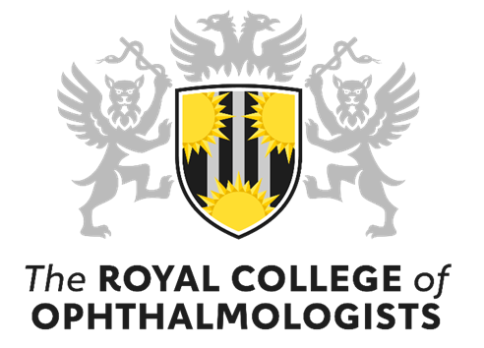

RCOphth Annual Congress 20 – 23 May 2024, ICC Belfast
Session proposal form

Please note all sessions will take place in person at the ICC, Belfast

Name & affiliation of proposer

Email address

Proposed title

Subspeciality/ covered (please include any that apply)

Synopsis of session (up to 150 words)

Proposed length of session (60, 90 or 120 minutes)

Aims and objectives of the session (up to 150 words)

Proposed speakers (please indicate if they have agreed or are those that you would like to invite)

