IMPLEMENTATION NOTE NO 1 – CURRICULUM TRANSITION CHECKLISTS (CTC)

Introduction
This is the first in a series of Implementation Notes to help trainees, trainers and those with a responsibility for managing training locally with specific tasks or activities for implementing Curriculum 2024. The Notes will be put on the Curriculum 2024 website as well as emailed to target groups. They have been drawn up and approved by the Curriculum 2024 Project Board.

Purpose of this Note
This Implementation Note is intended to inform Heads of School and TPDs about the CTC.

Curriculum Transition Checklists
The Curriculum 2024 Project Board has been working with the Curriculum Transition Checklist Task and Finish Group (of the Training Committee) to develop a tool to assist the transition of trainees into the new curriculum. This work has been led by Miss Fiona Spencer, Training Committee Chair. This tool is known as the Curriculum Transition Checklist (CTC).

Four versions of the tools have been developed as follows:
- Level 1 – contains all the new requirements for Level 1 for both Patient Management and generic domains
- Level 2 – ditto
- Generic Level 1-4 – contains all the new requirements for all Levels for the generic domains
- Cataract Surgery Special Interest Area Level 1-4 – contains all the new requirements for all Levels

Purpose of the CTC
The main purpose of the CTC is to help ST1-3 trainees prepare for the new curriculum, as they will be in the later stages of training when the new curriculum formally begins. The CTC should be viewed as a developmental tool, not as a formal assessment. It is very important that by the time trainees reach ST6 there are no significant gaps in training. The table below illustrates the progression expectations for these trainees.
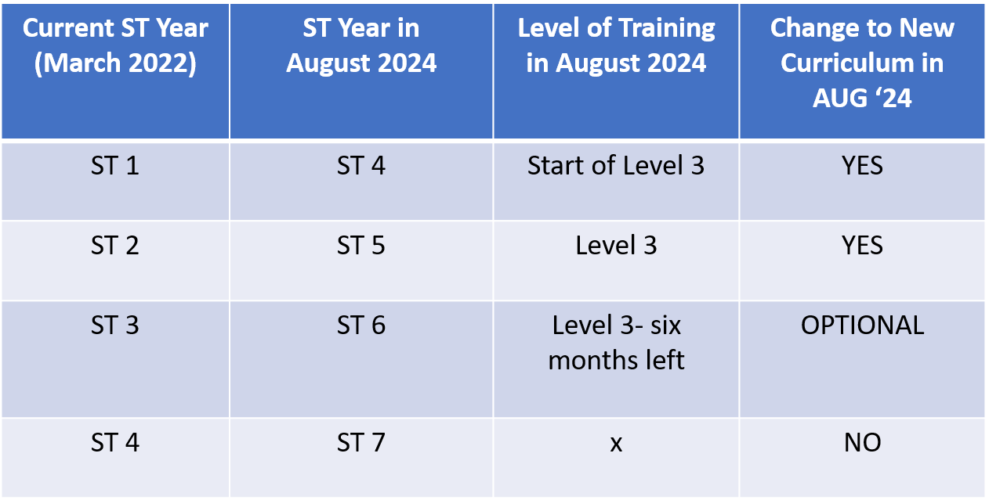

CTC process
- The CTCs will be sent to Educational Supervisors and Trainees on or around 9 May 2022. They will also be put onto the RCOphth website.
- The CTCs include guidance for completion.
- All ST1-3 trainees should pre-populate the CTCs for review with their Educational Supervisor, preferably prior to ARCP.
- The completed CTCs should be uploaded to the ePortfolio for future reference. They are not be a formal requirement of ARCP or of the new curriculum.
- The process should be completed by 30 June 2022.
- A similar process will be repeated for Level 3 and Level 4 around October 2022.

Further information
Please contact Curriculum2024@rcophth.ac.uk if you have queries or want further information.

