CURRICULUM TRANSITION CHECKLISTS FOR LEVEL 3 COMMUNITY OPHTHALMOLOGY & URGENT EYE CARE – IMPLEMENTATION NOTE NO 4

Purpose of this Note
This Implementation Note is intended to inform trainee ophthalmologists, Heads of School and TPDs about the new Curriculum Transition Checklists (CTC) for the new Level 3 Special Interest Areas (SIAs) in Community Ophthalmology, and in Urgent Eye Care.

Purpose of the CTC
The main purpose of the CTC is to help ST1-3 trainees prepare for the new curriculum, as they will be in the later stages of training when the new curriculum formally begins. The CTC should be viewed as a developmental tool, not as a formal assessment. It is very important that by the time trainees reach ST6 there are no significant gaps in training. The table below illustrates the progression expectations for these trainees.
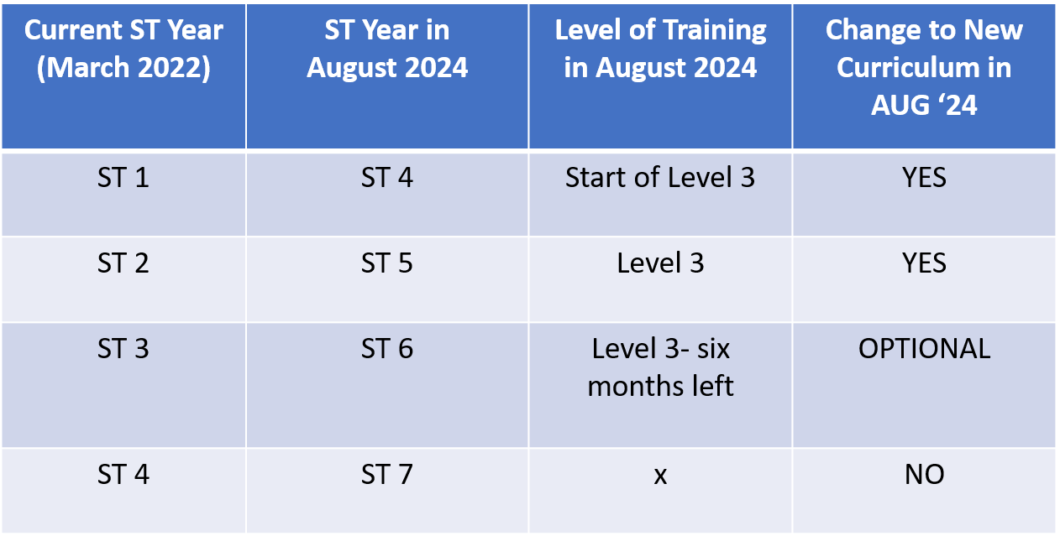

List of CTCs
The Curriculum Sub-Committee has developed the following CTCs:
- Level 1 – contains all the new requirements for Level 1 for both Patient Management and generic domains
- Level 2 – ditto
- Generic Level 1-4 – contains all the new requirements for all Levels for the generic domains
- Cataract Survey Special Interest Area Level 1-4 – contains all the new requirements for all Levels
- Community Ophthalmology Special Interest Area Level 3 (NEW)
- Urgent Eye Care Special Interest Area Level 3 (NEW)

