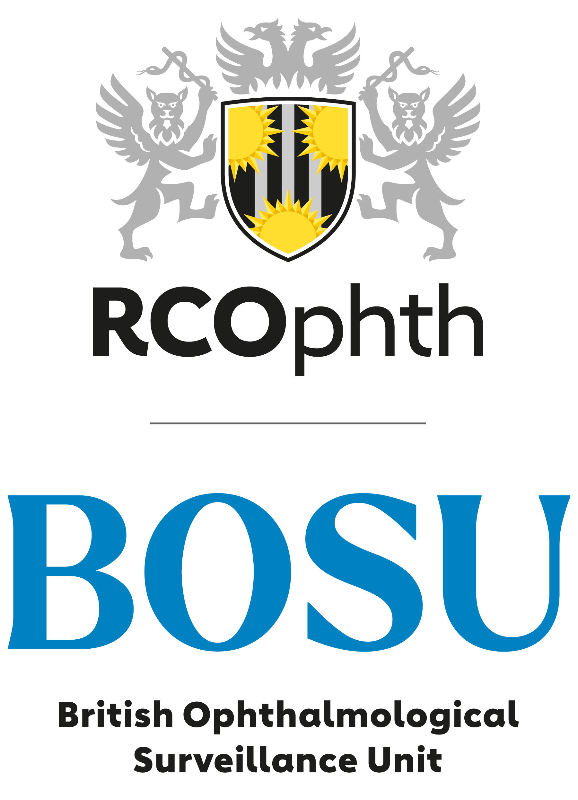
The British Ophthalmological Surveillance Unit:

The RED Trust Bursary-
for an ophthalmologist in training

The BOSU is offering a research bursary of £6000 to support an ophthalmologist in training to undertake an epidemiological study of a rare eye condition through the British Ophthalmological Surveillance Unit.

This award is targeted at Ophthalmologists in Training with limited prior research experience who are looking to develop their research skills through a national epidemiological study of a rare eye disease, condition or event.

Suitable conditions/events for BOSU studies are a predicted annual incidence of less than 5 per million (approximately 300 cases per annum in the UK)

We suggest studies anticipated to ascertain between 75 to 150 ‘cases’ per year are most suitable for this bursary. This sample size is sufficiently large to afford the award winner an opportunity to learn and undertake meaningful statistical analysis but sufficiently small to make the study be manageable with time available within a training post.

The objective for this award is to:
- Enable the successful applicant to develop their research knowledge and skills.
- Add to the body of knowledge of rare eye diseases and conditions.

Applications
Advice and assistance with preparation of applications is available from the BOSU and applicants are advised to contact Barny Foot (barny.foot@rcophth.ac.uk or 07808 581659) for an informal discussion initially.
Application guidelines and the form are available here.
Applications will be assessed on the scientific or public health importance of the topic, the suitability for surveillance via BOSU, potential for impact of the research, clarity and completeness of the submitted application, and the potential to develop the bursary winner’s research skills.
Please submit the completed form, a two page CV which includes previous research involvement, and a phase 1 application containing background, research questions/surveillance objectives, case definition, an estimate of numbers and anticipated impact.
The award will be judged upon the quality of the written application, the suitability of the topic for surveillance and its likely impact upon ophthalmic practice along with the potential for the applicant to develop research skills and experience.
Closing date for applications is Friday 23rd August at 12 noon.

