INFORMATION ABOUT THE PROPOSED CHANGES TO CURRICULUM 2024
This document gives more information about proposed changes to Curriculum 2024 for the benefit of those responding to the consultation – which you can access here. The proposed changes build on the principles set out in this Implementation Note, with the aim of keeping the curriculum safe, coherent and deliverable while reducing unnecessary assessment burden. The proposals: (1) simplify early progression requirements, (2) clarify terminology, and (3) introduce more flexibility in the timing of refraction assessment without reducing expected standards.
These proposals will not affect doctors on the Portfolio Pathway.
The Curriculum Sub-Committee has developed three proposals, approved by the Training Committee for submission to the GMC. The diagram below shows the combined effect of the three changes.
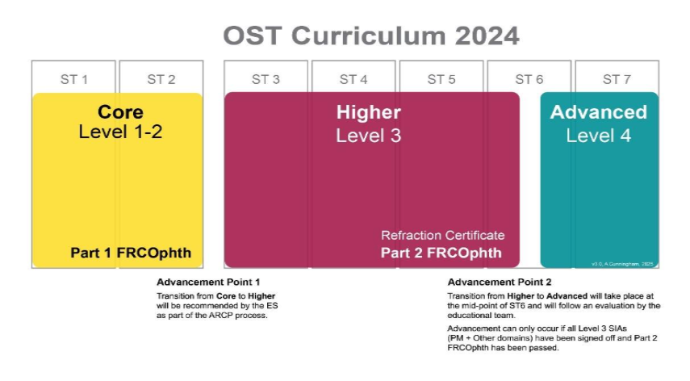
1) Streamlining the Curriculum – Core (combining Level 1 and Level 2)
What is changing? Level 1 and Level 2 would be combined into a single Core level, assessed through one Core EPA and one Core GSAT.
Why are we proposing this? Although Level 1 and Level 2 have distinct purposes on paper, in practice most residents aim to complete Level 2 by the end of ST2. This means there are two early advancement points in quick succession, with duplication across syllabi and assessments.
What stays the same? Residents would still be expected to meet the same standard as a current Level 2 resident before progressing. Patient safety remains central: streamlining removes duplication, not expectations.
How will this work in training and at ARCP? The Core EPA would combine the mandatory requirements of the current Level 1 and Level 2 EPAs, with minor edits to improve clarity, and removes two clinical skills – operating microscope (this is effectively covered by the surgical skills assessment) and punctal plug insertion (unnecessary to include in EPA). To support ARCP panels, the Matrix of Progression would specify what is expected by the end of each year (ST1 and ST2). Evidence for the Core GSAT would be collected against the new Core Learning Outcomes.
This change removes an unnecessary waypoint and reduces assessment burden, while keeping the required standard for progression unchanged. TPDs have indicated strong support because it better reflects how training is delivered in practice.
2) Curriculum terminology
What is changing? Combining Level 1 and Level 2 into a single Core level removes one numbered level. To keep the structure clear, the curriculum would show the stage names Core, Higher and Advanced, while maintaining the terminology of levels (as shown in the diagram).
Why does this matter? Clear terminology supports consistent understanding across residents, supervisors and ARCP panels, especially during the transition to Curriculum 2024.
3) Refraction
What is changing? The requirement would move from being tied to a specific training stage to a more flexible waypoint: the Refraction Certificate must be passed before the Part 2 FRCOphth Oral examination.
Why are we proposing this? In the early years of training, residents may not know their future special interest area. Good basic refraction skills support safe general ophthalmology and are particularly helpful before paediatric attachments. However, the timing of paediatric attachments varies locally, and many residents learn refraction most effectively during that rotation. Introducing flexibility reduces pressure in the first two years and better reflects real training pathways.
How does the pilot fit in? A short-life working group recommended a pilot to test whether a workplace-based assessment plus logbook could meet the same standard as the Refraction Certificate examination. The pilot is underway and is based on the current curriculum requirement (passing refraction before entering Level 3). Although results are not expected until July 2026, the principle of flexibility is considered beneficial regardless of whether the final assessment remains the examination or moves to an alternative process (Refraction EPA + logbook).
What about patient safety? The RCOphth does not anticipate a discernible impact on patient safety. Residents would continue to be supervised and would not undertake refractions independently. Most residents would still aim to pass refraction within the first four years to remain on track for Part 2 FRCOphth Oral and progression through later stages of training. In addition, the new Core EPA would retain the CRSRet, ensuring that some refractive competency is evidenced by the end of ST2.
Summary of rationale for the three changes
Taken together, these changes are intended to make Curriculum 2024 easier to navigate and deliver. They streamline early progression by combining Level 1 and Level 2 into Core, clarify terminology to support consistent use across the UK, and introduce flexibility in refraction timing while keeping appropriate quality assurance before the final examination.
TAKE PART IN MAKING A CHANGE TO THE CURRICULUM!

