INSPIRE Digital Learning Content Proposal

Use this form to propose a piece of digital learning content for the College’s INSPIRE platform. It is intended for early-stage ideas so the Digital Learning team & INSPIRE Editorial Board can review, approve or decline proposals before full content is created.

You do not need to submit full learning materials at this stage — just the key information below.

Submitting a proposal does not guarantee publication; proposals may be approved, returned for clarification, or declined.

Send your proposal to inspire@rcophth.ac.uk
What happens next?
The Digital Learning Team & INSPIRE Editorial Board will review your proposal and contact you to confirm whether it is approved, needs further information, or will not be taken forward.

If approved, you will be asked to complete a full submission form. Submissions are reviewed for quality, accessibility, and appropriate governance requirements, including clinical review, in line with the INSPIRE Submission Process (see INSPIRE submission process overview here)

Please complete the sections below as fully as possible to support review.

Submitter Details (for correspondence)

Name:
Email Address:

Authors (for acknowledgement on INSPIRE)

Please list all authors to be credited. Add additional rows where needed
Name & Title | Role / Job Title | Affiliation

Proposal Overview

Title:
Provide a clear, descriptive title. Avoid abbreviations unless essential.

Audience:
Identify the intended audience, e.g. medical students, foundation year doctors, GPs, OST/OLT ST (levels 1, 2, 3, 4, 5, 6 or 7), consultant, advanced clinical practitioner.

Is prior knowledge assumed? If so, specify.
Specialty / Topic:
Content type:  (tick or highlight all that apply) | [ ] General learning content  [ ] Clinical case study  [ ] Surgical technique video  [ ] Webinar or lecture recording  [ ] Podcast  [ ] Toolkit / downloadable resource  ☐ Other: ______________________________________________
How will learners use this?  (tick one) | Is this to supplement a course, as pre or post learning?  [ ] Yes  [ ] No  If yes, please state the name of the course:
Learning objectives:  Identify a maximum of 3 learning objectives.  Use action verbs (e.g. describe, interpret, apply, differentiate) | By the end of this content, learners will be able to:  1.  2.  3.
Key topics:
List up to 5 key topics. Sequence from foundational knowledge to clinical application where appropriate.

Summary (max 100 - 150 words):
Provide a concise overview of the proposed content, including:
- Clinical context.
- Purpose and relevance to learners.
- Key learning points and messages.

This should give a clear sense of what the learner will gain from this content.

Does this proposal include any of the following?  (tick all that apply) | [ ] Patient information or images  [ ] Third-party copyrighted material  [ ] Clinical advice that may change frequently  [ ] None of the above / not sure  If you have any patient information or images, or third-party copyrighted material, you will need to ensure the appropriate consent & permissions are provided using our consent form.
Do you have existing materials to base this on or use? | [ ] Yes  [ ] No  [ ] Not sure

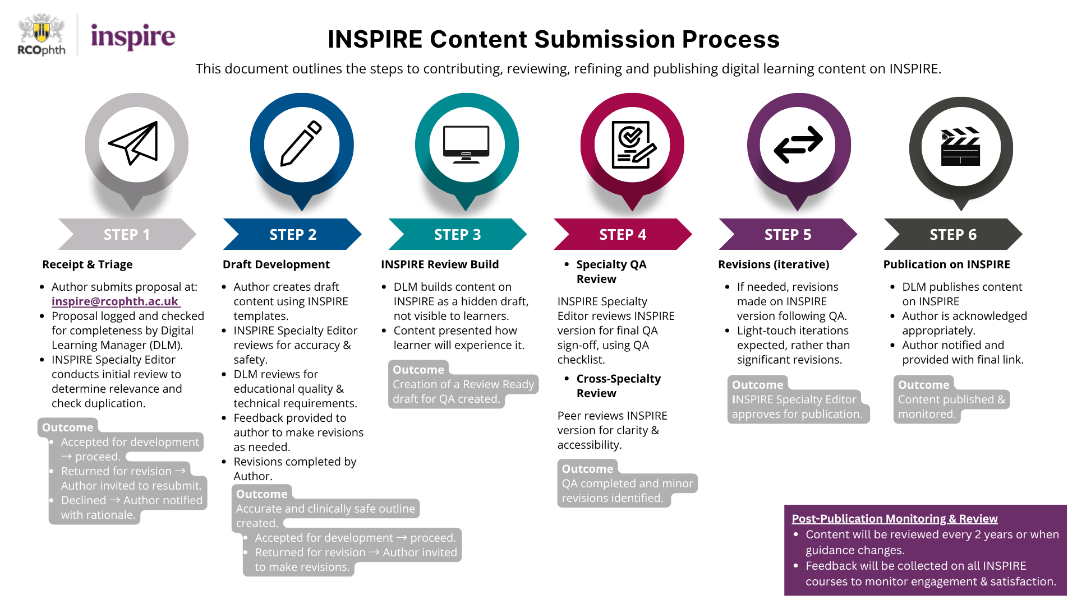
xxxx

